EEL 4914 Senior Design I:

Hydroponic System



**Group 23:**

Amidtzalee Laguna Mundo | ECE

Jean Seda | CPE

Majed Halawa | ECE

Jordan Sole | CPE

**Table of contents**

1. Executive Summary 2-3……………………………………………………………...……….....5

2. Project Description…………………………………………………………………..…………...6

2.1 Project Motivation and Goals ………………………………………………….……………..6

2.2 Objectives………………………………………………………………………………………..7

2.3 Requirements Specifications…………………………………………………..……………...9

2.4 Quality of House Analysis ………………………………………………………..…………..11

2.5 Overview Block Diagram………………………………………………………...…………...11

3. Research related to Project Definition and Part Selection………………………….……...12

3.1 Existing Similar Projects and Products……………………………….…………………….28

3.1.1 Under the Sea Hydroponics ……………………..……………………………...32

3.1.2 Mars Hydroponics ………………………………………………….…………….35

3.2 Relevant Technologies………………………………………………………...……………...37

3.2.1 Wick System …………………………………………………………………...….38

3.2.2 Nutrient Film Techniques System ……………………………………...……….38

3.2.3 Drip System…………………………………………………………………....…..40

3.2.4 Ebb and Flow System ……………………………………………………..……..42

3.2.5 Water Culture System ……………………………….……………………..…….44

3.2.6 Aeroponics System ……………………………………………………...……….45

3.3 Strategic Components and Part Selections ………………………………...……………..48

3.3.1 Choosing a microcontroller………………………………………………...…….48

3.3.2 Capability differences in the microcontrollers…………………….…………....51

3.3.3 Compatibility of the microcontrollers………………………………..…………..52

3.3.4 Power modes…………………………………………………………………...….55

3.3.5 Protecting the microcontroller …………………………………..……………….58

3.3.6 Programming Languages Available………….…………………………………..59

3.3.7 Types of Water Sensors…………………………………………………...……...60

3.3.8 Types of pH Sensors ……………………………………………...……………...66

3.3.9 Types of Nutrient Sensors……………………………………….……………….71

3.4 Possible Architectures and Related Diagrams……………………………………………..75

3.4.1 Software architectures ………………………………………………....………...77

3.4.2 Web Application………………………………………………….………………..78

3.4.3 Power Supply Design ……………………………………...…………………....80

4. Related Standards and Realistic Design Constraints……………………..………………..82

4.1 Standards

4.1.1 Wi-Fi Standards………………..………………………………………...………..83

4.1.2 Electricity Standards………………………………………………….…………..85

4.1.3 Water Quality ……………………………………………………………………...85

4.1.4 Agriculture Standards,........…………………………………………..................87

4.1.5 Temperature Standards ……………………………………………….………….87

4.1.6 Design impact of relevant standards………………………………………...….88

4.2 Realistic Design Constraints

4.2.1 Economic and Time constraints ………………………………….……………...89

4.2.2 Environmental, Social, and Political constraints …………………...………......91

4.2.3 Ethical, Health, and Safety constraints ……………………………………..…...92

4.2.4 Manufacturability and Sustainability constraints …..………………..……...….94

5. Project Hardware and Software Design Details……………………………………..…..….…..95

5.1 Initial Design Architectures and Related Diagrams

5.1.1 12-Volt Power Supply …………………………………………….…….………..…..96

5.1.2 Light Sensor ……………………………………………………….……..…..…..…...97

5.1.3 Microcontroller ……………………………………………………..……………..…..97

5.1.4 Data and Voltage Isolator…………………………………………………..……..….98

5.1.5 LCD Screen ………………………………………………………………………..…..99

5.1.6 Nutrient Sensor ……………………………………...……………………..…………99

5.1.7 Oxygen Air Pump ……………………………………………………………..……100

5.1.8 Water Level Sensor …………………………………….…………………..………101

5.2 First Subsystem, Breadboard Test, and Schematics ………………………...………….…101

5.3 Second Subsystem ……………………………………………………………….……………..103

5.4 Third Subsystem…………………………………………………………...………………….…103

5.5 Software Design ………………………………………………………...…………………….…107

5.5.1 Website………………………………………………………..………………….…...108

5.5.2 Wi-Fi Transmission ……………………………..……………………………………109

5.5.3 Bluetooth ………………………………………………..……………………………110

5.5.4 Wi-Fi vs. Bluetooth………………………………………………..………………….110

5.6 Summary of Design and Overall Schematics …………...………………………………110 - 11

6. Project Prototype Construction and Coding

6.1 Integrated Schematics ………………………………………………..…….…………113

6.2 PCB Vendor and Assembly ………………………………….…………..……………114

6.3 Final Coding Plan……………………………………………….………….…………...114

7. Project Prototype Testing Plan ………………………………………….………….……………118

7.1 Hardware Test Environment

7.1.1 Peristaltic Pump ……………………………………………….…………..…………118

7.1.2 Power System Testing ………………………………………………………….……119

7.1.3 Solution Level Testing …………………………………………………….…………119

7.1.4 LED Lights Testing ………………………………………………………...……...…119

7.1.5 Logic Level Shifting Test …………………………………..………………………..119

7.2 Hardware Specific Testing

7.2.1 Light Sensor Testing…………………………………………………………………120

7.2.2 pH Sensor Testing……………………………………………………………………120

7.2.3 Nutrient Sensor Testing………………………………...……………………………121

7.2.4 Testing with Conductivity Sensor …………………………….……………………122

7.3 Software Test Environment …………………………………………………………………… 122

7.4 Software Specific Testing …………………………………………………………….……122-124

8. Administrative Content

8.1 Milestone Discussion 4 pages………………………………………………..……………124-125

8.2 Budget and Finance Discussion 4 page…………………………....……………………125 -126

9.0 PCB Design ………………………………………………………………………………....127-133

Appendices

Appendix A - References…………………………………………………………….…………133-135

**List of Figures**

Figure 1 Project Prototype Illustration……………………………………………………10

Figure 2 The House of Quality…………………………………………………………….11

Figure 3 Overview Block Diagram………………………………………………………..11

Figure 4 Wick System …………………………………………………………………….38

Figure 5 Nutrient Film Technique System……………………………………………....40

Figure 6 Drip System ……………………………………………………………………..42

Figure 7 Ebb and Flow System ………………………………………………………….44

Figure 8 Water Culture System ………………………………………………………….45

Figure 9 Aeroponic System………………………………………………………………47

Figure 10 LDR & Microcontroller Schematic…………………………………………...50

Figure 11 Power Modes ………………………………………………………………….57

Figure 12 Liquid Level Sensor ………………………………………………………….64

Figure 13 Precautions While Installing in Tank ………………………………………..66

Figure 14 Analog pH Sensor ……………………………………………………………70

Figure 15 TDS Sensor…………………………………………………………………….74

Figure 16 Possible Hydroponic System ………………………………………………..77

Figure 17 Digital Potentiometer Schematic …………………………………………...96

Figure 18 Breadboard Microcontroller Test …………………………………………...102

Figure 19 Water Level Sensor Test …………………………………………………….102

Figure 20 Schematic for the ESP32 Microcontroller ………………………………...112

Figure 21 Connections for the Sensors ……………………………………………….113

Figure 22 Final Coding Plan …………………………………………………………….115

Figure 23 Web Application Plan ………………………………………………………..117

Figure 24 Database Design …………………………………………………………….118

Figure 25 Overall Schematic …………………………………………………………...127

Figure 25 Microcontroller Schematic ………………………………………………….128

Figure 26 Programming Port Schematic ……………………………………………...129

Figure 27 Power Supply Circuit ………………………………………………………..130

Figure 28 TDS Sensor Schematic ……………………………………………………..130

Figure 29 Water Level Sensor Schematic …………………………………………….131

Figure 30 pH Sensor Schematic……………………………………………………….132

Figure 31 LED Strip Schematic ………………………………………………………..132

Figure 32 PCB Footprint ………………………………………………………………..133

**List of Tables**

Table 1: Requirements Specification………………………………………………….9

Table 2: HID Watts Capacity ………………………………………………………….13

Table 3: CFLs Wattage ………………………………………………………………..14

Table 4: Comparison of Lights …………….…………………………………………19

Table 5: Lights Timer Relay Comparison…………………………………………….23

Table 6: Perilastic Pump vs Solenoid Valve……………………………………….....25

Table 7: Pump Pros & Cons …………………………………………………………..26

Table 8: Hydroponics Pros & Cons …………………………………………………..48

Table 9: Microcontrollers ……………………………………………………………...49

Table 10: Microcontroller’s Compatibility …………………………………………...55

Table 11: Water Level Sensor Compatibility ………………………………………..63

Table 12: pH Sensor Comparison …………………………………………………...67-69

Table 13: Electrode Comparison …………………………………………………….72-73

Table 14: Power Supply Comparison ……………………………………………….81

Table 15: Regulated Power Pros & Cons …………………………………………...82

Table 16: Unregulated Power Pros & Cons …………………………………………82

Table 17: Linear Pros & Cons ………………………………………………………...82

Table 18: Switched Pros & Cons …………………………………………………….83

Table 19: Battery-Based Pros & Cons ………………………………………………83

Table 20: Wi-Fi Frequency Comparison …………………………………………….84-85

Table 21: Electricity Standards ……………………………………………………..85

Table 22: Levels of EC for Plant Growth …………………………………………..86

Table 23: Temperature Standards…………………………………………………..88

Table 24: Test Case Table …………………………………………………………..123-124

Table 25: Senior Design I Milestones ……………………………………………..124-125

Table 26: Senior Design II Milestones …………………………………………….125

Table 27: Estimated Budget ……………………………………………………….126

**1. Executive Summary**

**Hydroponic System**

Around the world there is more and more talk about the environment and what we could do as a society to contribute to its well-being rather than add to its demise. In the STEM community there is increasing research to create technology that reduces carbon emissions and toxic waste into our environment. One of these technologies is a Hydroponic System. The word hydroponic means plants and or crops that are grown in either liquid, sand, or gravel. Currently in most places’ crops are grown in vast open spaces of land and require many different processes beginning from planting the crops, which would require a lot of manpower to do. Then we also need to fertilize the soil in which the crops are grown, this process presents a high-level health risk because fertilizer is mainly animal feces and given a change in temperature and or climate it could trigger big changes that could cause an abnormal growth of bacteria in the soil which could then get to the actual crops. On average in the United States there are around 265,000 illnesses and about 100 causes of death by E. coli contamination in plants grown for human consumption. This alone should be cause for some serious research for new and better solutions to these problems.

Apart from the problems previously stated there is also the logistics part of it. Once these crops are collected, they need to be taken to several facilities designed to clean and package these goods so they may then be taken and distributed to supermarkets, restaurants, and businesses across the country. So much for “fresh fruits and vegetables”, this quote is more of a marketing strategy, the reality is that if it’s not bought in a farmer’s market chances are it's not so fresh. Transporting all these vast quantities of crops will undoubtedly influence carbon emissions coming from the trucks moving these items from point A to point B and back.  This presents a problem along with the fact that some of these fruits and vegetables might arrive later than expected, and this can exponentially cut its sell by date which would then result in a loss. After looking more into all the problems related to food farming and harvesting, we looked into a solution, which is a hydroponic system. This system can be designed in many different ways, and it can vary in size given the size of the customer. Hydroponic systems could be designed for household use or industrial use. If designed in a vertical fashion this could save a lot of space without compromising the number of crops being grown. And given that they will not be grown in soil this would reduce previously stated health risks and concerns, which are currently an issue in our country. Throughout the semester we could highlight additional problems that a hydroponic system could possibly alleviate and additional benefits to the system.

Our goal for this project is to design a fully automated functioning Hydroponic System with various sensors to detect nutrients, pH levels, and water levels. This system should be small and portable, the purpose of its size is so that we would reduce the cost of production and can be easily transported for us to work on the project in several places. We created a system that could be used as a household garden but that could also be used for small businesses and given enough power could even be used at an industrial level.

**2. Project Description**

**2.1 Project Motivation and Goals**

The motivation to choose to do a hydroponic system came from a lot of different motives. We as a group wanted to apply our computer and electrical engineering skills to use, and at the same time construct something that would be beneficial for someone trying to grow food or a plant in a remote location. Ideally it can be used outdoors as well but since it has mobility it is more reasonable to be used indoors. It has more of an availability to those who live in rural areas where one has no land to grow outdoors. Not only its remoteness of the system but other motives that we had in mind when choosing this project was the added benefits that it brings when growing plants/food using a hydroponic system.

When comparing a hydroponic system to a regular soil based technique. The hydroponic system seems to trump over regular soil based techniques. With a hydroponic system it gives the grower/farmer complete control over the plant. The grower has the capability to absolutely control everything that goes into the plant. The grower is able to maintain a desired pH level when growing the crop allowing the plant to really grow to its maximum potential. Another added benefit of using the hydroponic technique is more effectiveness on the use of water. In soil water seems to spread out and not completely be directed to the plant's roots. When using a hydroponic system there are many ways to effectively recycle the water and have it flow back to the plant’s roots. This leads to a lower water bill which is a big plus for anyone performing this in a big scale operation. In addition to the water efficiency we also have a big space efficiency too. When using a hydroponic technique the space required to operate is significantly lower than a soil based style, allowing for more plants/crops to be grown in the same amount of space. Hydroponic systems also remove the factor of harmful chemicals being absorbed into the crop due to poor soil conditions. Another motive that really gave us the deciding factor is that when a farmer uses a hydroponic system to grow their crops they typically see an increase in the yield produced by the crop which is very beneficial to anyone growing any kind of crop that they are expecting to receive a yield from. Not only do the plants produce more, the quality of the product being collected also has a higher nutritional content compared to those that are being grown with soil.

The goal of our project is to attempt to create a hydroponic system that will give the ability to the user to also have complete control over the system via the world wide web. We want to create a hydroponic system that will be compact and robust in size for those with the inability to have large growing spaces, but yet want to grow some kind of food at home indoors. The goals for the project are as follows:

* Create a system that is versatile and easy to move for those with the inability to grow outdoors
* Create a web application that allows users to monitor their plants and have complete control over the lighting and water
* Create a system that is easy to use for the consumer and also make the web application easy to use and have the core necessities for normal operation

**2.2 Objectives**

The objectives for our hydroponic design will be very simple. We constructed a compact and versatile system that includes a variety of sensors to keep track of vital information in the plant's environment. This information will then be passed on via Wi-Fi that will be shared on a website so that the user can monitor the plant's vitals. The objective are as follows:

* Versatile lightweight design: We created an easy to move and lightweight design so that this will allow the user to move freely as desired. We need this to be versatile so that if needed to be moved it can be done. This will also allow other users that might live in rural and apartment areas to freely move so that the workspace can be cleaned or reallocated if needed. We used lightweight PVC pipes and goods that can be found at Home Depot to construct our system. The rest of the materials and sensors can be found online on Amazon.
* Sensors: For our design we needed a variety of sensors that can extract information from the plant's environment. We needed a pH sensor that would keep the user updated on the pH level of the water used to water the plants. This is a very vital sensor as an imbalance in the plant's water can ultimately kill the plant. The system also includes a water level sensor which was implemented so that if the user chooses a low maintenance plant/crop then the user will receive a notification letting the person know that the system is low on water and the reservoir tank needs to be replenished. This information will be then relayed over to an online server. The system also includes a light timer so that the lights can be turned on and off accordingly.
* Web and mobile based application: In our system it is very vital that we can keep a close eye on the vital information being retrieved by the sensors. With this we wanted to create a web and mobile based application that will allow the user to adjust any of the adjustable features in the design as well as keep a close eye on the information being sent back from the sensors.
* Hardware: For our system to work correctly we needed other hardware to ensure the system functions. We needed a water pump to constantly be pumping water to the plants. We will also need good lighting to reinforce the idea of the system being able to fully operate indoors. This will be connected to a timer that will switch on and off according to the users’ specifications.
* Low cost of creating: An important objective for our system is to create a low-cost system that can be easily replicated in the case that we need to recreate another system. This can be achieved by purchasing items directly from Amazon and eBay.
* Low power consumption: The system created will have an objective of keeping power consumption on the lower end of the spectrum to ensure the cost of running stays low.
* Usability: An important objective for the system created is keep things simple on the physical components and on the virtual side of the components. This is a necessity so that a new user can easily pick up on how to function the system and have very easy access to the information that will be provided online from the sensory data.

**2.3 Requirements Specifications**

| No. | Requirements | Specifications | Description |
| --- | --- | --- | --- |
| 1. | Water pump | ½ gallon per minute | This is done so there is appropriate water flow, and the nutrients can properly reach the plants. |
| 2. | Ph of the water | Range from 5.0 and 7.0 | The water needs to stay on this pH level for the plants to grow healthy |
| 3. | Sensor updates | 1 minute | The sensor should send the information to the microcontroller every 1 minute, so the system can be closely monitored. |
| 4. | Communication module | 50ft range | The communication module should have a reasonable range to access wireless internet connection |
| 5. | Water Level | 12 inches | The tank should be filled with water at 12 inches at all times. |
| 6. | Lights Timer | 14 hours ON | The lights should be on for 14 hours out of the day, and they should be turned off automatically. |
| 7. | Microcontroller Voltage | Input ranges from 2.5 to 7.5 Volts | The input voltages should stay between this range for correct operation |
| 8. | Light intensity | Up to 80,000 Lux | Exceeding the Lux of 80,000 can damage the plants, so we don’t want to exceed it. |

Table 1: Requirement Specifications

**Project Prototype Illustration**

Figure 1: Project Prototype Illustration

**2.4 Quality of House Analysis**

Figure 2: House of Quality

**2.5 Overview Block Diagram**

Figure 3: Overview Block Diagram

**3. Research related to Project Definition and Part Selection**

**Grow Lights**

Hydroponics systems have evolved as time goes on. These systems have gone from home scale to local scale, to industrial scale. People use it in their homes because they want to grow their own food, local markets might use them so that they may grow and sell their own crops fresh without the need of outsourcing to major farming companies and industrial size hydroponics are used to mass produce crops in a controlled environment to save on space needed to grow the crops and the time it takes to grow them conventionally.

One of the items that is needed to have a good hydroponic system is the fluorescent lighting needed for the plants to grow. The sun is the ideal lighting source for plants to grow but artificial lighting is mainly used for indoor hydroponic systems as a good substitute with the needed color spectrum. In the following I will be comparing several lighting sources often used in hydroponic systems as well as the one that was chosen to be a part of this hydroponic system. It was chosen considering power efficiency, light intensity, and proper design to fit our system.

Choosing the adequate lights for a hydroponic system is going to depend mainly on the actual size of the system. It will also depend on the design of the system since hydroponic systems can come in many different scales and designs given the consumers needs. Some additional criteria to take into account when deciding on the best lighting design for the hydroponic system would be what kind of plants once decided to grow in it. Some options include:

* Metal Halide Lighting System or (MH)
* High Pressure Sodium (HPS)
* Ceramic Metal Halide (CMH, CDM)
* Combination MH and HPS (“Dual arc”)

Both the MH and HPS are well-known High Intensity Discharge Grow Lights or (HID) and these are known in the market and whichever one chooses will again depend on which plants one would like to grow in their hydroponic system. High Intensity Discharge Grow Lights are a popular choice for indoor plant growth. These can provide us with a cost-efficient light source for plant cultivation for our system. HID grow lights are known to be much cheaper than conventional LED lights. HID lights, however, are also known to be less effective and much more power consumptive. The HID grow lights come in the following sizes in watts:

| HID Watts Capacity | Hanging Distance in Inches |
| --- | --- |
| 1000 Watts | 18 to 26 inches |
| 600 Watts | 12 to 18 inches |
| 400 Watts | 9 to 12 inches |
| 250 Watts | 6 to 8 inches |

Table 2: HID Watts Capacity

Some negative factors we encountered when researching HIDs are that they use more power than conventional LEDs, they generate a lot more heat than LEDs and require more equipment to set up as well as seasonal light bulb changes, meaning that the HID light build would need to be changed depending on the plants growing stage. Lastly, the HID light bulbs, although they are cheaper, are known to be of not very good quality. These bulbs are quite sensitive and break easily. The price range gap between HID’s and LEDs has shrunk nowadays, and these are parts of the reason why people go for LEDs more often than not.

Light emitting Diodes of better known as LEDs are grow lights that are composed of several individual light-emitting diodes which is a semiconductor light source that emits light when current flows through it, electrons will essentially release energy in the form of photons, and this is what creates the visible light. When LEDs are used as grow lights one thing to take into consideration is that LEDs only provide one color and therefore different colored light bulbs are configured together and mixed in the adequate proportions depending on the level of use for the plant growth.

In the past there have been studies on Photomorphogenesis which is a development using light where several different LEDs light spectrum are used to study the effect each of them has on plant growth. This is not to be confused with photosynthesis where the light is used as a form of energy for a plant. In these studies, it has been found that photomorphogenesis, the green, the red, the far red and blue light spectrums have a positive effect on root formation, on plant growth and even on flowering of some plants. There are however not enough scientific studies conducted for one to confidently recommend one color over the other and or specific ratios needed for good and quick plant growth.

There are different types of LEDs to look at, White LEDs are currently the most widely used form of growth lights because it provides a full spectrum of light to mimic natural light, and this provides the plants with a balanced spectrum of green, red and blue light. However, there is debate on which spectrum is the best to use. It has been shown that plants can grow normally if given lights in the spectrum of blue and red, but many studies also indicate that red and blue light spectrums are the most cost efficient but that plants grow better with a light supplemented with green light spectrum. There are several Fluorescent LEDs available in the market and some of them are:

* Tube- Style Fluorescent Lights
* Often used in office spaces, schools, etc. These lights are not as intense as High Intensity Discharge growth lights, but they are used for growing vegetables and herbs indoors. Tube-Style lights come in different form factors such as T5, T8, and T12. The form T5 is the brightest one and the latter of the three are used for plants with minimal light needs. The average life of these lights are 20,000 hours and can produce around 33-100 lumens/watt depending on the form factor.
* Compact Fluorescent Lights (CFL)
* These are the smallest version of lights, most commonly used in the household. They replaced the incandescent light bulbs because they last longer and are more electrically efficient. These can be used to grow light but when low light levels are required. In terms of design the CFLs built to grow lights have a similar light deflector as the HID lights that direct the light towards the plants. These lights can produce 44-80 Lumens/Watt and come in the following wattage and in the following spectrums:

| CFLs Wattage | Color Spectrums |
| --- | --- |
| 125 Watts | Warm/Red (2700 K) |
| 200 Watts | Full Spectrum or Daylight (5000 K) |
| 250 Watts | Cool/Blue (6500 K) |
| 300 Watts | White Light |

Table 3: CFLs Wattage

* Cold Cathode Fluorescent Light (CCFL)
* These lights are less common for the use of plant growing, a cathode is not electrically heated by a filament. These could be used for neon lamps, gas-discharge lamps, vacuum tubes and discharge tubes.

There is a light requirement that plants need on a daily basis in order to properly grow. If a plant does not have enough or proper lighting, then it might become stunted meaning that it will have less pigmentation. The plant will inevitably show physiological differences from the plants that are normal and healthy. Light quality is the amount of light a plant needs t=in order to grow and maintain itself, in previous years this was expressed in units of W m−2. In the present day scientists prefer to measure the photosynthetic photon flux density (PPFD) in units of μ mol m−2s−1. PPFD is a measurement of the amount of photons that are hitting a surface per square meter per second. This is a way to have a more accurate measure of how plants interact with photons. Another way scientists measure good light quantity is the Day Light Integral or DLI. The DLI takes the results of the PPFD and the total amount of hours a plant is exposed to the PPFD and with that information it gets a total amount of photons per day in the units of mol m−2d−1. If we assume that the PPFD is constant, then we can use the equation for converting the PPFD to the DLI as the following:

DLI (mol m−2d−1) =0.0036 * PPFD (μ mol m−2s−1) *Hours of Light

For our light sources we had several options. There are different types of light sources out in the market for people to choose from depending on which type of hydroponic system they will be using, its design, plants to be used and also its size. These light sources could vary in size and in power consumption and light emission as we previously showed.

For our hydroponic system project, we decided to look at several options within a range of small lights that could be positioned in vertical fashion so that it would be adjustable to our design. We looked at lights with the following criteria:

* Be able to be placed vertically to match our design
* Lights that would fit our price range budget
* Power efficiency
* Practical delivery time

We needed to take into account the fact that some of the items required for us to build our capstone project would be coming from other countries such as parts of Asia and Europe, and therefore we added this factor into our design constraints. We are in the middle of a pandemic and therefore getting some of the items needed might be more time consuming than previously due to the fact that some countries have had factories and workplaces shut down and because of this there might be a shortage of equipment as well as delayed delivery times due to this pandemic, we needed something that would arrive in a timely manner.

The first option we looked at as a possible light source in our project was the WS2811 LED Pixel Strip. The main reason for choosing this particular model of LED is because it is a strip of light that can be adjusted and cut to easily fit our hydroponic system design. This strip of light can be fashioned in a vertical position and glued with hot glue or double-sided tape on the side of plastic tubes and positioned to look towards the plants which are placed in the middle of our system mounted vertically.  Another reason for selecting this model as a possible light source for our system is that this strip of light requires a microcontroller in order to be used and these are compatible with our microcontroller which is Arduino.

We need a power source of DC12V in order to use these lights. If it were 5V it would be perfect but at 12V we would need to add a voltage divided in order to be able to power up these lights. Some of the main features included with the WS2811 LED Strip are:

* Flexible PCB (IP30, IP65) with 3M adhesive tape on the back for an easier installation
* Energy saving and environment protection
* High Brightness of 5050 SMD LED light strip
* Solid-state, high shock or vibration resistance
* Low power consumption, high resistance
* Match the RGB controller and power supplier system
* Wide viewing angle

The WS2811 LED Strip is easy to install and can be configured with our microcontroller. This mode of lighting is flexible to accommodate our design constraints and it can also be configured with a light’s timer so that apart from the lights being energy efficient, if we used a timer to coordinate specific times that we would want our lights to be on or off, this could help us reduce the hydroponic systems power consumption. The parameters of this product are as follows:

* Working Voltage: DC 12V
* LED Source: SMD 5050 RGB
* LED Chip: Epistar
* LED QTY: 30 / 48 / 60 / 96 / 144 LED/M
* IC QTY: 10 / 16 / 20 / 32 / 48 Pcs/M
* Power: 9 / 14.4 / 18 / 28.8 / 43.2 W/M
* Grey Scale: 256 / Color
* Cutability: 3 LED / Cutting (External 2811 ic, 1 ic control 3 LED)
* Beam Angle: 120 °
* Color Mode: 133 Pattern & 100 Speeds
* Dimensions: 5000mm x 10mm x 2.4mm

Our second pick for a possible light source for our hydroponic system would be the ALITOVE WS2812B Addressable 5050 Smart RGB LED. This particular LED system is sold individually or in packs. These lights are also compatible with various microcontrollers including Raspberry Pi and Arduino. These are individually addressable meaning that each light can be controlled separately.  These are ultra-bright and full-color LEDs meaning that they can grow plants with a full spectrum of red, blue and green light which is highly recommended for most plants. When growing plants indoors, one must focus on the correct light spectrum which is in the band of 400-700 nanometer range. This is also known as the Photosynthetic Active Radiation, this is a wavelength of light that most plants are able to use for the different processes that are related to photosynthesis, and within this PAR band of light there a sub-area that plants use for their own particular purposes such as:

* 400-490 nanometers is known as the blue light and plants use it mainly during their vegetative growth phase
* 580-700 nanometers is known as the orange-red light and plants use it during their flowering and fruiting phase

Additional research suggests that something called the “Pink” light which is a mixture of red and blue lights is really all a plant needs to grow normally. Once you figure out the correct light spectrum one must select the correct intensity of the light that you want to use. Now we can create a growth lamp using the Arduino Microcontroller and the neopixel LEDs. The ALITOVE lights can be controlled and configured separately in order to create a well-balanced light spectrum for healthy growing plants. These particular lights would need a 5V DC PCB Board which would fit our microcontroller without the need to add a voltage divider. The following are main features for these lights:

* Smart-Full Spectrum LEDs
* 256 Brightness Display
* Full 24-bit (16, 777, 216) color display
* Can be configured to any color or animation
* Can be soldered to a small PCB board
* Easy to wire up and control
* Only need one digital pin plus 5V and ground to control as many
* Can be controlled with WIFI controllers and or pre-programmed app

The third pick to be a possible light source in our hydroponic system were the Electroluminescent (EL) Panel or wire.  The Panel is plastic coated with EL material, so it looks like one big glowing square. Electroluminescent materials can also be used to emit enough light in the correct color spectrum to be useful for indoor plant growing. Both the EL panel and wire are flexible enough to be fashioned in a way that could fit the needs of our hydroponic system design. Some of the parameters and features for the Electroluminescent panel are: 

* Measures 20 cm x 15 cm (7.9” x 5.9”)
* 0.5mm thick
* The panel is covered with a PVC, so it is spill proof, but the connector is not waterproof
* The full panel draws about 210 mA from the 12V supply

The EL panel comes with a high power 12V inverter and a female DC jack so one could plug it into a 12V supply. The plastic panel can be cut and molded in the way we need it to be so as long as the connector is still attached. Some technical details this EL Panel comes with are as follows:

* Size: 20 cm x 15 cm (7.9" x 5.9"), about 0.5mm thick
* Panel lifetime: >25000 hours
* Operating voltage: 60-250VAC
* Operating Frequency: 50-5000HZ
* Current Draw: 0.14mA/cm2 (max) @ 110V / 400Hz
* Initial Brightness: 85 cd/m2
* Operating Temperature: -50 C / 65 C
* 175 nF per panel

There are a few big cons to using this type of lighting source for our hydroponic system project. One big one is that this model or type of light source does not configure microcontrollers, especially the one we are using which is Arduino. Another major concern for using this type of light source is that when it comes to mounting it to our system it will inevitably come with some design constraints. We would need to modify our original design idea of the way we wanted to mount our lights for our Hydroponic system in order to be able to fit these lights into the system. Not to mention that the connector that it comes with is not waterproof and that might be another design constraint that using this particular light fixture might present.

A recent option that we looked at for a possible set of lights that our hydroponic system needed is the Alitove WS2812B LED Strip. These are individually addressable RGB LEDs and are programmable and compatible with Arduino and Raspberry Pi. A big reason to look into this option is that these lights come in a pack of two and are 5V DC which is very good for us because this means we would not need to add a voltage divider to our layout to be able to power the lights up. Some of the main features for these particular set of lights are as follows:

* WS2812B Individually addressable LEDs
* Supports several controllers including Arduino
* Easy to install lights
* Pre-Cut & chainable
* Measurement: 3.3 ft/1m

As a final choice we decided to go with the DIYmall 24 X WS2812 WS2812B 5050 RGB LED Ring Lamp Light. These were our final choice because they would fit perfectly into our last design and would be easy to connect and implement with the rest of the system. Some specs for these lights include:

* DC 4-7V
* 24-bit full color spectrum
* Single wire communication
* Light weight
* Individually addressable LEDs

| Lights | Specs | Reasons |
| --- | --- | --- |
| WS2811 LED Pixel Strip | * Working Voltage:   DC 12V   * Dimensions:   5000mm x 10mm x 2.4mm | Easy to manipulate and adjust to our design |
| ALITOVE WS2812B Addressable 5050 | * Working Voltage:   DC 12V   * Dimensions:   1 x 5M 2811 | These can be fully custom assembled which gives us flexibility on our design |
| EL panel | * Working Voltage:   DC 12V   * Dimensions:   20 cm x 15 cm (7.9" x 5.9"), about 0.5mm thick | These are new option we looked into that could also work in our favor for our design |
| Alitove WS2812B LED Strip | * Working Voltage:   DC 5V   * Dimensions:   3.3 ft / 1m | It needs only 5V to operate and this serves our design |

Table 4: Comparison of Lights

Lights Timer Relay

The next portion of materials that we wanted to implement into our hydroponic system capstone project was a lights time relay. Grow lights timers are often used to control the amount of light one exposes the plants in an indoor system. It is another way to regulate and maintain proper lighting for a plant to grow healthy. Just like the sun has certain times when it shines and when it sets then so can a hydroponic system. Light timers have been used since the mid 1900s. Various forms of timers include a mechanical clockwork; this particular design is rarely used nowadays. Then we also have the electromechanical which an example would be a slowly rotating geared motor that would operate switches mechanically. Lastly, we also have electronics which have a semiconductor that times the circuitry and switching devices but with no moving parts.  The earlier versions of light timers were electromechanical time switches mainly used for:

* Electric signs
* Store window lighting
* Apartment hall lights
* Oil & Gas burners
* Stokers

There are various plants that may require a lot of manual labor even when growing them indoors in a hydroponic system, so it is therefore recommended to automate as much of the system as possible to reduce the manual labor and room for error. As plants go in and out of their different growing stages, they will inevitably require different amounts of light. If one uses a grow time relay for the grow light one does not have to do the process manually and makes the system much more effective for growing plants.

Hydroponic systems are quite popular because they are a cost-effective way for growing vegetables and herbs whether indoors for personal use or at the industrial level for mass production. These systems require a more limited land size, this will inevitably reduce the amount of water one needs for plants to grow, it will also reduce the cost of nutrients one need to purchase for the plants to grow healthy, the plants are protected from the outdoor elements such as unpleasant temperatures the hinder plant growth, storms that damage crops, animals that might infest and eat the plants and many more benefits. 

An additional element that could be added to the list would be that it can be energy efficient which would make it even more cost effective. Overall, better for the environment considering all of the previously mentioned benefits of the system. By adding a lights timer relay to our system, we could achieve optimal energy efficiency. We looked at several options that are available in the market and decided to weight our options on the following:

* Teyleten Robot DC 5V/12V 1 channel relay board
* MakerHawk Time Delay Relay 12V 5 V USB Relay
* Walfront DC 12V infinite Cycle Delay Timer

The Teyleten board is the first option that was researched for our project. It is a programmable board with multifunctional modules cycle timing circuit switch that is compatible with our main microcontroller which is Arduino. This timer relay board comes with an LED display and it also comes with a function of the stop key or STOP button and opto-isolator. This helps the ability of anti-interference; a reverse connected protection function just in case to protect the module from burning out. This board can set OP (Conduction Time), CL (Off Time), LOP (The Number of Cycles) amongst other parameters which are all separate with each other to store, all of the settings for the parameters are automatically saved while the power is turned off.  Some of the main features of this board are as follows:

* Input Voltage Range: 6-30V and supports micro-USB 5.0V power Supply
* Time Adjustable Range: 0.1s to 999 minutes continuously adjustable
* Clear LED display to check the value
* High Voltage Level Trigger (3.0V-24V)
* Work Temperature: -40 - +85 degree

The second option that was researched as a possible option for a grow lights timer relay was the MakerHawk Time Relay. This particular board is also compatible with several microcontrollers that could be used in our project, mainly Arduino. This board has a similar set up than the previous one however, it has an LCD display which is of higher quality than that of an LED and it makes it much easier to read. It also has modifiable independent parameters such as OP, CL, and LOP as the previous board. They can each be saved. It runs on a power supply of 5V making it energy efficient and some of its main features are the following:

* Voltage range between DC 6-39V
* LCD Display can show current mode and parameters
* Sleep mode: without operation in 5 minutes the LCD backlit will close making it energy efficient and it re-awakens with the touch of any button on the board
* Auto Save of independent parameters
* Hibernation Function for low power consumption

The third option for a grow lights timer relay was the Walfront DC 12V Infinite Cycle Delay timer. This board has an ON and OFF switch module as well as an LED display. The size of the board is 65mm x 36mm x 18mm and it has a high precision timer with reliable performance. The board can be connected for a period of time as well as disconnected and can be set to have an infinite loop and it has memory support for any possible power failure that might occur. This board includes a wide time range for setting the device for ON or Off mode and its time adjustable. Some of its main features are as follows: 

* Output Capacity: DC 5V-30V, AC 220V 10A
* Quiescent Current: 20mA
* Working Current: 50mA
* Working Voltage: DC12V (fluctuate 10V-16V won’t be affected)
* Operating Temperature: 40℃~85℃

We finally decided to opt out of using a timer’s relay device because we decided to go with the ESP32 microcontroller chip and this chip has a function that would allow us to be able to put a timer relay on the lights to be able to turn them ON and OFF every 14 hours as it is recommended that plants be exposed to light at least for 14 hours for proper healthy development. Below you will see a comparison of the aforementioned devices.

| Lights Timer Relay | Specs | Reasons |
| --- | --- | --- |
| Teyleten Robot | * Voltage Range: 6-30V * LED Display | This option is simple and it has an option that prevents the module from burning out |
| MakerHawk | * Voltage Range: 6-39V * LCD Display * Sleep Mode | This option has a very clear LCD display to use and accurately see our data |
| Walfront | * Voltage Range: 5-30V * LED Display * Sleep Mode | This option has a power failure option to it which would be beneficial for any electronic device |

Table 5: Lights Timer Relay Comparison

**Sensor Introduction**

We all are living in a world full of sensors. Different kinds of sensors at the domestic, commercial, and industrial levels make our lives easier by performing daily life tasks. All daily life automation tasks are only possible because of different sensors. All these and many other automation tasks are possible because of sensors. Before defining a sensor, its different types, advantages, and applications of different kinds of sensors let us discuss a simple example of an automated system composed of a sensor and many other components. We can simply define a sensor as an input device that gives us a signal as the output according to the input. The term input here is a component of an extensive system which is providing a signal to the main system.

We can also define a sensor as a device that converts signals of other energy forms into electrical energy. We can understand this definition of the sensor through the following example, LDR is a simple sensor that is a light-dependent resistor whose resistance changes according to change in light intensity.  When light intensity increases, its resistance decreases, and when light intensity becomes low, its resistance increases. By connecting LDR with a voltage divider, we can measure the voltage drop in LDR.

**Working principle**

The primary purpose of using a sensor is to convert real-world properties, such as mass, speed, temperature, and pressure, into electrical signals measured. This electrical signal becomes the real-world property's identity and commonly represents it in the form of a voltage. We can understand this process of converting a property into an electrical sensor with a simple example of a temperature sensor that can produce an output signal of 0 to 10 volts DC. This voltage will vary directly according to the temperature measured with the help of a sensor. So, it may be possible that 5 VDC will represent -25 C and 10 VDC will represent +25 C. So, all values of temperature can be determined with the correct scaling factor and measured voltage.

Some sensors use a combination of material properties to transform the measured property into electrical signals. For example, a barometric pressure that consists of sealed bellows changes its shape because of barometric pressure changes. The measurement principles of sensors according to the type of devices used is wildly diverse. So, we can conclude that a sensor is simply a device that converts the change in environment (stimuli) into an electrical signal which can be measured precisely and accurately. So, a sensor takes the stimuli as an input and generates an electrical signal as an output.

**Application**

Sensors have a wide range of applications. They are used at the domestic level as well as at the industrial level. A sensor is a measuring device and senses a change in their surrounding environment, also known as stimuli, and sends an electrical signal to the primary system. Sensors are also included in fields like security, monitoring, surveillance, and safety. Sensors play a vital role in all industrial applications and are widely used to monitor and control a process. Sensors also play a central role in the medical field in diagnosing, detecting, and monitoring several diseases. Sensors help improve the performance of different energy sources used in renewable technology. Sensors play a vital role in exploring space and improving the environment's grave situation through environmental monitoring sensors. Sensor technology is entering into an era of new and long-term vision by developing self-monitored, self-repairing, and self-modifying sensors. It will enhance the ability of a system to observe, smell, feel, hear, think, and move according to the environment's changes, which illustrates the exciting future of the sensors.

IoT's main working principle is to acquire information about an environment, the state of objects, and consideration and activities of the object. This collection of data and information is collected by embedded sensors embedded in the objects. So, sensors are used on a large scale in IoT systems as their nervous systems.  The addition of sensors in the IoT systems makes these systems smarter and efficient.

**Perilastic Pump vs Solenoid Valve:**

|  | **Pros** | **Cons** |
| --- | --- | --- |
| **Perilastic Pump** | Higher accuracy over solenoid valves thus precise dosing | Cost |
|  | Perilastic pumps allow the stock tanks to be positioned on the floor allowing for more free space |  |
|  | Very easy to install and maintain |  |
|  | Good durability |  |
| Solenoid Valve | Cheaper than Perilastic pumps | Stock tanks need to be raised above the mixing tanks |
|  | Last longer than Peristaltic pumps | Could suffer blockages thus potentially causing harm to the plants |
|  | Allow high flow rate for a low cost |  |
|  | Have a low power consumption |  |

Table 6: Perilastic Pump vs Solenoid Valve

For the simplicity of our project, we decided to use the Peristaltic pumps. Since this method will be a lot more compact for our system and deliver a high accuracy of solution to our crop every time.

**Pump selection**

One of the main components of a hydroponic system is the need for pumps. There are two pumps that we are going to need to construct a hydroponic system. Compared to growing plants regularly with soil. Hydroponic systems altogether remove the need for soil. Instead, we replace it with very nutrient-rich water that allows the plants or crops to grow without the soil. With the help of water pumps and oxygen pumps, we can completely give more nutrients to the plants and allow them to grow a lot better than with the old soil-based techniques. For our hydroponic system, we will combine the use of two different pumps, which are the oxygen and water pump.

| **Pump** | **Pros** | **Con** | **Choice** |
| --- | --- | --- | --- |
| VicTsing 80GPH (300L/H,4W) Submersible Water Pump | Price and comes with adjustable knob to adjust flow of water emitted | Needs to be serviced quite often and cannot be turned on out of water unless damage could occur | **X** |
| PonicsPumps PP12005  800GPH | Has adjustable water flow, and is very easy to clean and maintenance | Most expensive pump on list |  |
| Hydrofarm Active Aqua Submersible Water Pump, 400 GPH | Easy to install and has the dynamic ability to be used as a submersible pump and a dry in-line | Not a very high quality product, and the output parts are not standard sizes so installing with a PVC pipe might be difficult |  |
| Simple Deluxe 400 GPH Submersible Pump | Includes a prefilter so the life of the pump is longer than most, and the cord is long and waterproof | Pump is very noisy and the prefilter has to be maintenance often |  |

Table 7: Pump Pros & Cons

An oxygen air pump is very important for the hydroponic system because if the plants do not receive dissolved oxygen, then the plants will simply die. The use of the oxygen pump with a rock stone will give the plants the necessary oxygen for them to grow to their fullest potential. Following the oxygen pump, the water pump will also be essential to the plants.

Following the oxygen pump, the water pump is just as essential to the equation for the health of the plants. When plants are grown in the soil the roots need to search for nutrients. Therefore, the plants need to require themselves to exert force to search for nutrients. Now compare it to our hydroponic system, where we will need a water pump constantly pumping water directly to the roots of the plants. The water pump pumping very nutrient rich water to the plants completely removes the need for the plants to exert themselves to find nutrients and can just focus on growing. Thus, why many plants grown hydroponically are shown not only to thrive but to grow much quicker as well.

Next, we will need the choice for a component that will exert the proper levels of solution into the system to ensure our plant will get the necessary nutrients and correct pH level. We are faced with choosing between a Peristaltic pump and a solenoid valve. For the simplicity of our project, we will be choosing a Peristaltic pump.

For the water to have the essential and proper limits of nutrition and the correct levels of pH. We might find the use of a Peristaltic pump to come in handy. The whole reasoning behind having the water-based system is to remove the need of soil and give the plants the nutrients constantly. For this we will need the Peristaltic pump, which will constantly be injecting the necessary solution into the water to keep the nutrients at their designated levels. We will also find the need for this pump to ensure the pH level of the water is at a good level so the plants can grow properly. If the sensor in our system detects the levels of pH in the water, then we can accordingly call this pump to push out the necessary solution in order to bring the pH levels back to their designated levels. If we fail to correct the imbalance in the pH levels, then the growth of the plants will suffer. Inadequate levels of pH levels lead to the plants not being able to absorb the nutrients as efficiently if the levels were at their correct levels, so right pH levels mean a bigger yield of a crop. These fluids are pumped through a very small hose that just pumps into circulation of the water. We are going to need the pump to be reactive to the sensors in our system. Whenever one of the sensors is in distress, we are going to need the Peristaltic pumps to act accordingly and push out the correct solution.

 There is another system we can use instead of the Peristaltic pumps. These are solenoid valves which allow the solution to get delivered to the tank via a valve. This system also allows the use of being controlled by a microcontroller. Essentially these valves open and close in order to release the designated solution necessary to the plant. All together we decided to implement a separate pump from the system which would not need to be included in the PCB design because the hydroponic system we choose would need to have a pump running 24/7 and therefore we decided to not implement a pump with Arduino code and instead add it to our design as a separate part of our project.

3.1 Existing Similar Projects and Products

Hydroponics is known as the act of growing plants (whether it be herbs, vegetables, fruits, or even medicinal plants). These plants are grown in either liquid only or in nutrients, sand, gravel, and with a growing medium, these systems come in various sizes and assembly designs. The meaning of the word hydroponics comes from the following two words:

* Hydro = which means water
* Ponic = which means labor

Some of the earliest hydroponic systems can be traced back to thousands of years ago from the times of our earliest civilizations such as the hanging gardens of Babylon and even the floating gardens of China.

The general idea of hydroponics has remained the same throughout time but with the benefit of having modern technology available this has helped us expand our knowledge and perfect the idea of the hydroponic system by helping find ways of growing stronger and healthier plants with less time. The invention of the modern hydroponic system could be traced back to 1937 by a man named William Frederick Gericke.

Doctor Frederick started doing his research on the matter at the University of California, Berkeley and started spreading the idea that one could grow plants without the need of soil. He proved his hypothesis by growing huge vines of tomatoes using only water and nutrients. This shocked his colleagues, and quickly after the University of California scientists were doing their own research and experimenting with various mediums for growing plants.

A big finding was the fact that a huge advantage of growing plants in hydroponics versus in soil is that there is a big conservation of water. This could be beneficial in areas where potable water or even rainwater is scarce. Also, the grower must know how much water a specific plant consumes because if one over-saturates the plants’ roots with water, this will not allow oxygen to penetrate the roots and therefore the plant will die. If you don’t give the plant enough water, then the plant will dry out and die. So, this process was very trial and error many times over. In hydroponic systems the issue of how to grow plants can be solved within these three different ways:

* Oxygenated Nutrient Reservoir
* Use Less Water
* Growing Control

One can look at the oxygenated nutrient reservoir as the plant’s supplemental food in a way. The roots of the plants can be well oxygenated by assuring that the roots get a good amount of oxygen and also the plant wouldn’t need much watering per say since there is no soil therefore there is nothing to block the pathway of oxygen to the roots of the plants.

Using less water is an added benefit to this system and this can be done because since there is no soil in the system, the water can be in a sense recycled and recirculated through the system. In most types of farming, water is simply poured on the ground and it gets absorbed by the soil. Only a small portion of all the water that is poured onto the ground actually gets to the plants. In a hydroponic system we could take the water that was not used and re-run it through the system. Once again, this could be a huge benefit for areas that are usually dry and arid.

Hydroponics allows you to have total growing control meaning that the individual that is growing the plants can have full control of the surrounding environment of where the plants are growing in. The following are a list of benefits one has over the control of the environments surrounding the plants:

* Temperature control = one could grow plants year-round if one doesn’t have to worry about weather conditions such as snow or heavy rains and winds.
* Pests and rodents are easier to control
* Cleaner environment
* No soil-related diseases
* Use the precise amount of nutrients
* Saves money

Things such as pests are easier to manage since the hydroponic system doesn’t use soil and it is usually portable and raised off the ground which would inevitably make it difficult for bugs and other rodents to get to the plants. Any soil related diseases could also be eliminated by using a hydroponic system such as bacterial infections and things of that nature. One could be precise in the nutrients one punts in the water for the plants so as to not oversaturate your plants with nutrients. This could help save some money and overall, the system is cost effective in the long term because you won’t be using over amounts of water, nutrients, soil, and even plants themselves which will save money.

Hydroponics systems are now known as the farming of the future. Their versatility and one’s ability to control its environment makes it very attractive for when one needs to grow plants within unconventional environments. These environments include:

* Under the Sea
* Outer Space
* Mars

These are the types of talks the scientific community is having for when humanity has developed enough and is able to venture out into unknown worlds, we will be able to go while still maintaining a self-sufficient system to grow healthy plants for our consumption. Hydroponics do seem to be the perfect way to grow plants but there are a few set-back to these systems and they are that if there is an error within the system it will be more costly than if we were growing plants in regular soil. Additionally, if there are high levels of humidity in the system this could invite several different forms of mildew and fungi which will not only kill the plants but present the grower with some potential health risks as certain people do have severe allergies against different types of fungi.

Overall, hydroponics are sustainable and ecologically conscious. This makes it attractive to use in many areas and one such area is outer space. Currently NASA has a hydroponics system lab inside of the International Space Station. Because future space exploration will most likely be very lengthy, we cannot rely on storing our pre-made food in storage compartments within a space station, scientists are trying to find out how to grow their own food for long term missions.

Nasa has figured that astronauts growing their own crops can have several benefits because they are able to not only grow plants for their own consumption to support a healthy diet but also, they can grow plants and use them to remove any excess carbon dioxide from inside of their spacecraft and in exchange generate oxygen that could potentially sustain life within the spacecraft. Within the lab scientists are trying to find out how the following categories affect crop growth:

* Amount of Light as well as light spectrum
* Temperature
* Amount of Carbon Dioxide in the atmosphere

Scientists at the Kennedy Space Center are studying how radishes, green onions, and lettuce grow. They use a control environment where the temperature, lights and carbon dioxide are carefully monitored. They are also monitoring how plants grow when they are mixed cultures instead of monocultures. Mixed cultures refer to when different breeds of plants are grown together. Monocultures means when plants are grown by themselves which is more common when it comes to hydroponics.

The main reason for investigating how plants grow when they are mixed cultures is because some plants actually give off different chemical compounds that can actually be poisonous to other plants around them. Investigating this can help better understand and clear the way of aggressive plant spread. This behavior is not entirely known to be common in crop plants but when dealing with research for potential long term space exploration, it doesn’t hurt to properly investigate and make sure.

Another reason as to why this research is being done is to further investigate mixed cultures of plants needs. Some plants may require additional amounts of nutrients than other plants. This could lead to the plants that use nutrients more aggressively to block any nutrients to other plants within the mixed culture. Some plants might be the kind of species that use a lot of nitrogen which would be okay if the plants were on their own, but this would not be the case if the plants were mixed with other plants, this may end up killing the plants from other species.

An additional concern to consider when growing plants in hydroponics is that some plants might compete with others for light. Different species of plants can and will grow at different rates and with different heights, therefore some plants might grow much taller than others and spread our which will inevitably block the light from penetrating and reaching the other plants which this will cause the other smaller species to die if they do not get the proper needed amount of light.

3.1.1 Under the Sea Hydroponics

On the subject of growing food in a sustainable manner by using hydroponic systems, we have under the sea hydroponics. Now this type of hydroponics is much riskier and of course much more costly than your average on the surface hydroponics because it entails many more aspects to consider when growing plants under the sea. For example, some of the things you might consider for Under the Sea hydroponics would be:

* Scuba Diving Equipment
* Professional Scuba Diving Certified Team
* Strong equipment to handle pressure of water
* What can grow in a saltwater environment
* Design of a hydroponic structure for underwater use

Currently there is a project that was developed by scuba divers and agricultural experts to see if growing plants inside of pods located on the seabed could be a potential option for the growth of food in the future. The average farming practices that have been used for thousands of years have many drawbacks to them and one of them is that they require a large space of land to be able to plant and grow crops. This is a reason why hydroponics is becoming popular because you can grow a number of crops without the need of a large space. In modern times we have the issue of overpopulation in some parts of the world, so hydroponics does make a lot of sense. The problem with overpopulation is not a problem that will be soon solved and with time it may actually get worse, so scientists are working with interdisciplinary teams to come up with a better solution for growing foods.

About a hundred meters off the coast of Noli in the Northwest part of Italy there is a cluster of some sort of balloon-like pods which are fastened to the seabed by ropes that are about half a dozen meters long. Within these pods one could find a variety of plants being grown, both fruits and vegetables. The following plants are being grown inside of these pods:

* Lettuce
* Beans
* Strawberries
* Basil
* Red Cabbage

This research project is called the Nemo’s Garden and it was first started in 2012. This project has seven pods each with their own biospheres. Each pod can hold around 8 to 10 trays of plants which is around 22 plant pots overall. This project was a trial and error as over time there have been some mishaps within the pods. Because of the water pressure, earlier versions of the pods were a failure because the material that the pods were composed of were no match against the water pressure. The pods would also rot and flood from time to time, but the company Ocean Reef Group was ready to step their game up in order to make this project work.

The Ocean Reef Group is a company that specializes in making equipment for underwater ventures. It was created at the end of the 1940s which was right after World War II. This company is based on Genova and has been a part of many different projects but one of its most popular it’s the Nemo’s Garden. The company has a special government permit to perform this research and it operates five months at a time. The structures for the pods used are patented.

The company has designed a system within the pods using hydroponics to create fresh water from the process of desalination. The seawater inside of the structures would evaporate which creates drops that will eventually condense on the roof and then drip down as fresh water onto the herbs, fruits and vegetables, essentially watering them. This under the sea hydroponic method is unique because apart from being the only one currently in existence it has some added benefits that land hydroponics need to have added additionally to them. For example:

* Heating System
* Cooling System
* LED Lights

Under the sea hydroponics offers us a stable temperature for the crops and it will also inevitably help with the reduction of pests, at the same time we can avoid any extreme weather conditions such as:

* Tornadoes
* Storms
* Earthquake
* Snow etc

Under the sea hydroponic system, although more expensive, it can help us solve problems for food shortages after a major disaster for example. Now in terms of sunlight exposure there have been recent studies that have found that the majority of plants, excluding seaweed, are dependent on the red-light spectrum in order to physiologically develop. The red-light spectrum is known to be able to penetrate the surface of water to around five to fifteen meters in depth.

In order for the plants within the pods to get the light spectrum necessary to survive under the sea, the pods are submerged under the water to a depth of five to eight meters below the surface. The pods themselves have been designed to go into deeper water but little is known on whether or not the plants could survive the submersion.

The aim of this project is to see if under the sea hydroponics can be a viable future way of growing crops. Benefits that could make it worth the while versus land hydroponics would that:

* No pests to enter the dry enclosure
* Sealed environment
* No slugs
* No disease spores

Not much can get inside of the pods that could potentially harm the crops unlike with land hydroponics. Tests and research that were carried out by the Ocean Reef Group have suggested that crops that are grown underwater do indeed grow faster than those crops grown above water even if using on land hydroponics.

Not everyone has looked at under the sea hydroponics as a good potential form of sustainable agriculture for mass commercialization for areas such as those in the middle east and Maldives where there is not much fresh water and suitable soil to grow crops. There are some who have expressed concern of whether or not a hydroponic under the sea that is set up in the coastal line could potentially disrupt the local food infrastructure because coastal communities always rely on the fish for things such as their everyday diet but also as a source of income like many fishermen do.

This could disrupt the ecosystem built around certain coastal areas and could diminish the sea life population and inevitably affect the economy around coastal areas. For a project like this one to work there would need to be several changes to the hydroponic and the location of it as well as mindfulness of local customs and the environment which in this case would be the ocean.

There are several recent updates on this hydroponic research and back in October of 2019 unfortunately there was a storm which did destroy the biospheres. The pods were compromised by the storm, but the team soon started to rebuild the biospheres. This experience was definitely eye opening for the team because yes doing under water hydroponics is a very good option for future agricultural development but the fact that the pods were pegged very close to the shore-line presented them with the risk that if a strong enough storm came or even a tsunami this could have a catastrophic effect on the pods and the crops growing within them.

The team decided to rebuild the hydroponic pods to give the experiment a second chance. This time they made some slight adjustments to the structures but there is still some research needed to ask how to prevent this from happening again in the future. Climate change can present this system with some challenging problems, but by the summer of 2020 which were very challenging times in Italy because of the pandemic, Nemos’ Garden was once again hosting life as all the pods had been rebuilt and the plants had been regrown after the catastrophic storm. Currently there are three monitoring stations for the physical data collected and there are six interconnected biospheres which are currently holding five hundred plants.

3.1.2 Mars Hydroponics

Hydroponics are currently being studied at the International Space Station and at NASA’s Kennedy Space Center. But these systems are only being studied at the moment for long term spaceflight missions. Now there is new talk within the scientific community of how to grow crops once astronauts touch land on alien worlds such as other planets. The planet everyone is raving about at the moment is the planet Mars. Hydroponics on a distant planet would be different from those conventional ones on planet Earth. The idea would remain the same but the materials and the size scale for these hydroponic systems would be much more expensive and stable versus those on Earth.

SpaceX is currently looking into how to feed the first micro colonies of humans that arrive on mars. There have been discussions on having the set hydroponic systems within some specially built habitats. This would be necessary before Mars could be terraformed. The main power source of these hydroponic systems within the habitats would be solar power. Specifically, unfoiled solar panels on the ground that would feed the hydroponics from under the ground. Things to take in account for hydroponics on Mars would be that the enclosure and the power system must be strong enough to withstand the following:

* Tornadoes
* Sandstorms
* Extreme Heat
* Extreme Cold
* Excessive Ultraviolet Radiation etc.

The University of Arizona has done some research in 2015 demonstrating the simulation of how it would be like to have hydroponics in a Mars setting. The research into the use of hydroponics on the surface of Mars however, goes much deeper than simply being able to feed astronauts when they go on ventures on the red planet. This research includes the goal of at some point transforming the Martian atmosphere and making it more suitable to sustain human life. This is an idea that could help humans have a greater degree of freedom while being on the red planet.

At the Embry Aeronautical University these types of Martian hydroponics are being researched and for a complete and necessary set of vitamins, amino acids, carbohydrates, fibers, minerals and other nutrients needed for healthy human survival there are a few crops being researched to grow on the red planet which include:

* Kale
* Chia
* Moringa
* Bamboo
* Sweet Potatoes
* Hemp
* Goji Berries

A thing to take into consideration when creating a biosphere hydroponic on the surface of Mars is that Mars is further away from the sun than planet Earth is. Therefore, you have to take into account that the sun's intensity is not the same as it is on the surface of Earth. Also, Mars' atmosphere is almost non-existent so there will be an excess of ultraviolet radiation hitting the surface of Mars versus Earth. The light intensity on the surface of Mars is approximately 590 W/m^2. The relationship between Mars and the Sun are the following:

* Length of a Day: 1 sol = 24h 40m
* Length of a Year: 668.6 sols
* Axial Tilt: 25.2°

Embry-Riddle Aeronautical University also researched four types of hydroponic systems to use with different fruits and vegetables in order to conserve the most amount of water. They used the following:

* Vertical Tower – Goji Berries
* NFT Table – Kale
* Raft System – Sweet Potatoes
* Dutch Bucket System – Chia, Moringa, and Bamboo

They also used several sensors such as the Monnit Wireless Sensors in order to get an accurate reading on the following measurements:

* Humidity
* Sunlight
* Temperature
* CO2

The plants are set to be grown for one year and then dehydrated and weighed in order to record accurate weight and growth. The fruits and vegetables will also be taken and compared to their Earth equivalent using the USDA Food Composition Database in order to know the accuracy of their nutritional value for human consumption.

**3.2 Relevant Technologies**

When it comes to hydroponic systems there are many different kinds of variants to the hydroponic systems. Four our build we wanted to specialize in portability since our system is not going to be stationed at one current location. We are going to constantly be moving it around. Another limitation to our design is that we are not going to be pushing it to the extreme by replicating a massive operation. There are many growers in the industry that incorporate the hydroponic design to maximize production. In modern times Hydroponic systems have become more and more popular as cities become overpopulated, and space and fertile lands become scarce. It is this very reason that has pushed interdisciplinary groups to come together and develop new ways and technologies to do farming using hydroponic systems. Currently, there are several different available types of growing crops using hydroponics. The following are examples of different methods for hydroponics:

Different Kinds of Hydroponic Designs

* Wick System
* Nutrient Film Technique
* Aeroponics System
* Drip system
* Deep Water Culture
* Ebb and flow

3.2.1 Wick System

Wicking systems are the easiest designs to replicate and it is one of the systems that has been used for the longest. They are not as efficient as other systems but are very user friendly. This method is more suitable for plants that are low maintenance and smaller. The reason why this method is not as effective for bigger plants is for obvious reasons. Larger plants consume a lot more water like tomatoes for example. Lettuce and other kinds of herbs are great for this method.

Figure 4: Wick System Diagram, box and whisker chart

Description automatically generated

3.2.2 Nutrient Film Technique System

Nutrient Film Technique systems are a very popular choice when it comes to  choosing a hydroponic system. It is similar to the Ebb and flow system. This technique uses a pump to deliver nutrient rich water into a grow tray where the plants are in. Then the water will flow downwards to a drain pipe and it will go back with the rest of the water. This way it recycles any unused nutrients. The use of gravity that makes the water flow downwards constantly keeps water flowing on the roots of the plants. Unlike the wick system this method is an active system. Or that it has moving parts for it to work. When the water flows it does not necessarily mean that the plant's roots are completely immersed in water. It keeps flowing and just keeps the roots watered and fed. This method ensures that the top parts of the roots will have the ability to receive oxygen. Plants that do really well in these systems are lightweight, quick growing plants. Like the wick system tomatoes would not be ideal for this strategy.

Nutrient Film Technique or NFT is a type of pf hydroponics is usually used to grow smaller plants that tend to grow quickly such as lettuce. One can also grow herbs, strawberries and even baby greens as do some commercial growers do. This system can be designed in several fashions, but the main concept is that the design must have a shallow nutrient-filled solution that pours downward through a tubing system. The roots of the plants are left bare and are able to absorb the nutrients in the solutions when the water pours onto them.

The NFT system is very similar to the previously mentioned Ebb and Flow method because they both use water pumps in order to deliver the nutrients to the plants. They differ because in the NFT system the mechanism is set up to be constantly flowing versus in Ebb and Flow where the system is periodically flooded. It is an easier system to build, and it is easier to run as well. The main plants to grow within this system are those that are lightweight, and fast-growing plants such as the aforementioned. The two main components to maintain in the system are the grow tray and the reservoir.

There are some benefits to using the NFT for hydroponics. Main thing is that it is easy to inspect the roots for any sign of disease and one is able to feed them accordingly because there is no medium in the system. There is low water and nutrient consumption in this system mainly due to the type of plants that are usually grown in systems like this. It is environmentally friendly since it has a reduced risk of contaminating localized groundwater. It is easy to clean and disinfect the roots and the hardware compared to other systems. Also, the roots of the plants are able to maintain a stable pH and conductivity because of the regular feeding that helps prevent any mineral build up in the system.

Some cons to using the NFT method is that if at any moment the flow of the nutrient-filled solution stops this will cause the roots to dry out. The channels can also become blocked by the roots growing which will block the flow of nutrients. If the pump fails to work this will cause the crops to die out if not fixed within a few hours. This system is not suitable for plants that have large root systems such as carrots and using saline water over and over again could cause the water to lose its salinity and cause build up.

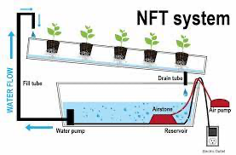

Figure 5: Nutrient Film Technique System

3.2.3 Drip System

Drip Systems is a technique that follows nearly the same principle of the Nutrient Film Technique. Instead of having running water going down the grow tray wetting the roots what we do in this method is that we will use a line that will just ever so slightly drip onto the plants. This way the plants do not drown and they are still being fed by the drip lines. The drip lines have to be adjusted accordingly to ensure that the drip rate is not too fast but also not too slow or else we might run into the issue of underfeeding the plants and this will yield less crop. Plants that will do good using this technique are lettuce, leeks, onions, melons , and peas. Unlike the other systems previously mentioned larger plants are suited for this kind of technique. Tomatoes are a good example of what can thrive with this technique. Downfalls to this method that is not suitable for smaller operations. The maintenance for this strategy is quite high at first and if the nutrients are not recycled properly this can lead to waste.

The drip system is a type of hydroponics that works mainly through a drip of nutrients solution on the crops’ roots to help maintain them moist and healthy. This system is the most widely used type of hydroponics system currently amongst either the home growers or the commercial growers alike. The main reason for it being so popular around the world is because this system is very easy to use, and it requires few parts. Even with it being easy to use the system is very versatile and can be designed in several ways.

The drip system is specially used for larger plants that require a lot of root space. The reason being is you do not need vast amounts of water to basically flood the system because larger plants tend to take up more space, the drip lines are also able to be run through large spaces easily. There is also the need for a larger growing medium which will keep the roots moist for longer periods. This will allow the system to be more forgiving to the plants. The term forgiving is used when a system does not need to be watered as often or a system does not have a strict watering schedule which is beneficial to some.

The drip system operates by having water with nutrients pumped up from the reservoir it has into the tubes that go all the way to the top where the growing medium is. The water filled with nutrients will then drain downward and it soaks both the growing medium and the roots until it gets all the way to the bottom of the container which has some openings. With the help of gravity, the liquid eventually drips all the way back down to where the reservoir is. The container used to grow the plants needs to be placed about 6 – 8 inches above the very top of the reservoir of nutrient filled water in order for gravity to be able to drain all of the excess solution.

There are two types of drip hydroponic systems, one is the Recirculation/Recovery drip systems and the other one is named the Non-recirculating/Non-recovery drip systems. The recirculation and recovery drip system is a system more geared towards home growers and it is also the most common of systems. This system is heavy on reusing and cycling the already used nutrient solution once it has moistened the roots back to the reservoir where it will eventually be recirculated through the whole system over and over again. However, this system does require you to regularly check, maintain and balance the pH as it is needed because the nutrient solution is run through the system over and over. A drawback to this particular system is that the nutrients capacity as well as the pH of the solution will change over time because the solution gets recycled through the system. Neglecting to check up on these could affect the over health of the plants and effectiveness of the drip system.

The second type of drip system is called Non-Recirculating/Non-Recovery drip system, this system is more common in commercial settings. The name of this system could be misleading because it makes it sound as though this system wastes a lot of water which is simply not true. What commercial growers do in order to not waste so much water is that they time their watering cycles in a very precise manner, by using something called cycle times, they can actually adjust the watering times down to the very minute and sometimes even to the second if need be. They then make sure to water the system long enough to simply get the growing medium wet. Therefore, the water that drips down to the plants is then absorbed and held in the growing medium which the roots of the plants are able to access. They then flush the water out of the medium with fresh water to avoid there being any buildup over time from the nutrient rich water solution. The non-recirculating/non-recovery drip systems tend to be less maintenance than their counterparts because the nutrient rich water solution does not need to be maintained and or monitored very often because this water is not recycled through the system. This helps the water to always maintain its pH and its nutrient potency.

Figure 6: Drip System 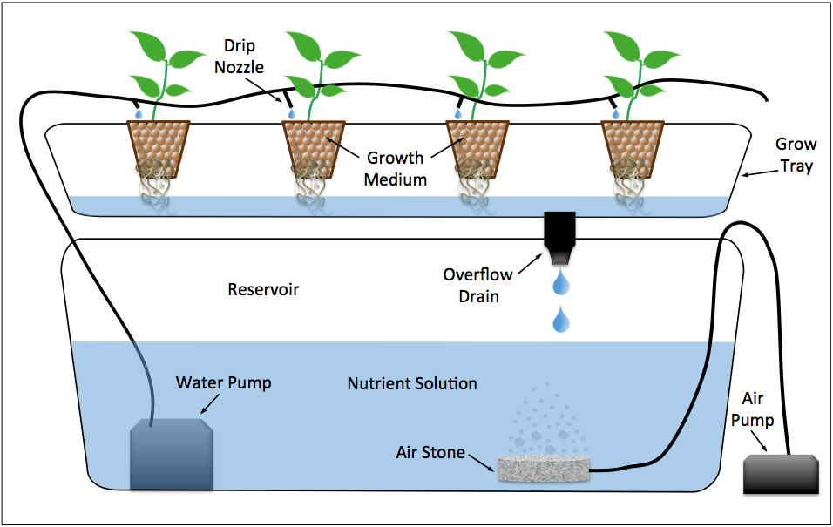

**3.2.4 Ebb and Flow System**

Ebb and flow systems are very similar to nutrient film techniques as well. It is one of the most recognized systems and the set up difficulty is not too complicated. The cost to set up one of these systems is on the low end of the spectrum. This method practically follows having a flow tray that is connected to a reservoir. The reservoir has oxygenated water and is nutrient rich for the plants to have food. The water will flow through the grow trays and then once it reaches the end of the grow tray the water will go back into the reservoir for the unused nutrients to be recycled and then put back into rotation.

The third method used for hydroponics is called the Ebb and Flow System. This system is also referred to as the flood and drain. These systems are easy to use and can be designed in a way that would help one grow almost any type of plant. This system works by basically having a grow tray which is slowly flooded with a nutrient solution. The water pumps for this system are normally set up with a timer to flood growing trays periodically. Once the nutrient solution has reached the level that is desired the solution will flow through the outlet and then back into the reservoir. As the nutrient-laden solution flows through the growing tray it will expose the roots to the oxygen they need. The growing medium will stay moist until the next cycle of flooding the growing tray starts over. By doing this process constantly it provides the roots with an abundance of oxygen and also nutrients which helps the plants to grow much faster and healthier than with non-hydroponic methods.

This system is relatively low cost and versatile meaning it can be set up in many different ways. It is considered to be an intermediate level in terms of difficulty to design and maintain for home growers. This method makes it easy to add and remove plants without affecting the surrounding crops. Building the system could be complicated to some because of the number of components needed to design a system like this but once the system is assembled it needs very little maintenance and can produce crops with little use of electrical power as well as water.

Some main components needed for this type of hydroponic system are the plant tray, reservoir and the submersible pump with a timer for it. The plant tray which can also be called the flood tray is normally a large and shallow container that is placed on a tall stand. The seedlings can be planted in half a gallon perforated pots that are filled with a growing medium such as perlite. The pots normally have a debt that’s twice as the depth of the tray itself and this tray will be pumped with nutrient filled water that comes from the reservoir that is below it.

The reservoir is the second most important component of this type of hydroponic system. It is usually placed right under the flat tray where the plants are growing on. There is a fill tube and a draining tube that go to and from the flood tray and the fill tube is attached to a submersible pump that also has a timer that controls the cycles of the water that floods the tray. The drain tube is also connected to the flood tray so that it can drain the water from the tray back into the reservoir so the water can be reused. When the water is changed from the system one has to keep in mind that they need to renew the nutrients in the water solution. It is also important to keep in mind that the system needs to be cleaned from time to time because mold can grow in the system which can affect the overall health of the plants and effectiveness of the system.

Figure 7: Ebb and Flow System

**3.2.5 Water Culture System**

The next option we research for the different types of hydroponics is the water culture system which is known to be one of the simplest methods of hydroponic systems. It is a simple yet very effective system and it is widely used in the home and commercial settings alike. The system is considered to be inexpensive and how it operates is that the crops to be grown are suspended in a basket above the nutrient solution which is in the reservoir. One could use something such as Styrofoam to make this. While the roots hang down from the baskets their roots go into the nutrient solution. The roots will stay there basically 24/7, they don’t suffocate because air bubbles form and rise up in the reservoir providing the roots with the necessary amount of oxygen and air not to mention that there is also some dissolved oxygen in the water.

This system can be designed to have several different aeration methods meaning ways the plants could get enough air. There is the Air Bubbles method, Falling water method, and Recirculating water culture method. The air bubble method is common in other types of hydroponics. This method uses an aquarium air pump and air stones are typically used for this method. The air stones are porous which actually make small air bubbles that rise to the top of the nutrient solution. The falling water method is not typically used in at home settings, but this method basically uses surface agitation by using falling water that splashes around and is another very good way of aerating the nutrient solution. This method is more common in commercial water culture systems because larger volumes of water are used compared to a home grower system.

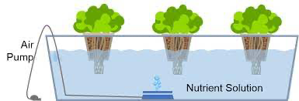

Figure 8: Water Culture System

**3.2.6 Aeroponics System**

The first option we can look at is an Aeroponic System, this is a system that takes the principles of hydroponics like growing crops with not much more than having roots held in a soilless growing medium and then having water laden with nutrients periodically pumped into the system. With Aeroponics one simply takes the roots of the plants and places them dangling in the air from which they are periodically sprayed with a specially designed misting device composed of a nutrient-laden water solution specifically designed for each type of plant one wishes to grow using this system.

In aeroponics systems one takes the seeds and plants them in pieces of foam which can be stuffed inside small pots. These will be exposed to light on one side and misted with the nutrient-laden water on the other side. Benefits of using a foam piece is that it can hold the stem and the roots in place as the plant grows so that it doesn’t start growing sideways which might hinder the plant's growth and development.

Some benefits of using the aeroponic system for growing crops is that there really is no need for a growing medium. Turns out that by eliminating the growing medium, the roots are freed which will inevitably let in more oxygen than if we used a growing medium and this will help the growth of the plants to be much faster. Not to mention that aeroponics is also extremely water efficient because the system is designed like a closed-loop and it will need around 95 percent less irrigation versus the plants that are grown in soil, also because the nutrients are in the water, they also can get recycled through the system.

In addition to the previously mentioned benefits to using aeroponics we can add that this system is very eco-friendly. It gets its reputation because this system has the ability to grow large quantities of crops within small spaces. This system is usually used for indoor vertical farms. These farms range in size but the taller the system the more plants one gets to grow on it. This type of indoor farming is growing more common in places like cities because this also cuts down on the environmental impact it takes to get food from the fields all the way to a plate. Because aeroponics is a system that is fully enclosed there is no need to use nearby waterways and also because this system is only sterilized when needed one does not have to worry about treating the crops with any harsh chemicals and or pests to keep the plants growing healthy.

There are some drawbacks to mention about aeroponics, they do require a lot of initial work to make sure the system runs smoothly, and the plants can grow fast and healthy. For starters one must be able to maintain the appropriate concentration of nutrients in the water as well as the parameters because a slight deviation from what is needed or even a malfunction of the equipment could cause crops to die out and the system to fail. An example of the system failing could be that the misters that deliver the water and nutrients might stop working for a bit maybe because the power goes out which will result in the roots that are dangling to quickly dry out.

Another thing to consider is that the mister themselves have to be cleaned regularly because with time they will get clogged because of the minerals that the nutrient-laden water deposits. Aeroponics does have a major environmental drawback and that is that it relies on electrical power to be able to pump water through the tiny misting devices. Aeroponics can be placed somewhere with natural light but the vast majority of these systems use artificial light that requires electrical power to run. A solution for the use of high intensity grow lights would be to place solar panels to provide the majority of the power needed to run these systems.

Plants that can be grown in this system are most plants that can grow in hydroponics such as leafy greens, herbs, strawberries, tomatoes and even cucumbers but unlike regular hydroponics, in aeroponics one can grow root crops which cannot be grown in a regular hydroponic system but can be in aeroponics because the roots have much room to grow and can be easily reached for harvesting.

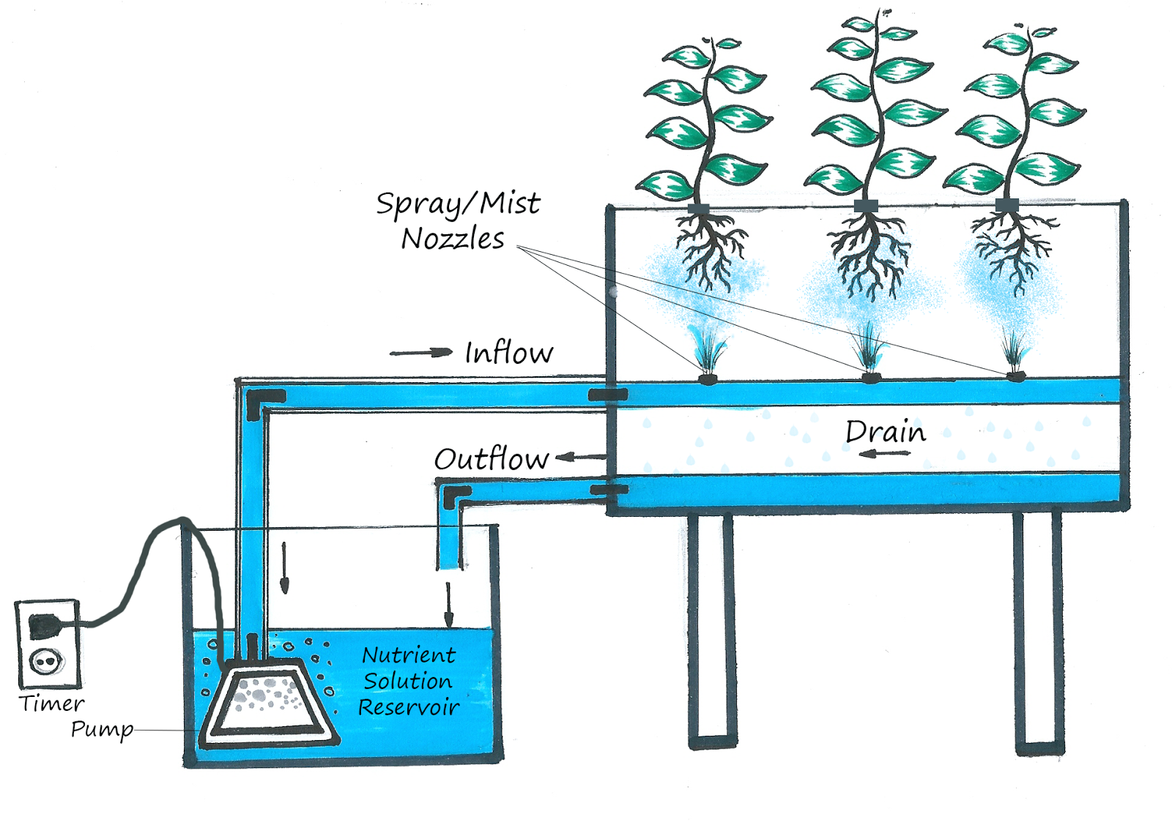

Figure 9: Aeroponic System

Our hydroponic system is designed using the Dynamic Roots System which is similar to the Nutrient Film Technique. Below there are some of the aforementioned hydroponic systems with their pros and cons.

|  | Pros | Cons |
| --- | --- | --- |
| Wicking Systems | Very low maintenance | Large plants seem to suffer with this growing strategy |
|  | Very suitable for smaller plants | Incorrect placement of wicks can lead to death of plants |
| Nutrient Film Technique | Nutrients do not get wasted and get recycled | If hardware stops working this could lead to the death of the plants |
|  | Less waste | Not suitable for larger plants |
|  | Allows for easy accessibility to plants roots for easy inspection |  |
| Drip System | Higher control on water flow and feeding | Not suitable for smaller gardens |
|  | Durable | pH levels might fluctuate |
|  | Cost effective | High on waste |
| Ebb and Flow | Easy to build | System failure of pump can lead to the death of the plants |
|  | Cost effective | pH levels can vary |
|  | Unused nutrients gets recycled | Roots of plants can become entangled |

Table 8: Hydroponics Pros & Cons

**3.3 Strategic Components and Part Selections**

**3.3.1 Choosing a microcontroller**

Microcontrollers are everywhere. They are in microwaves, fridges, cars, sensors, and many other places. A microcontroller is a unit used to control electrical components that do not require a lot of computing power. In contrast, computers that we use nowadays and devices that require a lot of computation use a microprocessor. Usually, the microprocessor needs to be attached to a motherboard, memories, and many other components to make it work. In this project, the group decided that a microcontroller will be a better fit for the job due to the low complexity. The group will choose the microcontroller based on three characteristics that we found to be the most essential for this project capability, compatibility, and reliability.

ESP8266, produced by Espressif Systems in Shanghai, China, attracted many professionals because of the low cost. Later, Westerners translated the documentation into English. The integrated WIFI module drew the group to this microcontroller. This WIFI module would cut time and add simplicity to the project. The downside of this microcontroller is that it contains only one analog input. It is possible to increase the number of analog inputs by using an analog multiplexer.

In 2020, Espressif introduced a new chip, ESP32, and it is pin-compatible with ESP8622. The ESP32 also includes the WIFI MODULE, and it has much better capabilities than its predecessor. However, we had second thoughts about choosing this microcontroller since it is not as widely used as ESP8266 due to being relatively new. The scarcity of information could limit the research or tutorials public on the internet, imposing a more significant learning curve on the group. This microcontroller made it to the list due to its increasing popularity.

The last choice that made it to the list of microcontrollers is Arduino UNO R3. This microcontroller is one of the most popular microcontrollers out there. The price is reasonable. It is 5V input, and the number of components or sensors we can find compatible with this board is impressive. It includes an integrated WIFI module. It has many analog ports. We can see the Arduino UNO in different kits included on amazon and many videos and tutorials on the internet. For our project we ended up going with the ESP32 as our microcontroller for our project.

| **Microcontroller** | **Specifications** | **Reasons** |
| --- | --- | --- |
| ESP8266 | Wifi Module, 16MiB, 32 KiB instruction RAM, 80 KiB user data RAM | It is a popular microcontroller and has a WIFI module. |
| ESP32 | Wifi Module, 2Mib to 4Mib, 520 KiB SRAM, Two Tensilica LX6 Cores | It is popular and powerful. |
| Arduino UNO R3 | 32KB of flash memory, SRAM is 2KB | It is very popular and easy to use. |

Table 9: Microcontrollers

How to connect a sensor with a microcontroller?

The microcontroller is just like a small computer on integrated circuits. A microcontroller contains a CPU with a memory unit. Microcontrollers are used for the automation of different products; we can produce automatically controlled products and equipment. They are used in many engine control systems, in devices used in the medical field, in RC toys & planes, and in industrial areas.

For example, Arduino UNO is a microcontroller. Arduino Uno is based on the ATmega328P. It contains 14 digital pins (of which 6 can be used as PWM outputs), 6 analog inputs, a 16 MHz quartz crystal, a USB connecting port, a power input port, and it has a reset button.

* its operating voltage is 2.7V to 5.5V.  its temperature range is –40°C to +125°C
* it consumes low power up to 1.5mA at 3V - 4MHz
* its temperature range is –40°C to +125°C
* it consumes low power up to 1.5mA at 3V - 4MHz

Figure 10: LDR & Microcontroller Schematic

*LDR attached with microcontroller*

The output of the sensor acts as the input of the microcontrollers. A few sensors provide an analog output but most of them in digital form. The above figure shows the interface of a microcontroller with an LDR sensor as an example of a sensor interface with a microcontroller. The microcontroller has digital input pins connected with a sensor that accepts digital sensor output, an electrical signal.

**Advantages**

Using the embedded sensors and sensing technology has a lot of advantages. It helps in the predictive and preventive maintenance of a system. Sensors ensure that measured data transfer faster and increase data accuracy, which improves the process control management and enhances asset life. The sensors capable of wireless transmission provide real-time and continuous data feedback from system and process, which helps monitor the process plant in a more secure and agile manner. The use of sensors improves the sensitivity in capturing the data and provides a loss-free transmission, which is helpful in continuous analysis. The sensor technology has been evolved into new and innovative intelligent sensors as compared to conventional analog sensors. Smart sensors have embedded circuits inside, which allow them to measure data in digital values that are more precise and reliable. These programmed intelligent sensors are helpful in several process conditions, which would enable its users to derive many benefits.

By switching a system on intelligent sensors, companies can enhance productivity and efficiency, which will reduce the cost of a system. The continuous monitoring process observer will be able to identify the areas of high energy consumption. So appropriate measurements will be taken on time to limit the wastage of energy. This approach will help industries attain the SGDs (Sustainable Development Goals) proposed by the United Nations. So, we can say that sensors will help us through.

* Accelerating the processes and by making them accurate
* Collecting the process and system data in a real-time format
* Monitoring our processes and systems much accurately and efficiently
* Increasing the productivity and reducing the total cost of the asset
* Lowering the energy consumption

**3.3.2 Capability differences in the microcontrollers**

Memory is one of the deciding factors when picking the correct microcontroller. The microcontroller's memory should hold all the required libraries and the code to run the operations. There was an investigation on the hydroponics project, and we concluded that the memory of 520 KB is adequate for this project. This memory definitely could work, but we would want to be safe and go with a little more memory. Another critical factor in choosing the microcontroller is how much RAM is needed. We do not wish to have a crashing system because we have picked a microcontroller with not enough RAM. Not enough RAM will lead to poor execution. Finally, it is crucial to consider the frequency of the microcontroller as well.

The flash memory of the ESP8266 is up to 16MiB is supported and typically ranges from 512 KiB to 4MiB. The RAM of the ESP8266 is a 32 KiB instruction RAM, 80 KiB user data RAM, and one core processor running at 80MHz. The memory might not be sufficient for our project.

The flash memory that the ESP32 includes ranges from 2Mib to 4Mib, and some do not have any in the chip. However, if the board has the memory mounted, then it comes from 2Mib to 8Mib. It is more than enough for our purposes. The RAM of ESP32 is 520 KiB SRAM. The SRAM memory consumes less power, and it is much faster than dynamic memory. The microcontroller is either single-core or dual-core. It can operate from 160 or 240MHz, and It includes an ultra-low-power (ULP) co-processor.

The Arduino UNO ATmega328P is an 8-bit AVR RISC microcontroller with 32KB of flash memory with 0.5 KB used by the bootloader, and it also has 1KB of EEPROM non-volatile memory used for long-term storage. The SRAM is 2KB, and the performance of this chip is 20 MIPS at 20MHz. The flash memory of ATmega328P could prove to be a problem for us. A flash memory of 32KB is not going to be sufficient for our project. That's why we will also consider the Arduino UNO ATmega2560. The ATmega2560 chip contains a flash memory to store the program of 256KB and EEPROM 4KB for long-term storage. The SRAM is 8,192KB, and the CPU speed is 16 (MIPS/DMIPS). This chip could be a good option. Our biggest concern about this microcontroller is the memory. We should be able to have sufficient memory to store the sensor code and the system code. In the case that we run out of data a solution would be to add another microcontroller to the circuit that would provide the memory storage needed. If the microcontroller could hold all this data, then it would be sufficient for this project. However, the ideal would have been 520KB, but 256KB will do the job.

**3.3.3 Compatibility of the microcontrollers**

This section is essential to consider the microcontroller aspects that will make our workflow more manageable. That is compatibility between the device's hardware and software, including sensors, communication categories, programming platforms, and programming languages.

When we talk about sensors, the interface category is crucial to consider; it includes direct digital, direct analog, and protocol-based communications. In the analog case, the quantity measured is received by a voltage signal from the sensor. The programmer's job is to use that information to correctly classify so that a conclusion can be reached from the signal received. The data can be related to temperature, pressure, Ph, water level, and many others. The analog signal tends to change continuously and smoothly over time. Also, these signals can be converted from analog to digital by using an analog to digital converter or ADC.

When working with analog, we need to be aware of the sensor's different operating voltage levels and the microcontroller. The most common voltage levels are 5V and 3.3V. The goal is to find components that will match our microcontroller's same range, so we don't add to the project's complexity. However, if there is no workaround for using a different operating voltage level, we would have to provide two voltage levels, one for the microcontroller and one for the sensor.

A way of doing this is called level shifting, and there are many ways of doing it. One way is using a voltage divider to reduce the voltage level of either the microcontroller or the sensor. Two resistors connected in series will be needed. The ratio of the resistors is calculated based on the input voltage and the output voltage. The downside is that a resistor can slow down a high-speed signal due to the resistor's built-in impedance.  The formula to calculate the two resistor's output voltage is as follows: Vout = Vin * R2/(R1+R2); if the resistors are equal, we can use Vout = Vin/2. Another way of doing this is level shifting with a Zener Diode. Zener diodes' beauty is that it has a breakdown voltage, meaning that the voltage level is cut out up to a predetermined voltage level. If we have input and output pins to spare, a level shifter IC can be used. The Level Shifter IC is generally the most expensive solution, but it is reliable. Many manufacturers of the Level shifter IC are Texas instruments with the TXB010X family.

When we talk about a direct digital sensor, the signal is being output in a discrete digital way. They are a digital representation of the quantity being measured. The outcome can be either a 0 or 1. The digital signals compared to analog have more accuracy in the measurements and can be sampled at very high speeds. The accuracy is also dependent on the number of bits that are used to represent the measurement. An 8-bit processor produces an accuracy of 1 in 256, while a processor of 16 bits gives an accuracy of 1 in 65,536 or 260 times more accurately.

There are two types of communication protocols in a microcontroller Inter system protocol and intra-system protocol. The inter-system protocol is done using a physical connection to connect the microcontroller to the computer. There are many different protocols for this UART, USART, USB.

The most common one being UART. UART stands for Universal Asynchronous Transmitter and receiver. The UART protocol has two cable lines for transmitting and receiving Tx, Rx respectively. It takes bytes of data and sends the individual bits to the computer or the microcontroller sequentially. It is classified as half-duplex, meaning that it can only transmit or receive exclusively. It is not possible to send and receive at the same time. As I said before, one of the most common ways of communication is found in most microcontrollers.

Another way of communication is USART. Very similar to UART. However, it is a full-duplex and allows for transmitting and receiving simultaneously, unlike UART. Finally, USB is also used for communications. It stands for universal serial bus. It has two wire protocols, and It is used to send and receive data serially to the host and peripheral devices. USB transfers data at different speed modes, 10kbps to 100kbps, and another mode from 500kbps to 19mbps.

The intra protocol establishes communication between components within the circuit board. The intra protocol delivers secure access to data from the peripherals. These communications are used to increase the number of peripherals connected to the microcontroller. The intra protocol communications are I2C, SPI, and CAN protocols.

Philips semiconductors developed the I2C protocol. The primary purpose of this protocol is to provide an easy connection to peripherals in the chip. The I2C needs to wire SDA (Serial Data Line) and SCL (serial clock line) to pass information across devices. It is a master-slave communication convention. A unique address is provided to the slave to be identified, and there are flags sent between devices to communicate about either reading or writing. The communication has to be first established for the transmission to start. The biggest downside of this communication protocol is the speed. There can be transfer rates up to 100kbit/s in the standard mode, 400kbits/s in the fast mode, up to 1 Mbits.s in fast mode plus, and up to 3.4 Mbit/s in the high-speed mode.

Motorola developed the SPI communication protocol. There are two types of 4 wire protocols named MISO (Master Out Slave In), MISO (Master in Slave Out), SS (Slave Select), and SCLK (Serial Clock). The same way as I2C, this is a master-slave communication protocol. The master device selects a slave device, and once the selection is made, it is ready to start communication. The master sets the slave by pulling the SS lines low where they would be high if they are not selected. It is a full-duplex communication, and it doesn't limit data to 8-bit words. The advantages to this communication protocol are that it is faster than asynchronous serial communication, supports multiple slave connectivity, is a low-cost protocol, and is universally accepted. The disadvantages are that it requires more wires than other protocols, the master controls all the slave communications, and the more slave, the more complexity is added to the circuit.

CAN is a message-oriented communication developed by Robert Bosch. It uses two wires, CAN high (H+) and CAN low (H-), for data transmission.  This protocol's advantage is that it is low cost and reliable, provides stable performance and is secure. However, it is automotive-oriented and a little more complex than other protocols.

For this project's purpose, we would try to stick with protocols like SPI, I2C, UART. We have worked with these communication protocols in the past and they have proven to be very easy to set up and reliable. A lot of this communication is going to happen over WIFI due to the website requirements. We can choose to send the data to the computer, and from the computer to the website, or we can directly send the data to the website.

These protocols are the ones we are most familiar with and have worked with them in the past. Besides, they are very reliable and popular.

| Microcontroller | Operating Voltage  Min-Max | Communication Protocols |
| --- | --- | --- |
| ESP32 | 3.0V - 3.6V | WIFI, UART, SPI, I2C |
| ESP8266 | 2.5V - 3.6V | WIFI, UART, SPI, I2C |
| Arduino UNO R3 | 5V | UART, SPI, I2C |

Table 10: Microcontroller’s Compatibility

**3.3.4 Power modes**

The power consumed by the microcontrollers is an important measure we want to keep into account. The hydroponics box is created with the idea that a greener world is better for everyone. If we were not to include power, we would be failing that same idea that inspired us to create the hydroponics farm. It is essential for the microcontroller we choose to be power efficient and reliable.

The high usage of power can drain the ESP8622 microcontroller, especially when connected to a battery. In our case, we are doing it to save energy and have environmentally conscious hydroponics. There are three low-power mode types for the ESP8622: No-sleep, Modem-sleep, light sleep, and deep sleep. The low power mode has different functions that adapt to our power-saving needs. The modem-sleep will turn off the WIFI, but the system clock, RTC, and CPU will be on. The average current will be around 15 ma. The light sleep has a WIFI and System clock off with an average current of 0.4mA. The Deep-Sleep has WIFI, System clock, and CPU disabled, and a current average of approximately 20microamps. The latter is the one that saves the most energy but also turns off many features that could be needed.

The ESP32 can be a power-hungry device if it's not set on a low power mode. There are five configurable power modes. They are active, modem sleep, light sleep, deep sleep, and hibernation modes. The active mode keeps everything ON, and it is not suitable for battery projects or energy-saving strategies like ours. In this mode, the chip would require more than 240mA current to operate. Also, if WIFI and Bluetooth are used simultaneously, the power can spike up to 790mA.

The modem sleep mode is active when Bluetooth, WIFI, and radio are disabled. The CPU and the clock are still ON. It consumes around 3mA at slow speed and 20mA at high speed. A strategy used to keep the WIFI, Bluetooth, or radio functioning is to wake them up when needed instead of having them on. 

The light sleep mode has all the modem sleep mode settings, except for the CPU being off while the RTC and ULP co-processors are active. The average current used in this mode is around 0.8 mA. The only downside of this mode is that most of the RAM, CPU, and digital peripheral connections are clock gated, which can prove a problem causing race conditions.

The deep sleep mode is even more aggressive than the previous modes. It will have the CPU, most of the RAM, and peripherals off. The only parts that remain ON are the RTC controller, RTC peripherals including ULP, and RTC memories. The average current consumption is around .15mA with ULP co-processor on to .10microAmps. The ULP co-processor does the measurement of data from sensors, and if needed, can power ON the microcontroller. A downside of this mode is that the chip's main memory is also disabled, and everything stored will be wiped out. However, the RTC memory will be on, and memory will be kept. It is one of the reasons why the Bluetooth and WIFI information is stored in RTC.

Finally, the hibernation mode shuts down everything but the RTC and some RTC GPIOs. It reduces power consumption a lot more, and it has an average current of around 2.5 uA.

Arduino UNO R3 has similar low power modes than the previously discussed. 

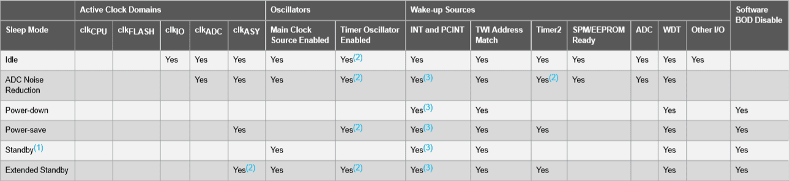

Figure 11: Power Modes

There are six low-power modes in the Atmega328p. The idle mode stops the CPU but allows two-wire serial interface USART, watchdog, counters, and SPI to operate. We can see in the table that the clock CPU and Clock Flash are turned off. The ADC Noise reduction is the second low power mode display in the table with all the previous components from idle turned off in addition to clock I/O.

The power-down method is a little more aggressive than the previous modes stopping all the generated clocks and allowing only the operation of asynchronous modules. The power save mode is very similar to the power-down mode, with the only distinction of the timer/counter enabled at sleep time. If the timer/counter is not needed, then there is no reason to use this mode, and the power down method will suffice.

The standby mode is similar to the power down method; the only difference is that the external oscillator is kept running. Finally, the extended standby mode is similar to standby mode, with the distinction of taking six clock cycles to wake up from the extended standby mode.

The microcontrollers that we have studied so far have many options in low-power modes. It cannot be distinguished which one is better because they are all very similar. It is essential to recognize that these power modes work better if we know exactly how we want the project to work and know what features are better on or off. Specifically, we don't have to be aggressive with this project when it comes to power saving because the project would be connected to a power wall. However, power consumption is vital for the scalability of the project. Many of the people interested in products like a hydroponics farm would be conscious of power consumption. If we want to set the standards for a green future we have to lead by example, and that would include making our project energy efficient. There are many ways this can be done like we already explained with low power mode, but also including other sources of energy like solar.

Solar energy would be a great addition to this project. We will not implement this in this project, but for future improvements. If we stick to this project a solar panel can be located on top of the hydroponic box. The hydroponic box would need to be outside in order for it to charge for part of the day. A battery can be included with the solar panel for nighttime lightning if needed.

**3.3.5 Protecting the microcontroller**

In addition to power, another important factor when dealing with microcontrollers is protecting our devices from large voltages. The microcontroller is receiving input from devices like switches, relays, sensors, and many other components. The input signals received by the microcontroller can be a threat if there are no safety protocols in place for protection. There are many ways to detect this problem: current limiting, filtering, clipping, diodes, and attenuation.

The causes of this problem can be ESD, Induced EMI, and user error. Electrostatic discharge (ESD) is the flow of electricity between two electrically charged objects. In physics, we were taught that when rubbing two objects together can produce electricity. The material with more affinity for electrons takes electricity from the other material. An example of this would be a plexiglass rod and wool rubbing together. That is why it’s always good practice to touch metal before working with electronic circuits.

The induced EMI is the creation of electromotive forces across an electrical conductor. This can be produced by a long wire connected to a microcontroller causing the wire to act as an inductor and create spikes in voltages.

A solution to these problems can be found in the options already mentioned. First, a current limiting resistor can be a great addition to our system to prevent high voltage. The resistors act as a voltage divider limiting the current. A suitable resistor can be from 100 ohms to 10K ohms. It works optimally for short, wired connections, so there is little chance of induced EMI.

However, more protection can be added to our previous example, and this could be a filter. If a capacitor is added to the prior circuit, we can create a low pass filter. In this scenario, a little more thought about the input has to be given to the circuit receiving it. Due to the low pass filter limiting capacity, we would want to have a signal that is ultimately received and not cut out by the filter. In addition to protecting the microcontroller, this method also helps cut out fast incorrect readings from the sensor. The approach is still not enough when we have significant ESD events and long wires because the circuit relies on the internal diodes for clipping.

An extra larger protection can be added to our circuit by adding an external diode. A Schottky diode would work well. It would make the external diode conduct electricity before the internal diode providing a buffer and completing the circuit even more securely. A small series of resistors must be used to protect the diode from over-currents, and a 10 ohms resistor would work well.

It is essential to include these safety features in our project for protecting the circuit. We only have many tries before we run out of time. The idea of protecting our circuit would go a long way in saving us time and money.

**3.3.6 Programming language available**

The programming language for an embedded system is an exclusive area. A few programming languages can join the embedded systems world due to specific requirements like low resource usage and low-level system access. An example of a low-level language is C, and a few other languages in the embedded system space are C++, Java, and Python.

C language is one of the oldest languages out there. However, it is still very relevant today, and especially in the embedded coding space. The low-level aspect of C makes it very desirable for coding embedded systems. It has low-level access to memory, a loose data typing policy, and smooth porting of embedded programs, in addition to being very fast when we compare it to other programming languages. A big community of coders backing this language provides excellent support for embedded systems programming. Also, the familiarity the team has with this language makes it perfect for this project. We all have worked with C before.

Furthermore, C++ is another language that is relatively popular in the embedded system space. It is very similar to C language, with the difference that C++ incorporates the object-oriented programming style into the language, and it would be a massive advantage for an experienced developer. However, for this project, C++ would not be our first choice due to the complexity it could bring to the project.

Java, another oriented programming language, can be used for developing embedded systems. An advantage that Java has over other programming languages is the portability. It can be written one time and be run anywhere. This feature and the many DevOps tools make it quite popular among embedded programmers. The lack of C operations restriction can lead to not ideal coding practices and unstable executions. The lack of a universal standard for multithreading and shared data protection can make the code hard to transfer. The Java language solves all the problems described before. The downside to using Java for embedded systems is the amount of memory required to run Java is too large, and it would not be suitable for many processors.

Python is a relatively young language, yet it is more popular than C or C++. Even though it is used only on 5% of all embedded system code, this language is set to grow in popularity among the embedded system space. It is known for its easy to write, readable syntax resembling everyday language. When python shows off is when it comes to complicated embedded systems like neural networks. Micro Python is a software implementation that is optimized for microcontrollers and written in C. It was created by Australian Programmer and physicist Damien George. It is a python compiler and runtime that runs on a microcontroller. It supports several ARM-based architectures.

For this project, it is better that we stay with what it's well known. Programming languages like Java would not be ideal due to the memory requirements. Python language would be an exciting learning experience and beneficial for our resume and career in the long term. However, coding languages that we are familiar with can result in a smoother and reliable process to complete the project. It would be better to go with the old reliable language C or C++ to complete this project quickly and efficiently.

3.3.7 Types of Water Sensors

**Float sensor**

The floating sensors work on the principle of buoyancy, in which the liquid level control system is done by utilizing a float sensor. The buoyancy principle is defined as that a float immersed in a liquid is buoyed towards an upward direction as a result of an applied force that is equal to the weight of the displaced liquid. As a result, the body gets submerged and drives partially upon the liquid surface. And this body covers the equal distance on which the liquid level moves. Such floating sensor systems consist of a ﬂoat, a magnet, a sensor stem, a weight that is suspended on the outside of the tank, and a reed switch. There is also a fixed scale on the outside of the tank, and the contents of the tank’s level are indicated by the position of the weight along the scale.

A float-type liquid level switch is used for the level detection of liquids. The switch is activated by a mechanical arm or sliding pole and activates a switch when the level moves upward. Sometimes the ﬂoat is also designed to have a small magnet used to vary the state of a switch. It moves to the original position when the liquid level gets moving up. This floating sensor comes with many advantages because they are simple, provide accurate measurement, and much suitable for various products. Float Sensors have many Applications according to requirements widely used in sealed tanks. For precise reading and accuracy, these float sensors are used in many industrial systems, which is a perfect example of the combination of electronics and mechanical engineering, helping to calculate the most accurate level-measuring system for different applications in storage tanks of larger sizes.

**Capacitance sensor**

Capacitance sensors, also called capacitance level sensors, are available for a wide range of slurries, aqueous and organic liquids. This technique is the radio-frequency signals that are applied to a capacitance circuit. These capacitive level sensors are designed to sense material as high as 88 for water and as low as 1.1 for coke and fly ash with dielectric constants. The capacitive level sensor works on the principle of change of capacitance. There are two capacitor plates in capacitive sensors and one acts as a tank wall and other acts as the insulated electrode. The capacitance of these two plates depends on the liquid level in a tank. So, the capacitance of an empty tank will be low compared to a tank filled with water.

As mentioned above, measurement of liquid level through a capacitive capacitor is done by applying a Radio Frequency signal. This radio-frequency signal is applied between the vessel wall and the conductive probe of the sensor. A very low amount of current flows due to the Radio Frequency signal through the dielectric process material inside the tank between the probe and the vessel wall. The dielectric constant decreases when the liquid level in the tank drops and this decrease leads to the drop of capacitance reading and a drop of current flow. This change can be detected by the liquid-level switch’s internal circuitry and translated into relay state changes of the level switch in case of a point level detection.

There are many advantages of using sensors based on capacitance systems as they are straightforward to install. They have a wide range of applications, more reliable and accurate measurements. Capacitance level sensor has many applications and used for the measuring level of probes are used for measuring the levels of:

* Wide range of fluids
* Metals in liquid for a very high temperature
* Gases dissolved in other types of matter at very low temperature
* Industrial processes of very high density

**Conductivity probes sensor**

Conductivity probe sensors work on the principle that the presence of a product between two conductors will make a change in the resistance present between these two conductors. This type of sensor system is useful for level measurement in different conductive liquids. The covering and not covering of probes in a conductive fluid changes the conductivity of insulation according to the state of probes. Like capacitive electrode sensors, conductive electrode sensors also have two probes. One acts as a wall of the tank, and the other is inserted into the tank. A Conductive probe placed inside the water tank or container filled with a conductive liquid is used as a liquid level indicator for measurement. When there is no connection between the product and the probe, it will show a high or infinite electrical resistance, and If the level of the liquid rises between the probe and the tank wall, and the probe makes a connection with the product inside, then the resistance gradually decreases. These sensors have many advantages because they are very simple to use, have low cost, and very reliable for multiple or dual point control.

| **eTape water level sensor**   | **conductivity probe sensors**  **(KY-059 water level sensor)** |
| --- | --- |
| **Specifications** | **Specifications** |
| * Sensor Length: 10.1" (257 mm) * Width: 1.0" (25.4mm) * Thickness: 0.015" (0.208 mm) * Resistance Gradient: 140Ω / inch (56Ω / cm), ± 10% * Active Sensor Length: 8.4" (213 mm) * Substrate: Polyethylene Terephthalate (PET) * Sensor Output: 1500Ω empty, 300Ω full, ± 10% * Actuation Depth: Nominal 1 inch (25.4 mm) * Resolution: 0.01 inch (0.25 mm) * Temperature Range: 15°F - 140°F (-9°C - 60°C) | * The S (Signal) pin is an analog output of the sensor, and it will relate to the analog pic of our microcontroller. that will be connected to one of the analog inputs on your Arduino. * Whereas the + (VCC) pin is our power supply pin for the sensor. And the recommended voltage for this sensor is 3.3V – 5V. * And last the ground pin (GND) is for the ground connection. |
| **Reason** | **Reason** |
| Unique sensor, very affordable, and accurate for measuring liquid levels. The addition of this sensor is a convenient addition to a hydroponics, aquarium, or pool level measurement controller.  With an 8" structure, a 4-pin connector, and a 560-ohm resistor, it's easy to interface the sensor with a microcontroller. Since the sensor is resistive, so it's easy to read the values by Arduino ADC pin | * Easy to install. Very little maintenance. Compact design. Automatic water level indicators ensure no overflows or running of dry pumps Saves money by using less water and electricity. It can Help avoid seepage of walls and roofs due to tanks overflowing. It Automatic saves manual labor time and consumes very little energy, perfect for continuous operation Shows incitation of water levels in any type of tank.   First of all, we need to supply the power to the sensor and we will connect the + (VCC) pin of the sensor with a 5V pin on the Arduino and the ground pin to the ground. And Finally, connect the Signal pin on your Arduino to its A0 ADC pin. The interface of the microcontroller with the sensor. |

Table 11: Water Level Sensor Compatibility

**Which water level sensor is suitable?**

For our hydroponic system, conductivity probe sensors will be suitable because of

* low-cost sensors
* very simple to use,
* reliable for multiple or dual point control

The sensor consists of a series of exposed copper traces totaling ten in numbers, and five of them are known as power traces and five are known as sense traces. All these traces are interlaced so this arrangement provides us one sense trace between every two power traces as shown in the figure-13. An important point to be noted here is that these traces are not connected but develop a connection when water is submerged The Power LED on the board lights up when the board is powered by voltage.

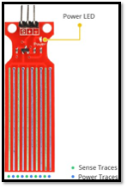

Figure 12: liquid level sensor

**Why is a water level sensor necessary for hydroponic systems?**

Monitoring the quality of your water using hydroponics is very important for growing plants. In order to do so, you should obtain suitable conductivity sensors and pH sensors that will allow you to continuously monitor the pH and conductivity levels of the water. With this monitoring system in place, you’ll be able to catch problems with the quality of the water early on and make the necessary adjustments with pH and conductivity controllers.

A hydroponic system mainly consists of three water tanks, these tanks included the cleaned freshwater tank, Ph controlled water tank and a nutrient-enriched water solution tank. The nutrient-enriched water solution and pH-controlled water tanks play a significant role in the growth of the plants. The solution's pH value and nutrient availability are controlled using valves and pumps to add fresh water and other compounds to water.

So, maintaining the water level and its quantity in solution to adjust the value of pH or the nutrients is very important in the hydroponic system. It is achieved by the water level sensor, which gives us the measured value of water level, which helps us to ensure the accurate concentration of nutrients and pH value. So, without a water level sensor, the whole system will be disturbed and will ultimately cause many deficiencies such as inappropriate Ph or amount of nutrients in a solution.

**Working principle of Conductivity Probe sensor**

This sensor's working is very simple and straightforward, very similar to the case of a potentiometer and the resistance of the series varies according to the level of water.  It mainly depends upon the distance of water from the top of the sensor, so there is an inverse relationship between the height of the water and the sensor's resistance. So, more water immersed in the sensor means better conductivity and lower resistance. On the other hand, less water immersed in the sensor means poor conductivity and will cause an increase in the resistance.  The sensor will generate an output voltage according to the resistance, which was calculated according to the water level value.

This kind of sensor is a unique sensor, very affordable, and accurate for measuring liquid levels. So, the addition of this sensor is a convenient addition to a hydroponics, aquarium, or pool level measurement controller.  With an 8" structure, a 4-pin connector, and a 560-ohm resistor, it's easy to interface the sensor with a microcontroller. Since the sensor is resistive, it's easy to read the values by the Arduino ADC pin. This sensor has the following specifications.

* Sensor Length: 5.2"
* Width: 1.58 ounces
* Thickness: 0.015" (0.208 mm)
* Resistance Gradient: 140Ω / inch (56Ω / cm), ± 10%
* Active Sensor Length: 4.0"
* Substrate: Polyethylene Terephthalate (PET)
* Sensor Output: 1500Ω empty, 300Ω full, ± 10%
* Actuation Depth: Nominal 1 inch (25.4 mm)
* Resolution: 0.01 inch (0.25 mm)
* Temperature Range: 15°F - 140°F (-9°C - 60°C)

**Installation of the Conductivity Probe sensor**

The below figure-14 shows the sensing point of the water level sensor which includes a signal pin, voltage supply pin, and a ground pin. The S (Signal) pin is an analog output of the sensor and it will be connected with the analog pic of our microcontroller. that will be connected to one of the analog inputs on your ESP32 chip. Whereas the + (VCC) pin is our power supply pin for the sensor, and the recommended voltage for this sensor is 3.3V. Last, the ground pin (GND) is for the ground connection.

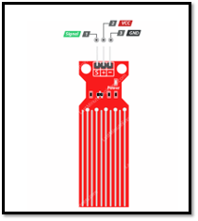

Figure 13: Precautions While Installing in Tank

**3.3.8 Types of pH sensor**

**Differential pH sensor**

Differential pH sensors are equipped with three electrodes instead of the two used in conventional pH sensors. The critical difference between a differential and a conventional sensor is in the reference cell design. The differential pH sensor reference is a measuring pH electrode in a buffered cell solution of known pH 7.0. The reference cell in the differential sensor makes electrical contact with the process with a dual junction salt bridge. Both the reference and the electrode measure the pH of a solution differential with respect to a third electrode, a metal ground electrode. This sensor is considered a heavy-duty sensor due to the equipped third electrode.  There are possibilities of contamination of a standard pH sensor due to a change in pH level. Still, with the presence of a third electrode that acts as a buffer for measuring the electrode, we can get an accurate reading even when the sensor is contaminated. So Differential pH sensors are considered ideal tough conditions and at the industrial level. The differential pH comes in three main series.

**Laboratory pH sensor**

The sensors work on the principle of combination pH sensor technology enclosed in plastic bodies and glass of 12mm. These sensors are lightweight and considered perfect for light applications related to research, pool, education, environmental sampling, and monitoring. These sensors have fantastic versatility. Because they can be fit according to the exact application that we need as laboratory sensors. There are three main categories of these sensors available for basic, advanced, and research level.

**Process pH sensor**

Process pH sensors also use the combination sensor technology, but they are more durable and larger in larger bodies. Process sensors are also enabled with a process connection, which makes them very efficient in case of continuous monitoring of pH. Process sensors are highly durable, and they can be mounted directly into a pipe and can be placed directly in a tank as well.  These sensors are also classified into three main categories: moderate sensors, moderate to heavy-duty sensors, heavy-duty/coating sensors, industrial source water, process water, or wastewater. They can be configured with a flat bulb glass which makes it a self-cleaning design.

| **Atlas scientific pH kit 0-14 pH**   | **Laboratory pH sensor (ph1000)**   | L**aboratory Analog pH sensor** |
| --- | --- | --- |
| **Specifications** | **Specifications** | **Specifications** |
| * 1 EZO™ pH Circuit * 1 Double junction silver / silver chloride Lab Grade pH Probe * 6x 20ml calibration solution pouches (2x pH 4, 2x pH 7 and 2x pH 10) * 1x 60ml (2oz) pH storage solution bottle * 1 Electrically Isolated EZO™ Carrier Board Weight: 25 grams Carrier Board dimensions: 56.2mm x 32mm (2.2″ x 1.2″). | * Reference: sealed * Junction Number: Single (1) * Junction Material: Pellom * Reference Solution: 3.5 M KCL/AgCl (gel) * Glass Shape: Bulb * Body Material: Polycarbonate * Strain Relief: No * BNC Boot: No * Temperature Range: 0-60 Co * Bulb Protection Slots * pH Range: 0-14(Na+ error at 12.3 < pH) * Response: 95% in 1 second (bulb glass shape) * Is potential Point: 7.00 pH (0mV) * Offset: +/- 0.20 pH * Span 97% of theoretical or higher * Connector: BNC (Standard Configuration) * Dimensions: diameter, length (12mm), (150mm). | * Module Power: 5.00V * Module Size: 43 x 32mm (1.69x1.26") * Measuring Range :0 - 14PH * Measuring Temperature: 0 - 60 ℃ * Accuracy: ± 0.1pH (25 ℃) * Response Time: ≤ 1min * pH Sensor with BNC Connector * pH2.0 Interface (3-foot patch) * Gain Adjustment Potentiometer * Power Indicator LED. |
| **Reason** | **Reason** | **Reason** |
| Direct output allows integration into a process control system without the use of a transmitter or controller.  Combination sensor output for deployment flexibility with various transmitters and controllers.  This pH measuring sensor kit is considered best for measuring water quality and other parameters like pH. It also has an embedded LED on it, which works as the Power Indicator, a BNC connector, and a pH sensor. This LED is also used for the calibration of the sensor kit. | Lightweight and considered perfect for light applications related to research, pool, education, environmental sampling, and monitoring. These sensors are versatile Because they can be fit according to the exact application that we need as laboratory sensors. There are three main categories of these sensors available for basic, advanced, and research level. | Simple to operate, strong and durable to use. Separated pH and temperature sensor probes pH & TEMP meter. Automatic shutdown and online monitoring. Apply in water sources, hydroponics and other water systems. CE and RoHS certified to offer safer and precise measurement. Clear LCD with backlight, easy to read and accurately measuring functions. Replaceable BNC pH sensor probe with protective cap. Very convenient to change its electrode and completes with various industry test needs. |

Table 12: pH Sensor Comparison

**Which sensor is suitable?**

When working with swimming pools, aquariums, and hydroponics, pH sensors, especially laboratory sensors, are considered ideal. These pH sensors provide reliable and accurate readings in different environments, ranging from greenhouses to science laboratories. These sensors can bear the usual wear and tear because of their durable polycarbonate body and extra protection for the pH glass measuring surface. These are suitable because

* Rapid response time
* Maintenance is not required
* Durable structure
* Always ready to use

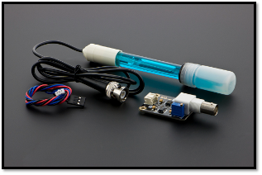

Figure 14: Analog pH Sensor

The above figure shows us an analog pH sensor, mainly a lab pH Meter that works on a laboratory pH sensor principle. This Analog pH sensor provides us with the following specifications.

* Module Power: 5.00V
* Module Size : 43 x 32mm(1.69x1.26")
* Measuring Range :0 - 14PH
* Measuring Temperature: 0 - 60 ℃
* Accuracy : ± 0.1pH (25 ℃)
* Response Time: ≤ 1min
* pH Sensor with BNC Connector
* pH2.0 Interface (3-foot patch )
* Gain Adjustment Potentiometer
* Power Indicator LED

This pH measuring sensor kit is considered best for measuring water quality and other parameters like pH. It also has an embedded LED on it, which works as the Power Indicator, a BNC connector, and a pH sensor. This LED is also used for the calibration of the sensor kit.

**Why is the pH sensor necessary for the hydroponic system?**

Maintaining the pH level in a hydroponic system is very crucial because it has a significant effect on the nutrient availability for the proper growth of the plants. High pH levels or alkaline can cause lower nutrient uptake and will lead plants to deficiencies. For example, in Iron deficiency, plants will make the leaves of plants pale or yellow. We need different Ph levels in hydroponic systems according to the requirements of the plant. So, it is very important to constantly monitor and adjust pH levels. It is inevitable to make sure that we are using pH recommendations of hydroponically grown plants. Not the soil-grown plants. For a hydroponic system, pH level is essential, and installing a pH sensor in our system is crucial for plant growth. The other was a lack of focus on this fact which plays a detrimental role in the growth could lead to deficiencies.

**Installation in the hydroponic system**

We install the pH sensors for continuous monitoring and control in a hydroponic system because our hydroponic system's water reservoir water reservoirs act as the plant's growth medium. Based on these sensors' measured data, control the opening and closing of valves or operation of pumps. For example, if our system's pH becomes too high, the pH sensor will send a signal to open the solenoid valve, allowing CO2 to flow into the water reservoir. This helps to make carbonic acid with the reaction of Carbon dioxide with water, which as a result, lowers the pH of the solution.

**3.3.9 Types of the nutrient sensor**

**Optical sensor**

The optical sensor method is based on nitrogen ions' ability to absorb UV light ranging from 190 -230 nm. The ultraviolet light is transmitted with the help of a flashlight through the medium. The light beam becomes split and directed towards two receivers equipped with filters. One filter determines the light intensity at the reference wavelength, and one determines it at the measuring wavelength. The ratio between these values is utilized as a result and converted later into the concentration of nitrate with the help of a preset calibration curve.

**Chemical sensors**

Wet chemical sensors have been optimized for deployment on a variety of platforms for minimum power and reagent consumption. These sensors are based on small industrial fluidic components like valves and solenoid pumps, which are used with the small volume absorption cells. Another method in Wet-chemical sensors is the use of the further step is the use of microfluidic MEMS (Micro-Electro-Mechanical Systems) components. These components are based on the electronics industry techniques, where mechanical structures are engraved into some substrates like silicon. These etched structures are combined with microfluidic components, for example, valves, mixers, and pumps.

**ISE sensor**

The main component of the ISE (Ion-selective electrode) is a membrane, which is selective for the measurement of specific ions. In this membrane, the ionophores are accommodated. These ionophores facilitate the selective “migration” of the ions by ISE electrodes. The electrochemical potential is generated due to a change in charge. And the potential is measured with respect to a reference electrode and a constant potential. It is not influenced by the medium's turbidity and color and is proportional to the ion concentration.

A comparison of the basic working principle, advantages, and disadvantages of nutrient sensors is given below in the table, which helps choose the perfect sensor according to the working conditions and the environment.

| **Atlas scientific Conductivity K 1.0 kit**   | **ISE for nitrate concentration** |
| --- | --- |
| **Specifications** | **Specifications** |
| * 1 EZO™ Conductivity Circuit * 1 Conductivity Probe: 5 µS/cm to 200,000 µS/cm * 1 Electrically Isolated EZO™ Carrier Board * 2 125ml (4oz) calibration solutions. | * Range (concentration): 1 to 14,000 mg/L (or ppm) * Reproducibility (precision): ±10% of full scale (calibrated 1 to 100 mg/L) * Interfering ions: CIO4–, I–, ClO3–, CN–, BF4– * pH range: 2–11 (no pH compensation) * Temperature range: 0–40°C (no temperature compensation) * Electrode slope: +56 ±4 mV/decade at 25°C * Electrode resistance: 1–4 MΩ * Immersion: 2.8 cm * Electrode length: 155 mm * Body diameter: 12 mm * Cap diameter: 16 mm * Cable length: 100 cm |
| **Reason** | **Reason** |
| Using this interface board is really a no-brainer. Accurate reading of pH probes simple with this board. You can use this board with an Atlas pH probe and it's interfaced to a Raspberry Pi 3 Model B using I2C for communications if you want accurate, easy, painless pH data in your projects.  These sensors are inexpensive and very easy to operate. They are not affected by the turbidity and provide a wide concentration measurement range. It is particularly useful in biological and medical field applications.  These sensors provide us real-time measurements to detect the change of ion activity with respect to time. It is helpful for both positive and negative ions. | * It is relatively inexpensive and easy to operate. It has a wide concentration measurement range. As it measures activity, instead of concentration, it is particularly useful in biological/medical application.   It is a real-time measurement, which means it can monitor the change of activity of ions with time.  It can determine both positively and negatively charged ions. |

Table 13: Electrode Comparison

**Which nutrient sensor is suitable?**

TDS (Total Dissolved Solids): indicates how many milligrams of soluble solids dissolved in one liter of water. The higher the TDS value, the more soluble solids dissolved in water, and the less clean the water is. This TDS Meter Probe is plug and play and easy to use. Also, the wide supply voltage of 3.3~5.5V and the analog signal output of 0~2.3V. Comes with XH2.54-2P/3P connector wires. It has many advantages, as given below.

* These sensors are inexpensive and very easy to operate.
* They are not affected by the turbidity and provide a wide concentration measurement range.
* It is particularly useful in biological and medical field applications.
* These sensors provide us real-time measurements to detect the change of ion activity with respect to time.
* It is helpful for both positive and negative ions.

The hydroponic systems consist of a combination of electrical conductivity and pH measurement sensors to monitor the quality and durability of nutrients present in hydroponic solutions. But hydroponic monitoring can be much further enhanced with the help of nutrient measuring sensors because the nutrient measuring sensors are used to directly measure nutrients in hydroponic solutions directly.

There is a large variety of nutrient measuring sensors available, and many of them can be used in hydroponic systems to control the concentration of different nutrients accurately. For example, TDS sensors exist for the hydroponic systems nitrate with excellent selectivity and little interference to accurately control the number of specific nutrients present in a hydroponic solution separately from other nutrients. They can easily detect and graph the changes in a certain period of growth. Another vital benefit of the ion-selective electrode is that we can get a real measure of ion concentrations. This technology is like the future of hydroponics because it can enable the ability to accurately control and resupply the exact amount of nutrients to the system needed by their growing plants. And such electrodes can also be wired with the computer software to monitor nutrient use 24/7 continuously. Here we are using a TDS sensor for sensing nutrients.

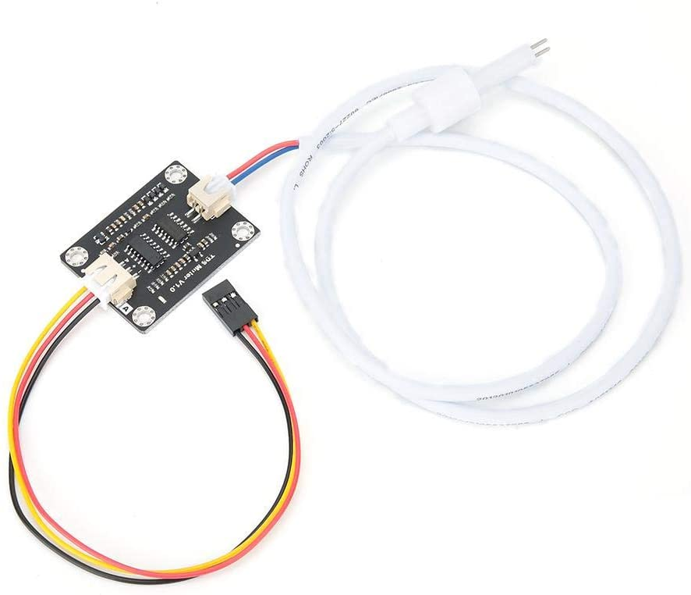

Figure 15: TDS Sensor

Which provide us the following specification,

* Input Voltage: DC 3.3 ~ 5.5V
* Output Voltage: 0 ~ 2.3V
* Working Current: 3 ~ 6mA
* TDS Measurement Range: 0 ~ 1000ppm
* TDS Measurement Accuracy: ± 10% F.S. (25 ℃)
* Module Interface: XH2.54-3P
* Electrode Interface: XH2.54-2P

**Waterproof TDS Probe:**

* Number of Needle: 2
* Total Length: 60cm
* Connection Interface: XH2.54-2P
* Color: White

**Why is a nutrient sensor necessary for the hydroponic system?**

Just like Maintaining the pH level in a hydroponic system, it is crucial to maintain the availability of nutrients for the plants' proper growth. The high pH levels or alkaline affects nutrient uptake and will lead plants to deficiencies. As mentioned above the Iron deficiency plants will make the leaves of plants pale or yellow. We need different micro and macronutrients for the proper growth of plants. So, it is also very important to constantly monitor and adjust pH levels and check the number of nutrients in the water reservoir.  For a hydroponic system, the nutrient level has great importance. The installation of a nutrient measuring sensor in our system is very beneficial for plant growth, and lack of focus on this factor, which plays a detrimental role in the growth could lead to deficiencies.

**Nutrient sensor installation**

For continuous monitoring and control of micro and macronutrients in a hydroponic system, we install the nutrient sensors in our hydroponic system's water reservoir. Because water reservoirs act as the plants’ growth medium, based on the measured data from these sensors control the opening and closing of valves or operation of pumps. For example, suppose the amount of nutrient concentration in our water reservoir is very high. In that case, the nutrient sensor could turn on the freshwater pump to add more water and dilute the nutrients solution. On the other hand, if the nutrient concentration is too low, the sensor will turn on the nutrient pumps.

**3.4 Possible Architectures and Related Diagrams**

We went through the various kinds of architecture we might use. Since the majority of the community members are familiar with the 8-bit microcontroller Atmega328, it was determined that this board would be used for the system. Two Atmega328s will be used in the setup, one to serve to control the LED light and the other as MCU. Owing to the pin number as the study evolved as more elements were added, something had to be achieved. Between the TDS and pH sensors and the MCU, a voltage and data insulator were introduced. This was intended to shield the signal from sudden voltage changes. The MCU's primary interface was altered as a result, but the existing design remained unchanged.

We will now explore and explain which components were picked and why they were picked. The first move in this phase was to look online at any appropriate tools that could be used to build a hydroponic device. Following the collection of all that data, the next step was to delete individual components based on a number of characteristics. The following are the features that should be avoided, the price, purchase ease, time for delivery, meeting the subsystem's necessary requirements, the flexibility with which it can be put into action, and the overall infrastructure is being improved.

A concise overview and explanation of the actual components selected for this hydroponic device can be found in the list below. All of the components were thoroughly researched and selected based on their reliability, performance, protection, and capacity to work within the confines of the project. The circuit's criteria All of the electronic circuit components will be graded to double what the device requires. Following`s a short rundown of all the elements.

* Sensors:
* Micro-Controller
* Capacitor
* Voltage Regulator
* USB to Serial Adapter
* Peristaltic Pump
* LCD Screen
* Transformer
* Diode
* Digital Potentiometer
* DC-DC converter
* IC
* Crystal
* Digital potentiometer
* Voltage isolation circuit
* Resistors
* LED

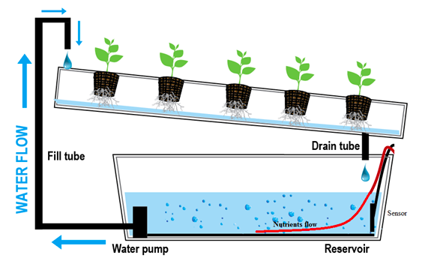

Figure 16: Possible Hydroponic System

**3.4.1 Software architectures**

An (IDE) integrated development environment is software that aids in creating code by increasing productivity and saving time with the right development tools for building a successful project. The IDE consists typically of an editor, compiler, linker, and debugger. It can be used mainly for one language, but it usually can be used for many languages. When picking an IDE, I would like it to be well known with a proven track record that it is helpful in the coding process, intuitive, and has online support. The most common ones that the team is familiar with and would like to explore are the Arduino IDE, Platform IO, and Code Composer studio.

One of the most popular IDE is the Arduino. It is used widely across a range of Arduino and non-Arduino boards, compatible with Windows, Mac, and Linux users, and written in functions from C and C++. One of the perks of using the Arduino is the software libraries it supplies, which provide the most common input and output procedures. The source code for this IDE is released under GNU. This IDE's popularity attracted other vendors to implement open-source compilers and tools to build sketches to other microcontrollers that Arduino does not support. That is why it made it to our list. We will want to be on the cutting edge of technology if we need to work with this IDE in our future jobs. However, many others seem to be very competitive, which brings us to platform IO in Visual Studio Code.

Another popular IDE that the group considers is platform IO. Platform IO is within Visual Studio Code, and Visual Studio Code is gaining a lot of popularity. It will possibly be one of the IDE most widely used in the future.  As it is well known, Visual Studio Code editor is made by Microsoft for Windows, Linux, and Mac. It has many features like debugging, syntax highlighting, code completion, code refactoring, embedded git, and most importantly, the ability to install extensions to add functionality. The extensions in Visual Code Studio are what allows us to install platform IO. Platform IO comes with an Integrated Debugger, Unit Testing, static code analysis, and remote development. It is cross-architecture and multiple frameworks. Professionals describe it as a truly professional tool for embedded systems engineers. It was nominated for the year's best software and tools in the 2015/16 IoT Awards. Besides, it removes the complexity of the coding process by cutting the process of finding and assembling an environment of toolchains, compilers, and library dependencies. This IDE can become the primary IDE of professional engineers in the new growing era of IoT. We as a group want to familiarize ourselves with cutting-edge technologies that will become the standards of the future, and that is why we picked platform IO to be on our list.

Code Composer Studio is another integrated development environment (IDE) selected to be on our list. It was initially developed by GO DSP company in Toronto, Canada, and Ti acquired it in 1997. We all are very familiar with Code Composer Studio because we have used it in previous classes, and it is mainly used to develop applications for Texas instrument (TI) processors. Code composer is used for embedded project design and JTAG based debugging. The latest version released is a version of eclipse open-source IDE and can be easily extended to include support for open-source compiler suites. One of the Code Composer Studio IDE downsides is that the interface is not intuitive, and it is a little old-fashioned. However, this IDE made it to our list due to the team's familiarization with the IDE.

The selection process for the IDE is tedious. We are leaning towards Platform IO due to the potential of the application and the features it offers. It is a very modern platform. We would like to explore new coding methods in embedded systems, and Platform IO is provided inside an IDE that we are very familiar with Visual Code Studio. We all feel very comfortable using Visual studio code, and after researching we found out about PlatformIO and how popular it is becoming, we knew it was the right choice for the project. We can always utilize different IDE to code, and which one delivers the most value to our project.

We would likely find ourselves using Visual Studio Code extensively in our future workplaces.

**3.4.2 Web application**

For our project to be user-friendly, it needs a web application. The web application should be able to store and monitor the measurements taken from the hydroponics box. The hydroponics box would send the information to the web application over the internet. The data would then be analyzed, and if anything is out of the standard, trigger a warning. The web application should be made using reliable frameworks and programming languages. Many web development frameworks could be used for this project, including NetCore, NodeJs, and PHP.

.Net Core is a Microsoft framework for building web applications. It is cross-platform, open-source, light, and fast. Experts believe it will be the future of web applications. It supports NuGet packages that will be very important when using a database with the application. Net Core is both asynchronous and synchronous. Every request is processed within its thread. It is a very scalable platform. The group thinks this is a great framework to build the project, and we already have experience working with it.

NodeJS is an alternative to the Apache server. It was first developed to be used in Mac and Linux operating systems. It is a JavaScript-based language, and it can be used for front-end and back-end development. Many packages within the Node.js repository can be used. It is an asynchronous platform; this allows it to simultaneously handle multiple requests and not block them. Another advantage to NodeJS is that it can run on various platforms. It is designed for distributed systems, so it is scalable. It has microservices-based software that allows the automation of scalability that prevents an app from failing.

PHP is another web development language that we are considering using. The PHP language first started as a general-purpose language. It has shifted into becoming a popular language for web development, and developers have begun to build the server side of the web applications. It is a universal language that can be combined with many other languages. For example, developers can write extensions to PHP using C language, which enables extra functionality. There are a large number of frameworks and libraries that extend its functionalities. Two of the popular and famous examples of software written in PHP are Facebook and WordPress. However, this is a great language/platform for coding web applications, but there is a declining lack of popularity and a lack of dedicated libraries for modern needs.

After going over the different ways, a web application can be built. We believe .Net core has the functionalities that we need without too much complexity. We can set up a server and a database very easily. In addition, there are many great libraries and add ons that we can find online to improve our website. We want our website to have the latest technologies. The team seems to be leaning towards the NetCore platform due to the familiarity we already have with it. It is a safe, straightforward, forward, and secure way of building a web application.

3.4.3 Power Supply Design

In the earlier stages of electrical distribution, the standard current in Europe was the alternating current or (AC) and in the United States it was the direct current or (DC). Alternating current had some disadvantages to it which were that during earlier times the load on the system was affected when appliances were turned on or off which would affect others using that same line. This did not happen with direct current because it had the ability to use the needed current without affecting the rest of the load on the set line. The power supply is the main backbone of an electronic system, it distributes power throughout the system and the way it does it depends on how it is designed. Depending on the design the system could either run at optimum levels or it could run at inconsistent levels. There are several power supplies one could use one of them is alternating current better known as AC, there is also direct current better known as DC. When choosing the correct power supply design for one’s device one must keep the following in mind; the power requirements for the load or the circuit which will include the voltage and the current, safety features to consider especially when dealing with water as such is the case for our particular project, the physical size and its efficiency for the system and the noise immunity of the system.

Another option could be the DC-to-DC converters which are also available in the market, if direct current is already in your system, then this DC-to-DC converter could be a better option as opposed to the active current mentioned. Direct current power supply comes in either regulated or unregulated form. The regulated form has subsections to it as it comes in several options including: Linear, Switched and Battery-Based.

Some basic information about the power supply is that it first takes the AC current from the wall outlet and it converts this alternating current into unregulated direct current. It also reduces the voltage by using an input power transformer which reduces the voltage to the load that is required by the electrical system. The transformer is also used for safety reasons to separate the input power from the output power.

An alternating current looks like a sinusoidal waveform and voltage alternates from positive to negative infinitely until a cutoff point. The process of alternating current from the wall outlet is when the voltage is rectified using a set of diodes. The process of rectification then transforms the sinusoidal AC, and it converts the normal sine wave into positive peaks. The sine wave composed of positive peaks is called a Full-Wave rectified, after the voltage has been rectified there is some fluctuation in the wave caused by the time between the peaks which needs to be removed. This is fixed by adding a capacitor which will filter the rectified AC voltage. The energy that is coming into the system is stored in the capacitor on the rising edge and used when the voltage drops. By increasing the storage capacity of the capacitor this helps make higher power supply quality. When the voltage conversion is done, the output still has variation which is called a ripple. In most normal power supplies, the voltage is passed through a regulator and makes a fixed DC output with less ripple effect.

| Power Supply | Specs | Reasons |
| --- | --- | --- |
| Alternating Current | * Regulated: Adjustable output voltage or current * Unregulated: Simple circuitry design | Various options here which are both inexpensive and could work well with our design |
| Linear Power | * Reliable and safe * Small residual ripple | This option is very reliable but presents us with a challenge which is large heatsinks |
| Switch Mode | * High efficiency * Small in size | It is efficient but presents a challenge since it is difficult to build |
| Battery Based | * Does not require on-site power * Portable | Batteries would make our design even more portable than previously possible |

Table 14: Power Supply Comparison

Alternating current power supplies come in two ways which are regulated and unregulated. The unregulated type is the most basic power supply out of the two and this type is unable to supply a consistent voltage to a load, but the regulated power supply does, and it also has various design options that one could implement. Some of the Pros and Cons of Regulated and Unregulated AC power supplies are as follows:

| **Regulated Pros** | **Regulated Cons** |
| --- | --- |
| Available in high quality power supplies | More expensive than unregulated |
| Precision tuning | Complex |
| Noise filtering |  |
| Voltage is consistent |  |
| Adjustable output voltage or current |  |

Table 15: Regulated Power Pros & Cons

| **Unregulated Pros** | **Unregulated Cons** |
| --- | --- |
| Durable | It is designed only for a fixed voltage or output current |
| Simple Circulatory Design | The voltage varies with the loan current draw |

Table 16: Unregulated Power Pros & Cons

Linear Power supplies are the least complex of them all, but they also are the ones that create the most heat. This type of power supply design is used when precise regulation and removal of noise is the most important aspect. Linear power supply is not the most efficient power source, but they do provide the best performance. They also don’t use a switch to regulate the voltage output, however they do require larger components and therefore dissipate more heat than switched power supplies. Some of the main pros and cons of Linear power supply are as follows:

| **Linear Supply Pros** | **Linear Supply Cons** |
| --- | --- |
| Less noise | Large heatsinks |
| Reliable and safe | Poor efficiency |
| Small residual ripple | Expensive |
| Stable | Large size and heavy |

Table 17: Linear Supply Pros & Cons

Switched mode power supplies (SMPS) have converters that are cooler and more intricate than Linear power supplies, but they create more noise. They are more complicated to build but have more versatility when it comes to polarity and power efficiency. They have more components than Linear Power supply, but they are less expensive and are smaller than them. SMPS also have a wider range for input voltage and output as well. Some of the Switched Power Supply pros and cons are as follows:

| **Switched Supply Pros** | **Switched Supply Cons** |
| --- | --- |
| Small in size | Higher Noise |
| High efficiency | Difficult to build |

Table 18: Switched Pros & Cons

Battery-Based Power Supply is a type of mobile energy storage unit. It produces negligible noise, but this type of power supply loses capacity and does not provide the system with constant voltage because of the battery draining. In most cases batteries are considered to be the least efficient way of powering an electrical system since most batteries are difficult to match the voltage to the load. Another thing to keep in account is that if a battery that exceeds the inter power dissipation is used in an electrical system this could damage the device permanently. Some of the Battery-based power supply pros and cons are as follows:

| **Battery-Based Pros** | **Battery-Based Cons** |
| --- | --- |
| Does not require on-site power | Short life span |
| Portable | Fixed voltage input |

Table 19: Battery- Based Pros & Cons

**4.1 Standards**

**4.1.1 WIFI Standards**

We use standards in our homes, workplace, and many places; without standards, many of the things we do would not be possible. Standards make our services and goods reliable and efficient. In this project, some standards can also be applied. There are many standards out there, but we will focus on specification, quality, and test method standards.

A specification standard is often a well-documented requirement that satisfies a service, product, or design. A test method standard lays out a procedure that produces a result. A public or private organization can develop it. The use of a standard is to make more accessible and straightforward the use of many goods and services by companies, engineers, businesses, manufacturers. When thinking about a product or project, it is essential to consider standards for doing it. This project will be dealing with multiple standards in WIFI, Electricity, water, and a food quality standard.

There are different types of WIFI standards, and their acronyms usually give information about the strength, data, and compatibility with other standards. IEEE (Institute of Electrical and Electronics Engineers) is the institution that decides on the standards like how much data they send and the standards for encryption. Companies participate in these standards, so their technologies work well together. A network can be broken down in speed and frequency.

| Name | Speed | Frequency | Details |
| --- | --- | --- | --- |
| 802.11a | 54Mbps maximum usually 6 to 24Mbps. | 5 GHz | It is one of the oldest standards. |
| 802.11b | 11 Mbps | 2.4 GHz | Compatible with g networks. |
| 802.11d | N/A | N/A | Usually, this is combined with other networks like 802.11ad. It provides additional information like an access point. |
| 802.11g | 54Mbps | 2.4 GHz | It is the most popular network type. Its speed and compatibility make it great for today's network. |
| 802.11n | 100Mbps | 2.4GHz and 5 GHz | It is the fastest type of network. Speed up to 600Mbps is possible under perfect conditions. |
| 802.11ac | 1300 Mbps | 5GHz |  |

Table 20: Wi-Fi Frequency Comparison

In modern times WIFI has been starting to be called WIFI 1, WIFI, etc. Instead of the 802.11a, etc., name conventions. For our project, we will be using ESP32 that includes wireless connectivity WIFI 802.11 b/g/n.

**4.1.2 Electricity Standards**

In this project, we will be following the standards of the United States of America. The United States uses 110 – 240V at 60Hz, while in many other countries, 220 – 240v at 50Hz is used. The original standards for electricity were done by the countries individually. If we were to sell these products to other countries, it would be reasonable to adapt them to each country's standards. Another critical change between electricity standards is the plug. There are types of plugs from A to N. The United States uses A and B types.

| Type | Plug standard | Voltage | Frequency |
| --- | --- | --- | --- |
| A | NEMA 1-15 | 125 V | 60 Hz |
| B | NEMA 5-15 | 125 V | 60 Hz |

Table 21: Electricity Standards

**4.1.3 Water Quality**

In addition to the previous standards required for our hydroponics box, water quality plays a vital role in plants' growth. The EPA oversees the WQS, which describes water conditions for recreation, enjoyment, fishing, and aquatic and human health protection. There is no clear standard for water use for agricultural processes but following the EPA law is an essential starting point. The water quality standard consists of three components. They are criteria for designated uses, antidegradation requirements, and criteria. Also, states or territories can add additional components to the water quality standards.

The WQS regulation requires the goals and expectations on how water is used. The law's designated uses are protecting wildlife, recreation, public drinking water supply, and agricultural, industrial, and other purposes. The criteria for the water are numeric. For example, there cannot be a large number of pollutant concentration levels or describe the desired condition. Finally, the antidegradation requirement is to maintain the chemical, physical, and biological integrity of the water that has been received.

There is no standard for hydroponics farms; however, it is crucial for the plants to grow healthy to analyze the EC (Electrical conductivity) and pH. The EC gives us a great insight into the water quality, and it is essential in sustaining plant growth. Electrical conductivity measures the concentration of ions in the water. The more ions it has, the better it is at conducting nutrients. Plain water is a poor conductor of nutrients. The EC can be measured by inserting two electrodes in the water, and current is passed between them, enabling the measurement of ions' concentration. Low EC water will make the plants develop sickness and turn yellow, and high EC level can lead to toxicity. The ideal EC level should be kept within 1.2 – 1.6 dS/m. However, some plants differ a little from this level. It is essential to notice that we can get a high EC value, and the water has no nutrients. For example, tap water has chlorine and sodium and gives a high EC, but there is no plants' nutrient value.

**Acceptable EC level for plants we plan to grow:**

| **Plant** | **EC (ms/cm)** | **pH** |
| --- | --- | --- |
| Strawberry | 1.8 to 2.2 | 6 |
| Peppers | 0.8 to 1.8 | 5.5 to 6.0 |
| Basil | 1.0 to 1.6 | 5.5 to 6.0 |
| Tomato | 2.0 to 4.0 | 6.0 to 6.5 |
| Broccoli | 2.8 to 3.5 | 6.0 to 6.8 |
| Lettuce | 1.2 to 1.8 | 6.0 to 7.0 |

Table 22: Levels of EC for Plant Growth

**4.1.4 Agriculture Standards**

There are crop production standards that we will follow in this project. First, I will talk about the USDA grade labels or seals as symbols of American agricultural products' quality and integrity. The label ensures that the product has gone through a rigorous review process by skilled graders and auditors that follow the USDA's official standard. One example of the regulations is the use of pesticides. There is a maximum amount of pesticide allowed in crops of up to 5 percent. Also, the USDA makes sure that products that are labeled organic have to be at least 95% organic, and products tagged as made with organic content have to be at least 70% organic.

**4.1.5 Temperature Standards**

There are two ways that we can think about temperature within a hydroponics system. We have the temperature of the water and the temperature of the environment. The way the plant processes energy is directly related to temperature. In the light cycle, the plants store sugars, and during the dark cycle, the sugar is transported throughout the plant. The plants need continuous energy to grow.

The temperature of the environment is essential for the plants to grow and stay healthy. The temperature range that is acceptable for most plants is between 72-82 Fahrenheit. When the plants are put in high temperature, anything above 85 F, the tiny pores on the leaves that allow for the water vapor and gasses to leave the leaf start to close as a defense mechanism. It will cause the vapor released by plants to keep themselves cool to be trapped inside the plants, causing overheating and making them unhealthy and sick. The plants will reduce significantly the number of fruits or vegetables due to the sugar energy being used so fast that they cut back the energy to make fruits, flowers, or vegetables.

There are many ways to remove a room's hot air by using an extractor, fan to pump fresh air, enclosed air-cooled reflectors, or air conditioner. An extractor that eliminates the hot air out of the area would be a good thing to have. Also, there can be a fan that pushes fresh air back into the hydroponics box. Enclosed air-cooled reflectors can be used to reduce the heat produced by lights. This can be fixed by using an air conditioner, which is costly but solves the problem. AC can take the humidity away, so it is advisable to acquire a humidifier. Finally, it is also possible to reduce the lights' energy consumption by using 5 V instead of 12V lights.

It is also essential to keep the water temperature in a reasonable range. The perfect range for hydroponic water is between 65 F and 75F 24 hours a day. High water temperatures can increase the risk of root disease and lower the oxygen in the nutrient solution. If the water is too cold, it is possible to warm the water by using warming mats around the pot. However, for circulating water systems, it is better to keep the water at 70F at all times by using a water heater or also using a nutrient chillier can reduce the temperature capable of lowering it by 10F

| **Area** | **Temperature** | **Time** |
| --- | --- | --- |
| Environment | 72F to 82F | 24/7 |
| Water | 65F to 75F | 24/7 |

Table 23: Temperature Standards

**4.1.6 Design Impact of Relevant Standards**

After analyzing the relevant standards related to hydroponics, we can say that it is essential to incorporate them into our design. It will allow the compatibility of our design with other technologies. Also, it will make our system safe and reliable for customers to use. The systems that require standardization in our hydroponics are WIFI, electricity, water, agriculture.

In hydroponics, it is essential to use a compatible WIFI network to transmit data over the internet. In our case, the microcontroller we are using comes with updated WIFI technology type WIFI 802.11 b/g/n. It will allow speed up to 100Mbs and communication with the internet. It is necessary to keep the information from the microcontroller to a website where it can be analyzed.

The standard that will be used in our hydroponics box, as said before, is the United States standardization, which consists of 120V and 60Hz. For our project to be compatible with this, we would need to use plug types, either A or B, to be connected to a power wall. The power design will be based on these protocols.

Our agricultural standards will comply with federal regulations as well as standards employed by people to have a reliable and effective growth of plants and fruits. To effectively implement these standards, we need to have a limit on the pollution caused by pollutants and have an effective range of electrical conductivity and pH balanced. The hydroponics design will not have more than 1% of contaminants. It will be kept in the range of 1.2 – 1.6 dS/m range of EC and 5.6 to 5.2 of pH balance for optimal absorption of nutrients. It is essential to notice that the use of pesticides will not be a problem when using hydroponics since it’s not necessary. Also, it is not required to use herbicides since the plants are growing in the water. There is not a need for them. The hydroponics plants are made in a clean environment, making them healthier than traditional crops.

The hydroponics box will be designed for inside use only under the air conditioner. We do not want to increase the complexity by adding extra cooling systems to the box. We will keep the environmental temperature set to 70F. The water temperature usually stays as cool as the room temperature, so if we keep the environment at 70F, we can expect the water to stay around the same. There are differences between day and night, so it is crucial not to deviate from more than 10F to keep the plants growing healthy.

Finally, It is essential to have safety in mind. It would be necessary to mitigate any possible fire hazards. Hydroponics requires an enormous amount of electricity, especially for large farms, and sometimes the power connections are poorly equipped to handle that great of an electric load. It is crucial to ensure that the electrical breakers are functioning correctly and that the electrical infrastructure is perfect. It is essential to have a clean environment because anything can get caught on fire, especially dry leaves, towels, Styrofoam, and others. Secondly, keeping cords off the ground is another critical part of preventing fire hazards, decreasing the chances of coming in contact with water.

In our hydroponics, we will have high standards for our design. The electrical wires must be appropriately connected and away from the water. We will do this by creating a separate box that is waterproof to store all the components and PCB board. The hydroponics will not be placed close to objects that can quickly catch on fire. It is better if it's a place away from the furniture of the area. Besides, we will keep the hydroponics box's cables elevated, so we don't have to worry about them getting in contact with water.

**4.2 Realistic Design Constraints**

**4.2.1 Economic and Time constraints**

**Economic Constraints**

Our initial budget for our project is $400. It has been enough so far to gather all the components needed, and we still do not reach the $400 budget. However, we are still early in the process. We are saving money by finding cheap products, reusing products we already owned, thinking about new ways to work around expensive components, and buying dynamically.

Many products can be found for a low price on websites like Amazon, eBay, and Alibaba. Amazon has worked great for us. We find components at competitive prices from amazon every time we need anything, and they arrive at a reasonable time, usually in two days. We have not tried eBay or Alibaba; despite their low prices, their shipping time far exceeds the shipping time of amazon. However, we are still open to try it in the future if the time permits.

There are many products we already own. For example, we had a breadboard, microcontroller, resistors, capacitors, wires, etc. The use of already owned components has cut the spending significantly. Also, we are open to exploring do-it-yourself alternatives to reduce the cost.

When we encounter the too-common situation of having an expensive product that we cannot afford, we try to work around the issue. Coming up with new solutions for a problem is a common technique that we employ to make It cost-efficient. There are many do-it-yourself tutorials online that can help us create components for a more reasonable cost. Also, it is always possible to change the strategy for a specific part if not available. There are always ways to achieve the same conclusion by traveling through a different path. For example, we can ask the question surrounding the main idea of what we are trying to accomplish. Suppose it doesn’t serve the primary purpose. In that case, we might not urgently need and continue with a different cost-efficient design, or we can also conclude that a similar product can be used instead of the expensive one.

Finally, the strategy that has saved us the most money so far is that it’s dynamically buying the parts. The parts are being purchased when we need them. We don’t buy things we don’t need at the moment and that way we find out that we don’t need to buy them because either they are not required, or we already have something that can do the job. Of course, it applies to materials used to build the hydroponic box. There are some things we cannot get around, like the sensors and some equipment. When the part that we bought has been installed and perfectly working, we go into buying the next one.

**Time Constraints**

For our project, time is one of the biggest challenges we face. The hydroponics box, including the design and documentation, will have to be done in two semesters, approximately eight months, give or take. We will focus on getting the critical functionalities done first and then focus on the not-so-essential functionalities and aesthetics. In the first semester, we have focused on planning and writing documentation for the project. We should be able to have a good idea of what we will do by the end. The PCB board and the schematics should be created and test it in the first semester. During this time, we have learned a lot about the implementation of our project. Due to time constraints, we have had to let go of some of our most ambitious ideas and keep the ones that are practical and doable in the given time. This research period has given us a picture of the necessary deadlines to complete the project on time.

The second semester is where the action happens. We would have one semester to make our project come to life. At the beginning of the semester, we should already have all the parts needed and our PCB board ready to be sent to the factory. The website should be in the process of being finished and connected to the microcontroller. It is essential to keep track of the set's milestones, so we don’t fall behind. These milestones keep track of the amount of time taken for each task. Once the milestones are completed, we will enter the testing face. The creation of multiple test cases for each of the subsystems of the project is critical. The sensors would need to be tested individually, as well as the lights and the pump.

**4.2.2 Environmental, Social, and Political constraints**

**Environmental, Social, and Political constraints**

Overall, hydroponics is primarily beneficial for the environment. However, one of the environmental constraints that can be a source of worry regarding hydroponics is energy consumption. Many things can affect hydroponics' energy consumption such as crop type, size, equipment needed to run the facility effectively. Of course, our small-scale hydroponics would not consume too much electricity relative to a farm, but it is still considerable. How can we better track the energy consumption of our hydroponics? It can be done by meters that can be plus in the socket and the device and can read the power usage of our hydroponic. However, we will not implement this in our initial design, but it is something that we will consider for future upgrades. We can also figure out the power consumption by finding how much the devices use per hour in watts and multiply that by the number of hours run for the devices. It has to be done for all the devices in the system. Overall, hydroponics is better for saving water. It uses ten times more water than traditional crops. It grows faster and without as many chemicals and increases 3 to 10 times the same space.

A political constraint of hydroponics can be the growth of illegal substances. For example, hydroponics has been famously known to grow marijuana, which is illegal in some states. Hydroponics has been famous for producing illicit drugs for many years, and police have become suspicious of people who have hydroponics systems. There is no reasonable way for us to control what the customers using our hydroponics grow. However, it will be advised that it is against the law to grow illegal plants with our hydroponics.

There are some ideas out there that can be applied to commercial hydroponics boxes about identifying the type of plant that is being grown to reduce illegal conduct; however, we believe that people have the right to privacy. We should not be monitoring what they produce. We can only advise the best use for our hydroponics box, which is to grow food sources.

**4.2.3 Ethical, Health, and Safety constraints**

* **Ethical constraints:**

Ethical constraints of a Hydroponic system are very few since it is a very eco-friendly system that has taken over the conventional farming systems as it is more effective and efficient. One of the Ethical constraints is that Hydroponic systems, whether in-house or on an Industrial level, have farming on a big scale, which produces many indoor toxic gases that are naturally supposed to be released in the air. Still, in Hydroponic farming, gases are present inside the farming area, which can be dangerous to people living near the farming area. People can often use hydroponic farming to farm drugs like Marijuana, which is unethical because it is not legally allowed to grow in all countries; In addition, Growing Marijuana has a powerful odor that can be very unpleasant for workers and people living in the vicinity. It is ethically wrong to use an easy way to farm and grow crops that are illegal or are prohibited from growing.

* **Health constraints:**

Many people assume that disease-free hydroponic plants exist. This is not the case since the majority of plants use the same approach. As a result, waterborne diseases can quickly spread in your greenhouse. In hydroponic processing, waterborne diseases that infect roots are a frequent issue. Pythium, a form of water mold, attacks greenhouse crops in several ways. In hydroponics, basil and spinach are vulnerable to economically crippling stages of Pythium root infection. Since the water is constantly circulated throughout the system, infections can easily spread throughout the whole developing system, impacting the entire range of plants. A waterborne disease can destroy all of the plants in a hydroponics system in a matter of a few hours in serious cases. Soil microbiology varies a lot, but dry compost typically has 100,000 to 1,000,000,000 colony forming units (cfu), which is a metric of active bacterial and fungal cells per milliliter (2, 3, 10, 30). (It's a strange analogy that water and dry soils are apples and oranges, so it's the most we have.) Unfortunately, no experiments have been conducted that compare the surface to the soil.)

To put it another way, the bacterial species of traditional hydroponic systems are right in the compost range. Not soil. In a report that looked at both fungi and bacteria in hydroponic systems, 1,000,000 cfu/ml bacteria and 10 to 1000 fungi cfu/ml fungi cfu/ml fungi cfu/ml fungi cfu/ml fungi cfu/ml fungi cfu/ml fungi cfu/ml fungi cfu/ml. A hydroponic device easily acquires microbial flora. An analysis of bacteria development in a hydroponic environment began with a nutrient solution containing 500-900 cfu/ml bacteria. The microbial population increased to 1,000,000 cfu/ml after 20 hours of running the solution through tomatoes in Rockwool. The majority of these bacteria were found to be plant root symbionts, such as Pseudomonas fluorescens (a bacteria which aids the plant in defense and nutrient uptake).

* **Safety constraints:**

Among the most important things to remember is that while doing Hydroponic farming system is making sure that all Electrical machinery is heavily insulated and tucked inside safe wiring passages because a minor short circuit can cause severe Safety hazard in the form of an electrical shock that can be fatal for both the Human Resource working on the site and the plants being cultivated. A hydroponic system requires a lot of maintenance. Any minor power outage or a mechanical fault in the system can result in a massive problem with respect to the safety of the plants being grown since their sole reliance is on the nutrients provided by water and the system that maintains it. It is essential to ensure that the workers that are micromanaging the whole hydroponic system are well equipped with precautionary safety suits that must include a mask so that they do not catch any of the diseases that may be growing inside the plant due to over or undernutrition. At least once a week, search for water leakage in the system. If leakage is not found and repaired quickly, it will cause severe damage to your home. While establishing a hydroponic garden can be costly, the value of using food-grade plastics is sometimes overlooked. Since hazardous chemicals will leach out of non-food-grade plastics and into growing fruits and vegetables, using them as a cost-cutting measure could contaminate your food crops. While specific hydroponics systems have flowing water, the majority of it is stagnant. Salmonella thrives in stagnant water and is difficult to diagnose. When you use pesticides to get rid of microbes in your acidic garden water, the situation gets worse. Fungi and other plant infections thrive in the high moisture content of the air surrounding hydroponically grown plants, allowing them to flourish and spread rapidly. This can be mitigated to a large degree by paying close attention to ventilation, mainly when the plants are in flower or fruiting when they are more susceptible. Since a hydroponic garden's nutrients are supplied by energy, a power outage could be disastrous. If an outage lasts for a long time, the plants can perish until a supplemental nutrition scheme is put in place.

**4.2.4 Manufacturability and Sustainability constraints**

* **Manufacturing constraints:**

Hydroponic cultivation relies on a variety of machinery that necessitates specialized knowledge. The plants would not survive or grow as much as you would like until you know how to use this equipment. Even the tiniest error may have a significant impact on plant development, potentially killing your hydroponic system. That is why it is essential that you become familiar with the machinery and techniques used in the farming process. Unlike soil-based gardens, the hydroponic garden can need more frequent attention. The amount of time you spend in the garden is determined by whether you use an active or passive method. However, you may need to devote more time each day. Hydroponics necessitates more supervision and micromanagement than conventional plant cultivation. Both device materials, including lights, temperature, and many aspects of the nutrient solution, such as pH and electrical conductivity, require continuous diligence to ensure a closely regulated growth atmosphere. To avoid buildup and clogging, the nutrient solution must be flushed and replaced on a daily basis, and the machine components must be washed often. Grow lamps, water pumps, aerators, fans, and other devices of both passive and active hydroponics systems are powered by electricity. As a result, a power outage would influence the whole grid. A lack of control in an active system can be harmful to plants if it goes unnoticed by the grower.

* **Sustainability constraints:**

Electricity and water are two critical factors in hydroponic cultivation. The Hydroponic system will not thrive if you do not have enough water or stable power, and other required resources. You must take adequate safety measures when growing plants in this method to ensure that plant growth is not harmed at any stage. If you rely on electricity to run your complete hydroponic system, you'll need to take precautions in the case of a power outage or dimming. Since the machine will not work due to a lack of power, causing the plants to dry out, it is critical to take this measure even before moving on with a Hydroponic system, as there is a massive risk of system failure, which ultimately could stop the entire procedure of hydroponic farming. A hydroponics system is more costly to buy and construct than a conventional greenhouse. The cost of a device varies based on its form and complexity, as well as whether it is prefabricated or designed from individual parts to produce a personalized design.

**5. Project Hardware and Software Design Details**

**5.1 Initial Design Architectures and Related Diagrams**

Dimmer control: The construction of the design and manufacturing aspects of this project will be covered. The group's original designs and architectures for some of the modules and the subsystems of this project will be covered, as well as the group's initial breadboard configuration for the different components of the device. After that, we would go into the system's program architecture. This segment would break down the various user interfaces and discuss each one separately. Finally, the whole structure will be summarized.

To remotely adjust the lighting scheme, you'll need to develop and install a digital circuit on a breadboard. To monitor the voltage going to the LED drivers on the lighting system, the optical dimmer will use the MCP4131 chip. The preliminary breadboard checking will be done with a single white LED and a 220 resistor, dimmed at least 10 measures. The circuit will be connected to the microcontroller until the chip, LED, and resistor is mounted on the breadboard. The chip would have a 5 VDC supply voltage, and the circuit must be grounded to the microcontroller. The microcontroller will be powered by a separate 9-volt power supply, which will ensure that the chip receives the proper voltage and current.

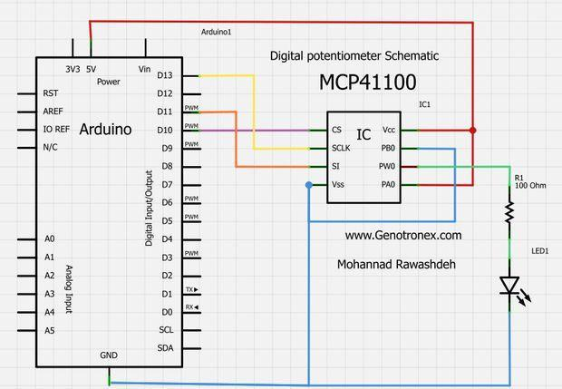

Figure 17: Digital Potentiometer Schematic

**5.1.1 12-Volt Power Supply**

For the circuit to work correctly, the main power used to operate the LED series had to be converted from ac to dc. Many of the circuit components were tested for electricity. We can determine the consumption that was used and registered once the overall power requirements were determined. The power supply had been measured and was able to be considered. There are some elements to consider. It was necessary to conduct research. The following is taken into consideration: Transformer, diodes, capacitors, and voltage regulators.

The transformer was the first thing that came to mind. For the total part requirements, the transformer would need to supply 1 ampere of current. After doing some testing, it was discovered that if the circuit requires 1 amp of current, the transformer must be capable of supplying at least two amps. The circuit requires a maximum voltage of 12 volts DC to function properly. A transformer with a 120-volt input and a 34-volt output was chosen. The first step was to rectify the input signal after the voltage was stepped down to 34 volts.

The circuit's input signal was sent as a complete sine wave. The first step was to rectify the circuit after the signal was sent from the transformer. To rectify the circuit, it was decided to use a complete bridge rectifier. 4 1N4007 diodes can be included in the complete bridge rectifier. It was necessary to fix the ripple after the signal was stepped down in order to obtain a solid DC transformed signal. The use of a capacitor was used to eliminate all of the ripples. The 4700 F capacitor was found to suppress the majority of the ripple after extensive research and thought.

Finally, a voltage regulator is used to provide the correct voltages for the various circuits. To avoid any failures, a voltage regulator was needed to provide a constant voltage supply inside the circuitry. This research allowed the correct decisions to be taken in order to produce a high-quality product supply of electricity.

**5.1.2 Light sensor**

The automatic light correction would be one of the distinguishing aspects of our hydroponics system. The sensor is an essential part of the automation. It must be both concise and reliable. We chose the Adafruit TSL2591 HDR Digital Light Sensor after researching multiple sensors. We took full advantage of yet another of Adafruit's offerings, which sell Arduino compliant sensors that make production a breeze.

The TSL2591 has onboard regulators that allow you to connect 5V logic and control, such as that found on most Arduinos, without worrying about logic level shifting. It also has a 3.3V output and a grounding pin, all of which are powered by the onboard regulator. It has two I2C pins: one for the clock and one for the results. You may use an I2C link to connect to other devices using these pins. A programmable interrupt pin is the last pin on this sensor. The unit is 19mm x 16mm x 1mm in size and weighs 1.1g.

The TSL2591 has four gain levels, allowing you to tailor your measurements to the amount of light you're working with. You can customize the module to relay a mixture of IR, Full spectrum, Visible, or Lux light readings when you create an I2C link. You may also adjust the integration timings in 100 ms intervals from 100 to 600 ms. In low-light conditions, a longer integration time would provide more precise performance.

**5.1.3 Microcontroller**

A microcontroller is needed to read and monitor the diverse sensors in our automated hydroponics system. These sensors will use up a lot of pins on a microcontroller, so make sure you have one with plenty of them. Following this rationale, we initially assumed that the larger Atmega2560 would be the better choice due to its higher pin count. Then after some preliminary testing, we discovered that we actually went marginally above the pin count of the Atmega328. We already had a few Atmega328s and were acquainted with them, so we wanted to use another one. The second Atmega328 will simply act as a multiplexer.

We could use only two pins to transmit sensor data to the second microcontroller, which could then send the necessary data to the LCD and Wi-Fi module. This transfers the pins for these two devices to the second microcontroller, which still has enough pins to add further devices if necessary.

The Atmega328 we've been working with is the same one used in the Arduino Nano v3. It's a little open-source software board that can be used on a variety of electronics forums. It has a mini-USB port on the back that can be used to control the computer as well as allow serial communication with the Arduino programme. On the board, there is also a reset button. There are 14 optical IO pins on the board, as well as eight analog inputs. Analog pins can be used as digital IO pins if needed. The board also has two active-low reset pins, a 3.3V output pin, an ADC reference pin, a 5V input/output pin (depending on whether or not USB power is connected), and a power input pin for connecting a 5V power supply. We will use two Atmega328s on our PCB in the final version, but these production boards will suffice for prototyping and checking.

**5.1.4 Data and Voltage Isolator**

The TDS and PH electrodes, as well as the circulating pump, will be included in the solution. Present and/or voltage are emitted into the solution by these systems. The TDS and PH readings would be affected by these unwelcome currents and voltages. The residual current and voltage must be dealt with as a result of this interference. AtlasScientific suggested using a voltage and isolator circuit during the testing. The following elements will be used in this circuit:

* SI8600 digital isolator with two bi-directional channels for data isolation
* SI8606 digital isolator with two bi-directional channels for voltage isolation
* Pull up resistors
* ROE-0505s isolated DC/DC converter
* 5-volt regulator on the output pin

Two of these loops would be used to ensure that the TDS and PH sensors are still correct. One will use the TDS sensor, and the other will use the PH sensor. The first will be a date isolator circuit, and the second will be a voltage isolator circuit.

**5.1.5 LCD Screen**

When it came to selecting our LCD, we might have gone in a number of different ways. We opted against using a touchscreen display after much deliberation due to its difficulty and higher cost. We found the cheapest touchscreen monitor for around four times the price of the 16x2 character LCD we chose. When we consider touchscreen screens, the sophistication of our hardware and applications increases significantly. Many of the ones we found wanted their own microcontroller, which meant we'd have to create an entirely new PCB just for the show.

We went for the Adafruit Standard LCD 16x2 as our LCD. It's a simple LCD with two 16-character display sides. It uses 5 volts of power and logic, making it ideal for use with our Arduino microcontrollers. The contrast on the LCD can also be adjusted to ensure that the characters on the screen are clear. It only needs 6 data pins, which is much more practical than adding another microcontroller entirely. It has blue backlighting and white characters. The Arduino also has a Liquid Crystal Display library built-in, which makes developing and programming for this LCD a lot simpler. The PCB is 36mm x 80.6mm x 1 mm in size, while the screen is 24mm x 69mm in size. Both the PCB and the projector have a combined height of 8.4mm. Once we began Senior Design II, we realized we did not need to implement a LCD Display to read us the data. We opted not using it to make our system even more energy efficient.

**5.1.6 Nutrient Sensor**

Liquid fertilizer containing salts of nitrogen, potassium, and phosphorus is used in hydroponic systems. When the nutrients dissolve in water, a certain salinity must be maintained in order for the plants to absorb the carbohydrates to expand to achieve a yield. As the salts dissolve in the bath, current can flow, and the conductivity of the solution can be measured to determine the correct nutrient level. To be self-contained, the device will be built with an electrical conductivity (EC) sensor that will monitor nutrient levels, provide input to the microcontroller that will power the supplementation pumps, and be long-lasting. To start, the device must determine the amount of nutrients present in the solution.

To start, the device must determine the amount of nutrients present in the solution. Measuring the EC of the solution is one way to do this. The sensor passes a tiny current through the water to determine the EC of the liquid, and the time it takes for the charge to pass from the sensor's output to its input is used to quantify the water's conductivity. The sum of salts in the water, which is what the nutrients are made of, is measured using this form.

Another factor that was taken into account was the sensor's output power. One of the reasons for choosing the AtlasScientific conductivity kit k 1.0 was that it is low-power, and the programme can be designed to be the only switch on the sensor when readings are required. Similarly, when the plants absorb nutrients, the solution can dilute, requiring more nutrients to be added. The EC of the water will be read by this sensor, which will then transmit the data to the microcontroller. When the microcontroller receives this input, it compares it to the EC value that's been set for the grown plants in order to determine whether or not to apply nutrients. Every day, a calculation will be obtained. The microcontroller would transmit voltage to the peristaltic pumps to apply a minimum volume that was measured in the lab to change the nutrients.

As a best practice tip, the probe should be washed as appropriate with soap and water and a soft cloth due to the elements. Since the probe requires no care, users would be able to immerse it in the solvent and simply clean it with soap and water when they notice buildup.

During the development of the device, however, only a few sensors for measuring the nutrients in the water were discovered. Building a custom sensor was one of the options considered. On the internet, there was material on how to make one. The cost savings by constructing a sensor would have been important.

It would have cost a quarter of the price to create a sensor to test the nutrients. However, it was discovered that building the probe and getting precise measurements from it would be extremely difficult with the custom-built sensor. The probability of getting too much current in the solution, which would interfere with other sensors in the water, was one of the two key problems with this approach. Another problem was keeping the sensor tips clean. The tips would be made of a metal such as copper, but they would become contaminated over time, necessitating further maintenance from the end-user.

**5.1.7 Oxygen Air Pump**

Water and nutrients for the plants are used in the hydroponic solution. The nutrients are made up of live bacteria that help the pants split down the molecules in the water for internal consumption. If this bacterium is allowed to stagnate, it can become poisonous to the plants, causing the microbes to invade the roots, causing the plants to die. Adding an air compressor and an aeration stone to the main tank is one way to avoid this. The extra oxygen in the water would save the microbes from being dangerous to the plants.

**5.1.8 Water Level Sensor**

The water level system is the most basic measurement to keep track of in any hydroponics system or virtually any system containing water. Low water levels can damage or destroy plants due to poor circulation or stagnation. We understood that keeping track of the water flow was critical to our system's success. We debated which kind of sensor we could use to monitor the water level and ultimately decided on the Milone Technologies eTape Liquid Level Sensor. We went for the 8” variant. It operates by having an envelope running down the middle of the tape, which is attached to a pin at the end. On the top of the disc, there is also a reference resistor.

On the top of the disc, there is also a reference resistor. When water comes into contact with the envelope, the strain causes the sensitivity of the pin to shift. By evaluating the envelope pin resistance to the reference resistor and doing the proper measurements, you can accurately interpret the water level.

**5.2 First Subsystem, Breadboard Test, and Schematics**

The preliminary analysis was ready to be voltage tested until the chip was attached to the microcontroller. It was essential to inspect the output voltage range and ensure that the maximum output voltage was between zero and five volts. The microcontroller was programmed after the circuit was constructed, and the circuit was validated by measuring the voltage at pin 6. The first calculation was made at 0.64 volts and was taken at the lower end. The code was changed to achieve the highest voltage of 5.02 volts, which was registered. It was within the predicted range of results.

An automated potentiometer was set up to monitor a single LED, and tests were taken to ensure the LED array would not be affected. The LED light was operated by the digital potentiometer as planned. The LED array was attached to the digital potentiometer after the single LED was tested, and the array performed as planned. Now since the LED array is working, it was disassembled to plan the wire routing to the wireless potentiometer. During the initial inspection of the LED series, it was observed that the manual potentiometer also powered the fans that control the heating process in the electronics. The fans would need to be operated separately under the new configuration. The three fans would need a continuous twelve-volt supply and will only be turned on when the lights are turned on. As various designs were considered, the most critical aspect was not to empty the MCU prematurely. The fans must fulfill the following requirements: 1) 12-volt supply 2)100 mA current to drive the fans 3)12 mW power supply.

Following much deliberation, the decision was taken to use to power the array's fans. To allow the current to flow and regulate the fans, the PN2222a transistor will be used as a switch. The 1N4001 diode is the other part that will be used. This circuit was given the appropriate voltage and field, and it functioned according to the MCU code.

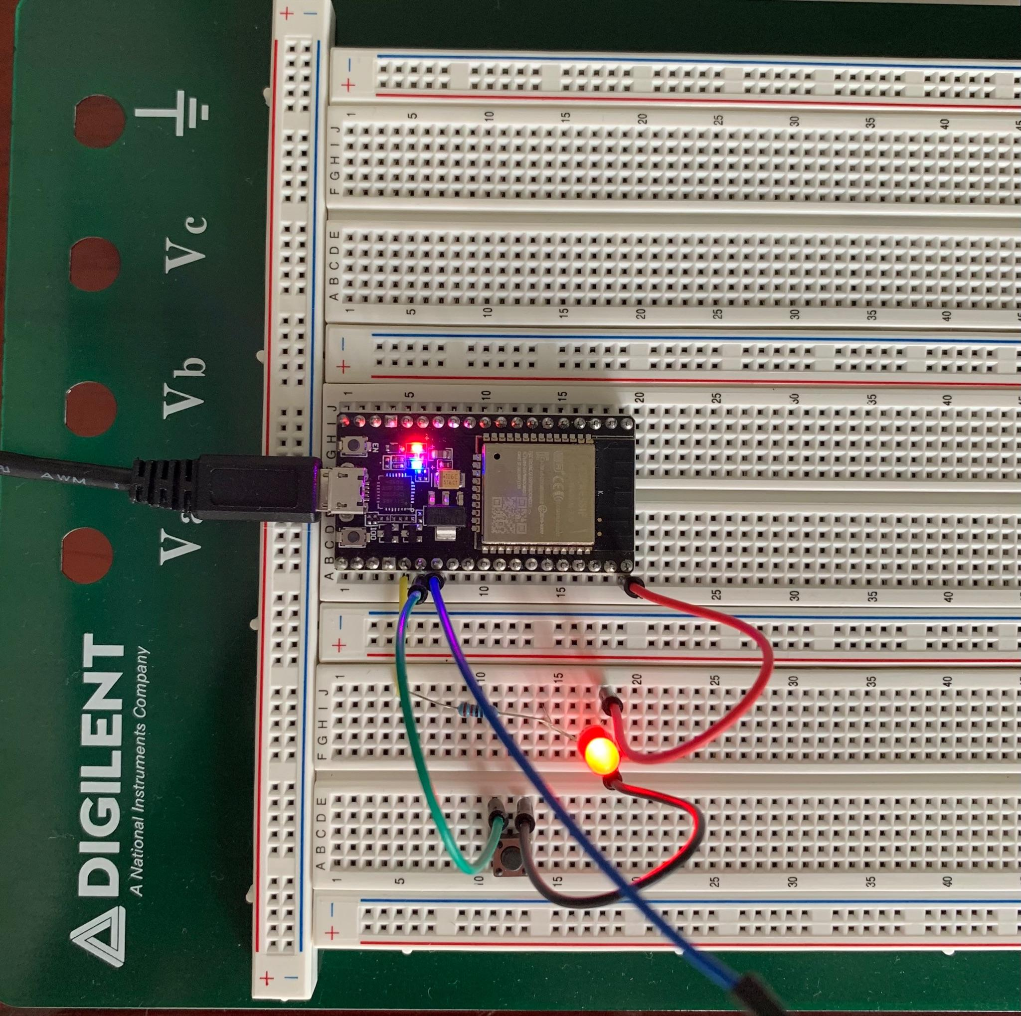

Figure 18: Breadboard Microcontroller Test

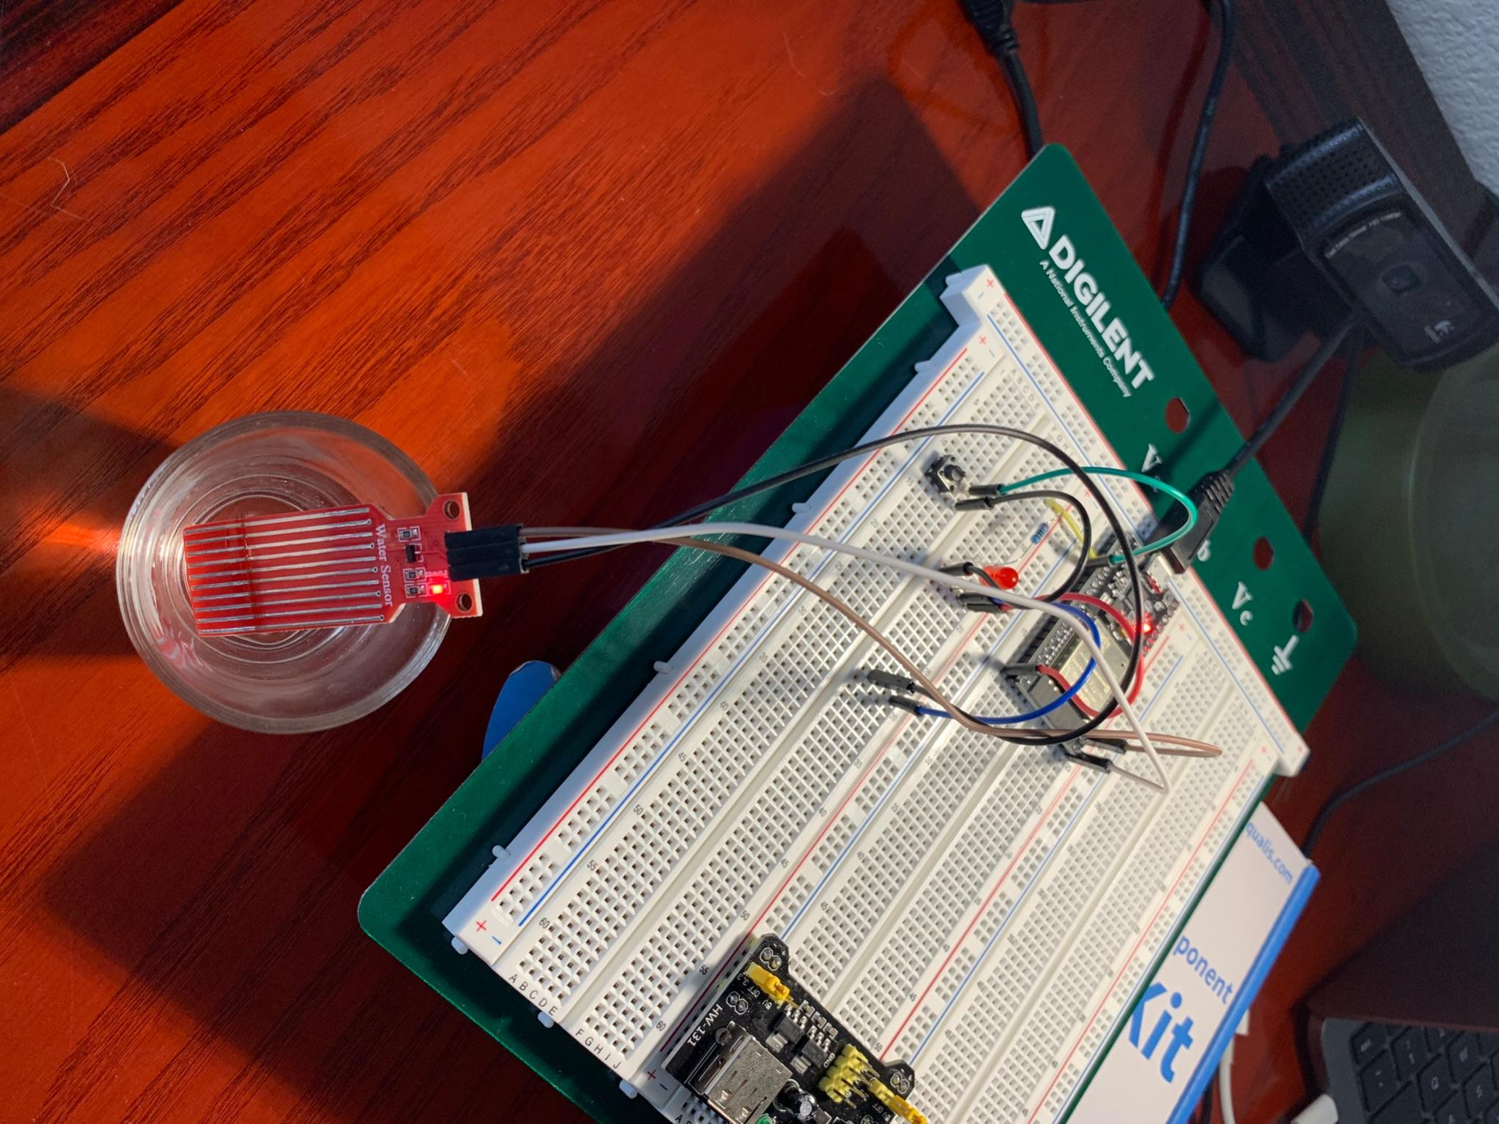

Figure 19: Water Level Sensor Test

**5.3 Second Subsystem (Lights and Pump)**

For our automated hydroponic system, we selected lights that would connect and work well with the microcontroller we are using so that we could also connect it to a timer relay. This will help us better control the power consumption of our system. We researched several options for lighting for our plants and came across a strip of lights that are compatible with Arduino. They will be directly connected to the microcontroller itself. These lights could be set up either vertically or horizontally which is perfect for us because it gives us the versatility we want and need to come up with the best possible design for our hydroponic system. We were originally looking into a vertical structure however we are now considering a horizontal structure mainly because our research has helped us better understand the different types and methods used for hydroponics and which ones work best with different types of crops.

For the pump we need the pump to be connected separately from all the other components. This pump is very much needed for oxygenating the water that flows from the reservoir to the growing medium and then back down to the reservoir to be reused. We researched a few methods for hydroponics and most of the ones that would work well for our system had an oxygen air pump.

**5.4 Third Subsystem**

**LED**

LED lighting will provide the required supplementary lighting for indoor plant development. The illumination has the following characteristics: Dimmable LEDs have light from 0 to 100% and are compact. Nine bands of illumination for plant requirements, UV 380-400nm, 470nm, IR(730nm), can be daisy-chained for several lights. Produces mostly the blue and red light continuum.

The MCP 4131 integrated circuit will include the requirements for this device to monitor the dimming of the lamps. The following parameters are compatible with the system:

Options for a single or dual resistor network, Rheostat setup choices potentiometer: Options ranging from zero to full scale, a 10 MHz SPI interface, a very high voltage Digital input pins with a voltage tolerance of 12.5 volts, -3dB service over a broad bandwidth (2MHz) with a maximum current of 25mA

**TDS and Voltage isolator**

AtlasScientific conductivity kit K1.0 is the TDS sensor that will be used. This sensor will carry two pins on the microcontroller, and the following parameters from the spreadsheet will match the device's requirements: Read conductivity, as well as the practical salinity of the solution, with an accuracy of +/- 2%. Calibration is only needed once a year. Operating voltage 3.3V – 5.0V. Sleep mode of 0.4 mA at 3.3V. I2C data protocol Discrete or sustained reading modes.

**Light Sensor**

The automatic light correction would be one of the distinguishing aspects of our hydroponics system. The sensor is an essential part of the configuration. It must be both concise and reliable. We chose the Adafruit TSL2591 HDR Digital Light Sensor after researching multiple sensors. We gained control of yet another of Adafruit's offerings, which sell Arduino compliant sensors that make production a breeze. The TSL2591 has four gain levels, allowing you to tailor your dimensions to the amount of light you're working with. You can customize the module to relay a mixture of IR, Full spectrum, Visible, or Lux light inputs once you create an I2C link. You may also adjust the integration timings in 100 ms intervals from 100 to 600 ms. In low-light conditions, a prolonged integration time would provide more precise performance.

The TSL2561 is the lighting sensor used in this project. Like the MCU master/slave setup, the connectivity between the MCU and the light sensor module is done via I2C. Throughout this task, the two pins used on the MCU, A3, and A2, connected the requisite power and ground. The light sensor was evaluated based on connecting it straight to the microcontroller unit’s breadboard configuration. Light from the LED series was used to test it on low, mid, and high levels. The serial data would be relayed through the microcontroller’s two analog pins, and the readings would be visible on the computer’s serial display.

**MCU**

The ATMEL ATMEGA328P is the first microcontroller that can meet the system's requirements. The internal design of the processor is shown in the Figure below. The ATMEGA328P is a resourceful microcontroller designed for low-power procedures. The chip supplies speed and the number of input pins. Following is a short list of criteria that were used to determine whether or not to use this microcontroller: CMOS 8-bit system, 32 Kbytes of flash RAM. 20 MHz crystal, 23 programmable I/O pins, 0.2mA of current during the active mode.

**pH sensors**

The Atlas Scientific pH kit is the pH sensor we selected for our device. A probe, a BNC connector for the probe, a module to interface with the probe, and four pH solutions for calibration and pH changes are included in the package. The probe weighs 49 grammes and has a maximum pressure of 960kPa. It also has a maximum depth of 60 meters and a maximum pressure of 960kPa.

When the pH sensor is correctly attached, it will send the pH reading to the serial pins. You can set it to take a reading every second or to operate in low-power mode before you give it an interpret command over the serial link.

This sensor will acquire two pins on the microcontroller, and the following parameters from the datasheet will match the controller's requirements: pH readings ranging from.001 to 14.000, Precise reading to just 0.02 percent, configuration is dynamic and supports single-point, two-point, and three-point calibration; calibration is only needed once a year; individual or consistent reading modes, I 2C is a data protocol, 0.0995 mA at 3.3 V in sleep mode.

**Water level sensor**

The water level of the system is by far the most basic measurement to keep a record of in any hydroponics system or virtually any system containing water. Because of poor circulation or stagnation, low water levels will harm or destroy plants. We understood that regular monitoring of the water level was critical to our system's success. We debated which kind of sensor we could use to monitor the water level and ultimately decided on the Milone Technologies eTape Liquid Level Sensor.

We went for the 8” variant. It operates by having an envelope running down the middle of the tape, which is attached to a pin at the end. On the top of the disc, there is also a reference resistor. When water comes into contact with the envelope, the strain causes the resistance of the pin to shift. By evaluating the envelope pin resistance to the reference resistor and doing the proper measurements, you can accurately interpret the water level.

Knowing your plants' water requirements is a trick to keeping plants in Hydroculture in a hydroponic system. The root depth, and water level of the reserve are two important factors in this regard and can be measured through a water level measuring sensor. Water Level sensors are used to detect the level of substances that can flow. For example, liquids, granular material, slur, and other substances in liquid form. It is possible to measure the water level inside containers as well as the surface level of a lake or river. This measurement of water levels helps us know about the number of materials inside the container or the flow of liquid materials in an open channel.

The water level sensor measurement system sends information back to the control panel to tell about the water body's high or low level. Commonly such systems use probe sensors as float switches, so such systems' main purpose is to manage the water level in a tank or process. The control panel that controls the process is also programmable, which can automatically turn on or turn off a water pump according to the adequate level.

Another name of the water level indicator sensor is the probe sensor, which tells the control panel about the correct action needed to maintain the water level according to our requirement. Commonly a combination of high and low sensors is preferred to send information to the control panel about water levels, whether it's too high or too low. It enables automatically switching off the pump on or off depending on set values of water levels. So, water level indicator sensors work on a simple principle. By using sensor probes, they indicate the water levels of a water body. Later, probes send back information to the control panel, and the already programmed control panel, as mentioned above, automatically turns on your pump to maintain the water again.

**Wi-Fi**

The Adafruit HUZZAH ESP8266 is the Wi-Fi module we bought for production. It's a breakout board with substrates for checking, like logic shifters on a few pins, push buttons for controlling the board, and LEDs for diagnostics and programming. To communicate with Arduinos and most Arduino-related sensors and modules, the ESP8266 chip uses 3.3V logic and hence requires a logic-level shifter. This breakout involves logic level shifters in the form of diodes on the contact pins, so we don't have to think about doing it ourselves during production.

This is a well-designed module, and we won't have to do anything to begin testing and refining it. Simply solder any headers to the broken-out pins, and you're ready to go on a breadboard. On the back, there are six headers that can be connected to an FTDI cable to control the system as well as communicate with the Arduino software for serial communication debugging and programming.

The board can run Arduino software and, in addition to the Wi-Fi connectivity, can act like any other Arduino-based microcontroller, with 9 GPIO pins for connecting to other hardware. This board is good and simple to use for initial development, but if we wish to install an ESP8266 to our PCB, we must have level shifters on the logic pins, a secure 3.3V power link, and the push buttons that are needed to toggle boot loading mode.

**5.5 Software Design**

**Programming Language**

When it comes to software we had to selectively choose a route on what kind of language we were going to use. Since we have two computer engineers in our group it came down to what they thought was more fit and what they were more comfortable with. Java is a preferred language amongst the group, but since we were going to be dealing with an Arduino we thought it would be easiest to program in C. Also this would be the better language since the coding environment is best for these types of embedded systems.

**Embedded Systems Software Design**

When it comes to our software design it is going to revolve on writing code to interpret the different types of data being retrieved by the various sensors. The data being retrieved will then be documented and sent out via Wi-Fi to an online server that will then display vital information about the plant's health. The information will also be sent out to an LCD monitor display. The software design will revolve around sending the correct information under the right labels and displaying it to the user. The design will also need to include the ability to adjust some of the hardware that will be connected to the pcb and the arduino microcontroller. On the physical side of the hydroponic system on the LCD display there will be some sort of buttons that will communicate with the microcontroller and adjust some of the components to the user's discretion. The code will have to decipher the button being pressed and make the change accordingly. When it comes to the virtual side of the software side on the website application we will need to write the proper software to communicate with the Wi-Fi module so that when a user makes a change online it is reflected on the physical system and the changes are made accordingly.

**Web Application Software Design**

When choosing how to create the online website application we are confronted with a few choices. We have to agree on a website-based programming language and a database to store sensory information. For creating the front end of the website, we went with simple HTML to create how the page looks and feels. We wanted the page to be very easy to use and very easy to the user's eyes so that there is no confusion, and we get straight to the point with the sensory data. Following the front end we are going to need some basic functionality to go along with the website that will allow the user to interact with the page and send information back to the hydroponic system. We will use a combination of css and javascript in order to get proper function calls with the website. When it comes more to the back end we are going to need a database to store user information and preserve the data that has been sent in the past if requested by the user. For our system we will use MySQL database since it is easy to use and its usability with handling information. To contact and add or make changes to the database we are going to use PHP in order to interact with the database accordingly.

**5.5.1 Website**

Our system will transfer all of the sensor’s data to an online server which will be connected to a website that we have created. There are many website builders that allow you to build an entire site from scratch with no experience needed. Good examples are:

* Wix.com
* Host Gator
* GoDaddy

Taking into consideration that our website will not be too complex, we can code a generic home page with all the functions necessary in order to read hydroponic information and make changes to the system as a whole. Every user will be required to create an account with the site, and then have an email verification to make sure it's the user. This step will prevent unwanted users from taking control over a person's plants.

The front end of the web page can be developed using very simple HTML. There are many templates floating on the web that are free and disposable for anyone to use. Common functionality can be separated into the other programming languages that are more the backend of the system. For the functionality we are planning on using a combination of css and javascript in order to make certain things work.

Besides the functionality we are going to need to store usernames and passwords in a database. If we wanted to keep a log of all the historical data that has occurred with the plant, we can adjust the database to store those values and have the website pull from the database in order to give the user the information they are looking for. For the database selection there are quite a few different varieties to choose from.

For the sake of simplicity for the project we are going to choose a MySQL database to connect and change around the information being stored and pulled from the database. We are going to need another programming language to work with these values. PHP or Hypertext Preprocessor and MySQL go hand and hand with each other making data transfer code easy to write and function.

Databases

* MySQL
* PostGreSQL
* SYBASE
* IBM-DB2
* Oracle Database

**5.5.2 Wi-Fi Transmission**

In our system we see the need for information to be transmitted via wireless. In today's time it has become a very normal occurrence to have all the information we quite desire disposable at our hands. In our automated hydroponic system, we definitely see the requirement of having the ability to check on the plant being grown. By having the Wi-Fi component in the system information will be sent to a server and a database. By doing this the grower will be able to remotely check the health and safety of the plant. By the readings of the pH sensor to the water levels in the system to the nutrients in the water at any given time. This will be done by the Wi-Fi component that will be connected to our microcontroller. Then sent to a database that will display the information on a public www website. We will be choosing Wi-Fi 802.11b/g/n communication. This is one of the most popular types of wireless transmission in today’s time.

Considering having a router in a person’s home has become extremely normal in today’s time this will be sufficient due to the usability. If the system were to be produced, then this will be a good practice to implement. Wireless transmission distance can often reach out to lengthy distances. Distances ranging from 80 – 160 feet still allow information to be transmitted to a router. Information will then be uploaded online. We are going to create a mobile application and a web version that will allow the materials being sent to be seen at a user-friendly level. We will implement the ability to control water output and solution output and light exposure expenditure.

**5.5.3 Bluetooth**

There is another alternative to wireless communication transferring, and that is Bluetooth. Bluetooth has been around since 1989 and has been commonly used in everyday life. In today's society we mainly use Bluetooth to connect to a short-range device. We have Bluetooth headphones, Bluetooth inside of our cars. The big issue with Bluetooth with our system is the lack of range. As compared to Wi-Fi having the range of 80-160 feet Bluetooth has approximately a range of 30 feet. Which would mean our user would have to be near the hydroponic system in order to read the information being sent out by the microcontroller. Another flaw with the Bluetooth system for us is the lack of the information being sent to the mobile web. Thus, not allowing the data to be posted to the wide web.

**5.5.4 Wi-Fi vs. Bluetooth**

|  | **Pros** | **Cons** |
| --- | --- | --- |
| **Wi-Fi** | Very inexpensive to use and maintain | N/A |
| Bluetooth | Low cost | Very short transfer distance |

The unique part about our system compared to other systems is going to be the implementation of a user-friendly mobile application and website usability. Considering our hydroponic system will be completely automated there will still be the urge to check on the plants. This is not only beneficial for the user, but for the plant as well. The information transmission to the user allows a grower to make informed decisions on the health of the plant. The challenges faced with having the sensor data transmitted online is where we are going to store this information. How are we going to display this information?

For the Wi-Fi module that we are going to incorporate into the system we decided to go with the ESP826 Wi-Fi module. We choose to go with this module because it will cost around $5, and other components online that are similar cost nearly $80+ and we want to keep production costs down to be able to redirect costs. Considering it is very low in cost it will also be very user friendly to us to connect alongside with the microcontroller. We need the Wi-Fi module to be able to transfer the data from at least five to eight sensors which should not be an issue.

The ESP8266 has an input of 16 GPIO pins that will operate at a 3.3V DC power supply and will have an operating current of roughly 80mA. The ESP8266 will support the 802.11b/g/n protocol. The ESP8266 will receive sensor data and use the ESP8266 W-Fi module and then use a DDAS server that will receive the data and respond accordingly. The data is transmitted at a certain interval that can be programmed. For Instance, with the temperature sensor, it can send information over to the Wi-Fi module at an interval of our choosing whether it be every second, every minute, every hour. It does not have to even be at a certain interval, it can be sent over once the temperature reaches over a certain temperature. Thus, information will continuously be transmitted to the Wi-Fi module and then via HTTP to our server. Once the DDAS server receives information and if we need to make changes to the hydroponic system. Then the DDAS server will reply back to the ESP8266 module with a certain response, and it will then pass that information along to the necessary component in order to make the changes necessary. HTTP stands for Hyper Text Transfer Protocol and it means since it can connect to the internet it can be accessed anywhere in the world with internet connectivity.

The ESP8266 module’s code will consist of the user’s router name and router password in order to connect to the user’s router.

**5.6 Summary of Design and Overall Schematics**

For our project our goal is to design an automated hydroponic system, it was designed to be user friendly and portable. Able to be set up indoors or even outdoors. We will be using pH level sensors, water level and nutrient sensors as well as connecting our system to a WIFI module to make it user friendly. In order to achieve this, we will be integrating these components together and take the microcontroller and program it adequately. We will be using the Arduino microcontroller to operate our system; however, a voltage divider might need to be integrated into the system also in the case of the components needing more than 5V to properly operate. The other option we have to mitigate any voltage requirements would be to change the microcontroller to something that could possibly hold more voltage power. The main microcontroller is going to have the sensors connected directly to it and also connect the LCD, Lights and possibly the WIFI module to it as well. If we were to need a voltage divider in our system, then some of the components would be rearranged to fit the design's needs.

The sensors are simple to integrate to the system and we will be programming them to get the accurate data from our system. As of now we are still debating on whether or not to integrate an LCD into our design for accurate data reading. We believe that the system might not need it since we will be having it connected to an app. As of now we are still missing some of the components we want to try and implement in our hydroponic system. For the WIFI module we are planning on testing it with a wireless hotspot function. Some of our phones have the capability of being a hotspot so we will be using that. In terms of designing the website, WIFI module, app, and the programming for all of the data, this portion of the project will be done at home.

Once our system is in its final stages the data will be uploaded into the website and stored in the database with the help of the WIFI controller. One of the components that won’t be directly linked to the WIFI module will be the LEDs and the Lights Timer Relay. We decided to go with a timer relay instead of a light’s dimmer sensor. The relay would be easier to control and set up and this could potentially help the hydroponic system to run continuously while still being power efficient since the lights won’t need to be ON all the time. We used the breadboard provided to test the components we already have, and we will continue to use the breadboard to test the additional components we still want for our system. Once we set them up and get them ready we will be sending our design to be printed.

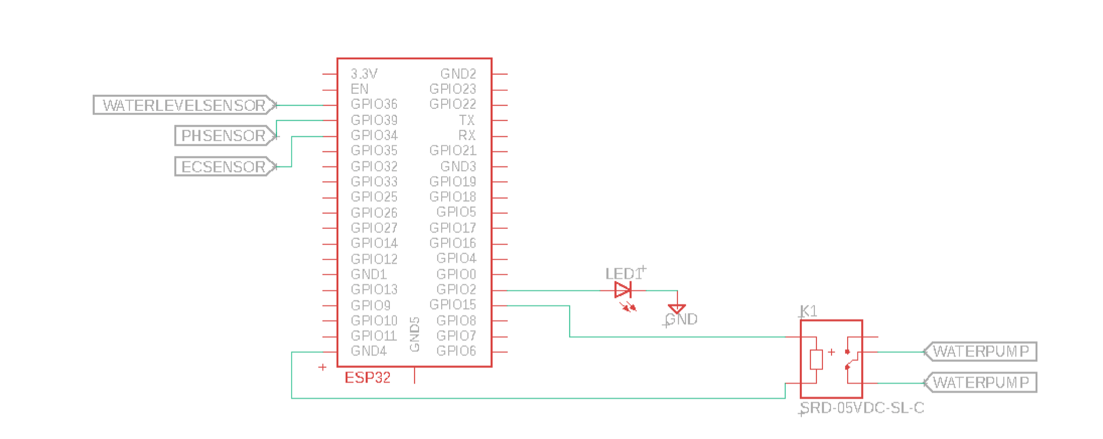

Figure 20: Schematic for the ESP32 Microcontroller

In the schematics above we can see the microcontroller ESP32 and its connections. We will connect the water level sensor in GPIO36, pH sensor in GPIO39, and EC Sensor in GPIO34. The pump will be connected to GPIO15 and the Led lights to GPIO2.

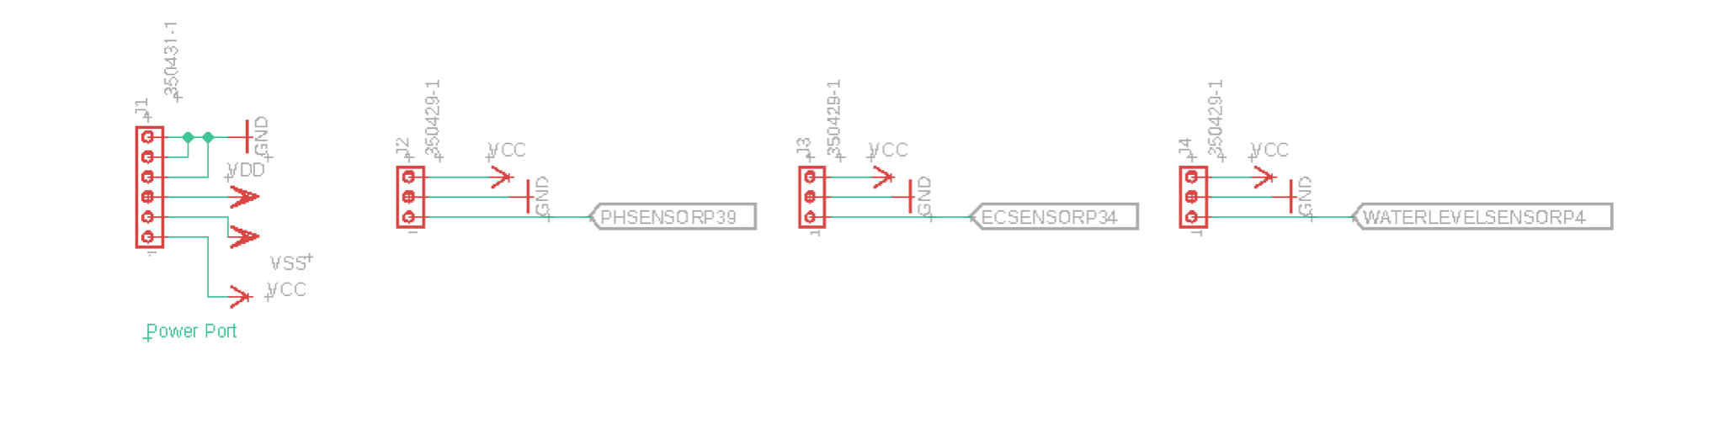

Figure 21: Connections for the Sensors

In this schematic, we can see the power port that is going to be used to power the board, and the connectors for the sensors.

**6. Project Prototype Construction and Coding**

**6.1 Integrated Schematics**

For our hydroponic system to work properly we have to bring all the parts together and ensure they are working properly. In order for our system to work unified as one we will have to create a printed board circuit. This is what enables the microcontroller, sensors , Wi-Fi module, and all other hardware to be connected and have the ability to be worked on. There are many different types of printed board circuit as per UCF senior design requirements we are required to create our own design and have it manufactured.

When it comes to deciding how to create one of these there are a variety of types. There are numerous layers that can go into a printed circuit board design. Usually what these layers are fabricated with are copper. Typically a first layer design is one of simplest ones and is used for the easier tasks that do not require many components or the workload of its task is simple. The more lawyers added the more complex the task it has at hand is. A smart watch typically has a printed board circuit of six layers. It can continue to add layers all the way past sixty layers. At that point practically the task at hand is a super computer. Printed board circuits can be created with many components ranging from resistors, semiconductors, capacitors, and diodes.

**6.2 PCB Vendor & Assembly**

For all Senior Design projects, a printed circuit board or (PCB) is required to be designed and implemented into the projects designed. In order for us to be able to do this part of the project we dedicated a large part of our time into doing research to try and figure out how to design a proper PCB layout for our hydroponics system. The printed circuit board is basically the brains of all electronics nowadays. If one designs a good PCB then the electrical equipment will function how it is supposed to and could become even more efficient with a good PCB design. If the PCB is not done correctly then the electronics will not function properly, and this could damage the piece of electronics and equipment. A printed circuit board is defined to be a piece of non-conductive substrate that mechanically supports but also electrically connects components by the use of conductive tracks amongst other features that are etched from one or several sheets of copper and laminated on and in between sheets of non-conductive layers.

A printed circuit board can have certain pieces of components such as capacitors, resistors and at times embedded active devices within the design of the PCB. The printed circuit board has several layers and the more layers it has the more detailed and intricate a design can be. These boards could have up to ten different layers and each layer connects through a “vias” which is a hole in the plate and these holes connect to the different components on each layer together.

Through our research we saw that in order to design a good functioning PCB we would first need to know the type of circuit we need to build in order for our hydroponic system to work. We need to make sure that the motherboard has enough power output to be able to power up all of the equipment that we will be connecting to it. Additionally, to this we also need to make sure that we use the correct software to code and simulate our system. In previous classes such as Junior Design, we used the software Eagle to learn how to design PCBs with their components. We could potentially use the Eagle software to draw a schematic of our PCB and observe if it is properly connected. We can verify that there are no errors with the schematic of the PCB using this software and once all of that is said and done, we can send the design to be manufactured so that we may use it for our hydroponic system project.

**6.3 Final Coding Plan**

The final coding plan for our hydroponic system will come down to what part of the component we are trying to program. When we are working with any of the sensors and anything related to the arduino microcontroller then the code will generally be written in the C programming language.

We are going to work on programming the microcontroller to read the input from the water level sensor, pH sensor, light timer, and the temperature sensor. Which will all then be translated into code through its assignment from its various pins. We then will have this displayed on a LCD monitor that will also be programmed to display just the vital information and time all coming from the microcontroller.

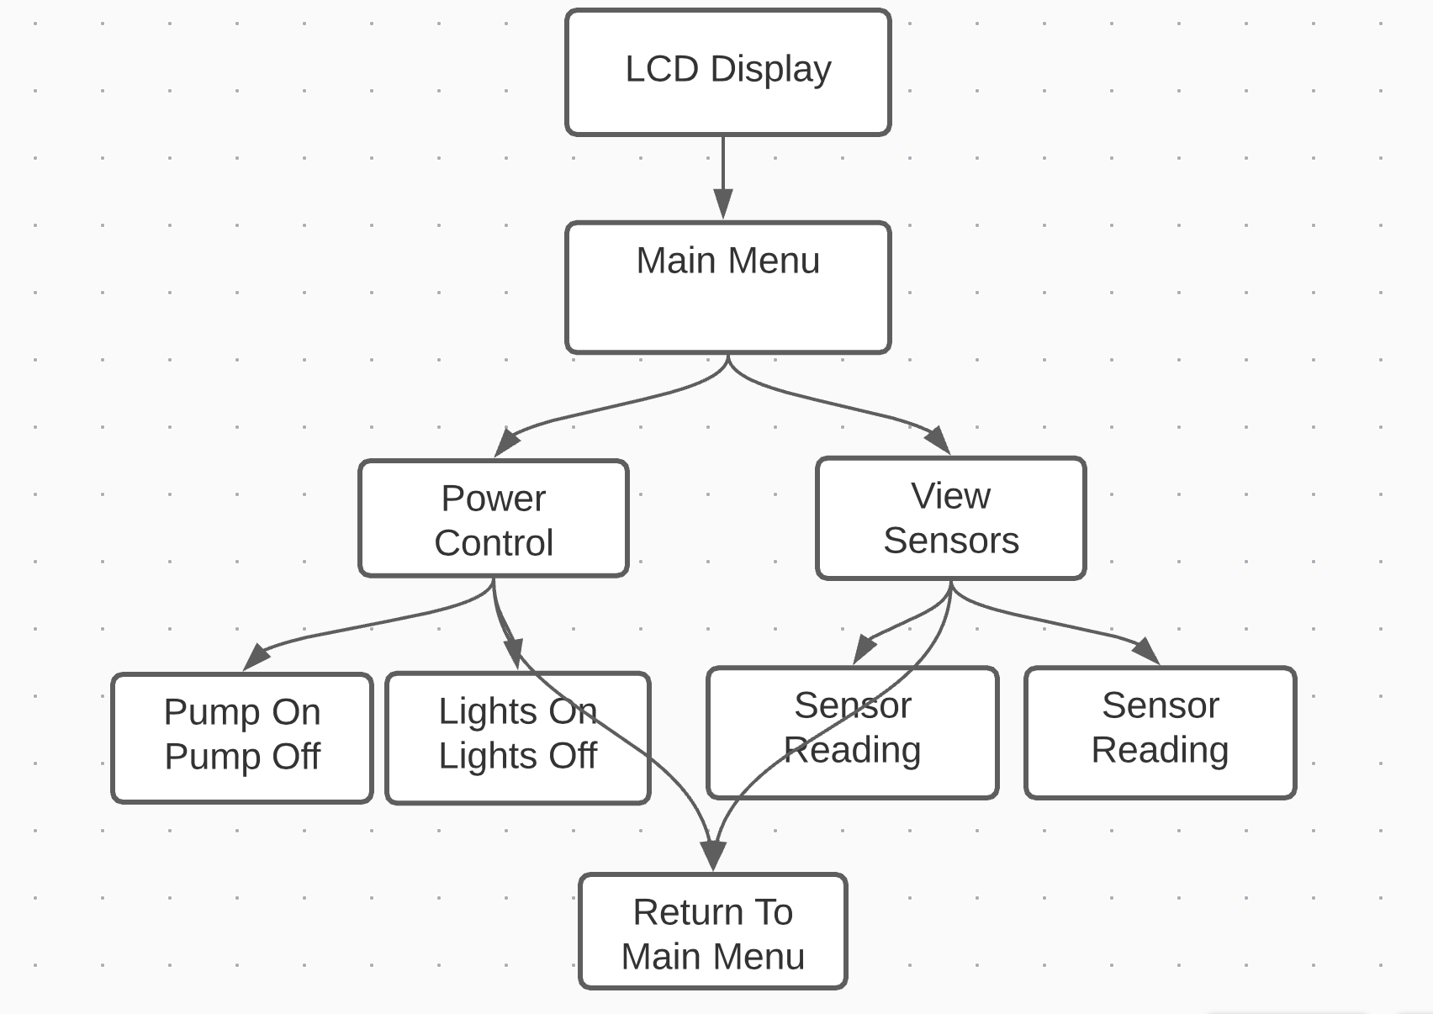

Figure 22: Final Coding Plan

The LCD display will have a certain layout to it. Once powered on it will come to the main menu where it will give the user the choice to go into the power settings or go into the sensor readings.

If the user selects to go into the power settings he will then be presented with all of the other components that require power to be on. This can be the water pump, air stone, or the lights. Our system's goal is to give the user complete control over the system. Sometimes some plants/crops require different growing strategies compared to other plants.

When the user selects to go to the sensors menu, they will be presented with a menu of the different sensors. It will have a sideways list displaying the water level sensor, temperature sensor, pH level sensor, humidity sensor, and a light timer sensor if selected. All menus will also display the current time.

**Final Coding Plan Web Application**

For our web application we have decided to go through and construct a site where all information received from the sensors is related to a server and then displayed on a website. We have taken this choice due to the growing standards and how normalized being on the internet is. We found this as our primary means of being able to control the various levels of output produced by the system. Also, a user can view the plant's vitals from nearly anywhere in the world with an internet connection.

When choosing a server to send information from we will be purchasing a domain name from GoDaddy. They are very low cost and will allow us to have an ip address to be able to send the information from the ESP8266. Which will then be transferred to the domain name of our choosing and then be communicated with the database to store the information.

When it comes to the front end of our website there are many website builders online that will help the appearance on the website itself. Since our group has little experience with website based coding infrastructure. Regardless of the website builders there are many resources online that will provide HTML templates. With these templates we can just use them for the appearance and then add functionality to them as we desire. For the functionality based portion of the website we will be using javascript and css to write functions necessary to perform correctly when the user decides to make a change to any of the hardware incorporated into our hydroponic system design. Each user will have to create their own account to ensure they are in their own garden. A template will be provided and the user will have to fill out the information necessary in order to be validated. Once the user creates an account and is validated then he will be brought to his/her dashboard. Once on the dashboard the layout will be relatively simple. It will contain nearly the same menu as on the LCD screen but on a web page format. There will be a power options button that will give access to the user's hard components and allow them to adjust the power on the different components accordingly. The dashboard itself will contain all the sensor readings being returned by the hydroponic system itself.

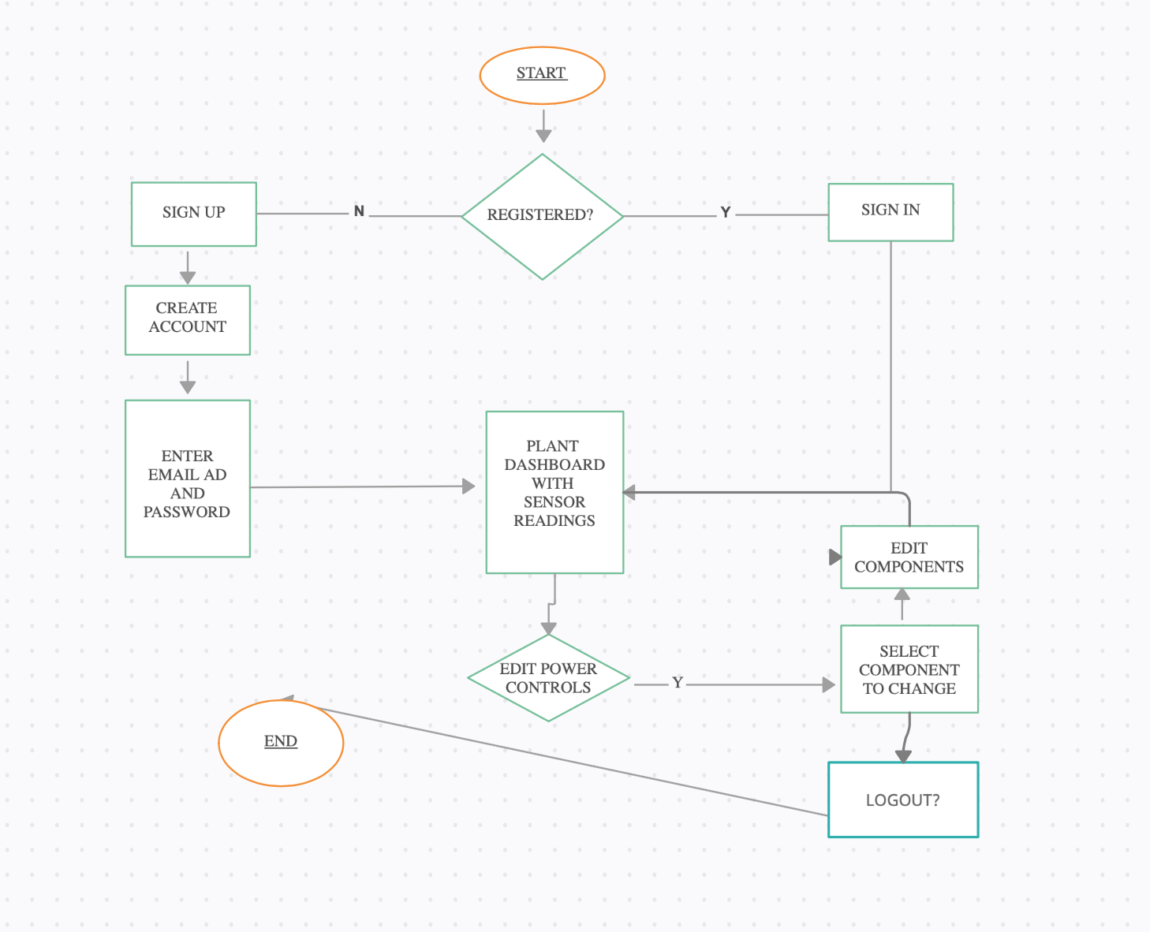

Figure 23: Web Application Plan

The back end of the entire system will have to be the database. With the database we intend on storing all of the plant's previous vital information. This can be beneficial and hopefully put us ahead of any other competition. This will give the user the ability to go back on old data and see the historical pH levels, temperature readings, water level readings, humidity readings, etc. Not only will this be stored but we will also need to store the users information. Such as first name, last name, email, password, and most likely a special unique key to differentiate between other systems. We will go with the MySQL database since its usability and functionality is fairly simple. To communicate back and forth between the front end and the back end we will be writing code in PHP.

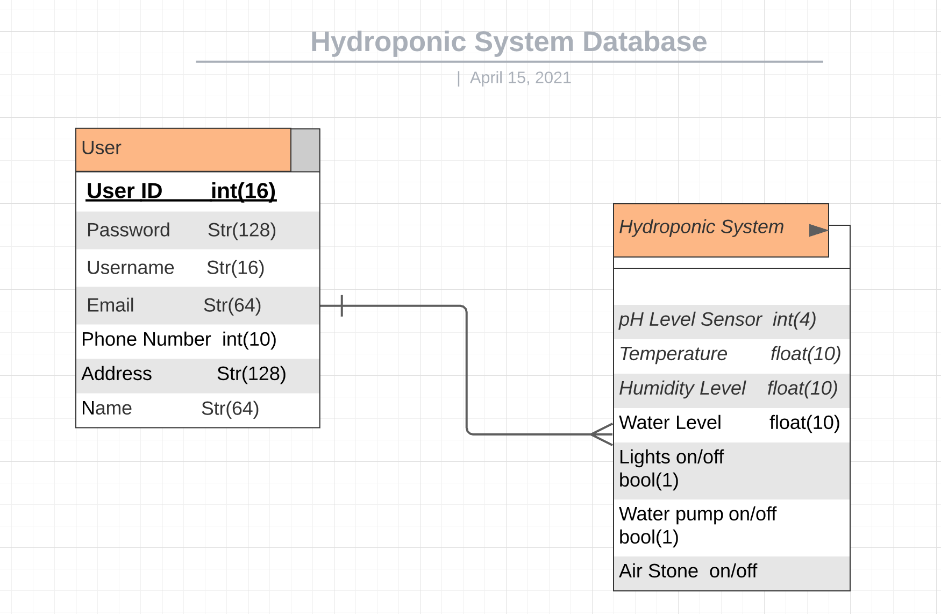

Figure 24: Database Design

**Mobile Based Application**

**7. Project Prototype Testing Plan**

**7.1 Hardware Test Environment**

In this section we discuss the steps for testing some of the components for our hydroponic system. The tests are made so that we may be able to confirm that the components chosen for our project can actually be integrated into the system. This section will continuously be updated as we receive and test each component to be well suited for our project. Overall, the hydroponic system is meant to be easily transported from place to place so it will be tested in various locations ranging from indoor and even lab settings to outdoors.

**7.1.1 Peristaltic Pumps**

Once the pH and TDS sensors have been thoroughly checked and determined to be in prime condition, our pumps will be put to the test. The microcontroller will transmit a signal to a bank of relays that will switch on the target pump for a fixed amount of time to monitor the peristaltic pumps. The machine will wait for the applied solutions to fully blend in the hydroponic reservoir after the timer has elapsed. The sensors will take another reading at this point to determine whether another dosage is needed.

**7.1.2 Power System Testing**

The power systems would need to be checked for stable voltage levels that are free of unwanted noise and ripple. A voltmeter can be used to make approximate calculations during these experiments. Once these readings are similar to the target values, a second evaluation with the oscilloscope can determine if the current is minimal enough to meet the device's requirements. Ripple refers to the minimum only off by DC voltage values that are undesirable in microelectronics. If the system is fully loaded, the next stage would be to double-check these voltage levels.

**7.1.3 Solution Level Testing**

Filling the nutrient tank to the correct level would be used to measure the solvent level or water level. The water level should then be checked by matching real hand-measured variations in the water level to that determined by our water level indicator by removing water from the device and adding more energy to the system. This sensor will determine how many inches are above or below the tank's normal levels. This data is fed into the UART, which is then read by the computer.

**7.1.4 LED Lights Testing**

LED series are checked to determine whether the code in the microcontroller will switch the lights on and off. We'll also check to see how this lighting device fits in our light sensor. If there is sufficiently natural illumination for the crops to be safe, our automated potentiometer can dim or switch off the LED lights as more light is applied from an outside source. As the daylight is no longer available, the LED array will be turned on fully. This research will be done with the light sensor as well as the optical potentiometer, which will be used in place of the physical potentiometer that came with the LED series.

**7.1.5 Logic Level Shifting Test**

Our device employs a logic level shifter to convert the microcontroller's 5V logic level to the 3.3V logic level of our Wi-Fi portion. This machine will be tested on the test bench with a function generator that generates a 5Vpp square wave with a 2.5-volt DC offset. This will generate a waveform that is square in shape with a logic degree of 5V high and 0V low for checking. This signal would mimic the conditions used in binary logic serial communications on the microcontroller. The input signal on the oscilloscope will be used to track this signal, and the output of the logic level shifter will be attached to the oscilloscope to compare the two signals and search for precision and distortion issues.

**7.2 Hardware Specific Testing**

The section presents an overview of the research schedule that will be carried out on the various modules and subsystems. These checks will be performed to ensure that the imported materials will satisfy the project's required specifications or restrictions. Since unexpected problems and improvements will occur as the project progresses, this section will need to be revised as the project progresses.

**7.2.1 Light sensor testing**

The sun emits the entire spectrum of light that reaches the plants, with a light intensity of up to 98,000 Lux. Lux is defined as "a unit of illumination equal to 0.0929 foot-candle and equal to the intensity provided by one lumen rising perpendicularly on a one-meter-square surface." Individual plants need varying amounts of light; however, most houseplants require at least 30 000 lux to develop meaningfully. This device is aimed to accomplish the minimal Lux needed by combining ambient light and fluorescent lighting.

A hand-held light sensor used in hydroponic systems will be checked alongside the light sensor. To see if the reading is correct, it will be compared to this known precise hand-held unit. The light sensor needed to be adjusted for bright light conditions because it was reading way off the map when we first checked it. It was discovered that a vector had to be set in order to interpret the LED array's incredibly bright conditions.

**7.2.2 pH sensor testing**

Connecting the pH sensor to its module and connector port was needed for testing. This section of the device, along with the TDS modules and one extra slot for future updates, will be housed on its own PCB. The sensor had to be optimized before it could be tested at various pH levels. The 7.0 approach was the one on which we tuned the sensor. The sensor was initially reading 7.2 pH, according to the serial display. The measurement was set to 7.0 by sending a command via the serial port on the computer. Several further experiments were conducted, and the pH sensor was successfully tested. Checking and calibrating the pH sensor with the three pH solutions that came with the sensor is part of the testing process. Our initial approach verifies the sensor's configuration to the base side of the pH scale; the second verifies the sensor's configuration to the acid side of the pH scale, and the third verifies the sensor's adjustment to the center of the pH scale. These sensor readings are sent to our desktop serial terminal, where they're being seen visually as a value in the location of the hundreds. Where the value on the serial display differs from the value in the solution, an instruction to reset the high, medium, or mid-range pH is sent to the sensor module. After making all the interfacing of sensors and other embedded devices, we put the pH probe in the water tank. A slight change in value gives us the value on the screen. For example, if you place the probe in fresh water and add a small amount of HCl to it, the screen will show the increase in value, and if you add NaOH, you will observe a drop in the value of pH.

**7.2.3 Nutrient Sensor Testing**

The nutrient sensor should be measured in the same manner as the pH sensor. It came with two proven complete dissolved solids solutions that could be used to measure the sensor's accuracy. After both solutions have been checked with the sensor, the module may be adjusted to dial in the findings to the measuring solution. Nutrient sensors control the outlets of wastewater treatment plants, ensuring regulatory compliance and minimizing discharge fees. Optimize aeration control and precipitant dosing is also possible with these sensors during biological treatment of wastewater—monitoring denitrification processes for supplying safe drinking water, process water, and mineral water.

Nutrient Sensors have become increasingly important tools to maintain and monitor water quality monitoring. Nutrient sensors are of interest because accurate and timely information on nutrient concentrations in water minimizes risks to humans and helps us to manage the underlying drivers that affect water quality. The contemporary emergence of modern tools to manage, collect, and share datasets is necessary for the successful use of nutrient sensors. And these sensors are making it possible the continuous monitoring to move forward rapidly. Unlike the conventional methods where discrete samples are collected and analyzed in the laboratory manually on a weekly to monthly basis.

Water quality sensors provide us continuous measurements, so they reduced the chances of missing water quality, which usually happens when we record the data manually in discrete time intervals. The process of collecting and transmitting data to the observer also helps us make decisions at the time and before any damage to the whole process.

**7.2.4 Testing with conductivity probe**

After making all the interfacing of sensors and other embedded devices, we put the conductivity probe in the water tank. A slight change in value gives us the value on the screen. For example, put a probe in fresh water and add a small amount of NaCl in. These screens will show the importance of changing Ph and another parameter by measuring the change in conductivity. By gradually increasing the amount of NaCl, we will observe the increasing value on the screen.

**7.3 Software Test Environment**

For the software test environment we have a variety of options to choose from. Since at UCF we have taken many classes that involve the use of Code Composer Studio. That is the environment most used when we program our microcontrollers. Once programmed and made sure it is uploaded properly to the microcontroller we can then use the debug feature that is included in the programming environment. We will then be able to see what will go into each variable and register and adjust our code accordingly. This allows us to easily figure out any potential errors.

For the online component of the testing we will be using a text editor. We will write our HTML and a javascript code on a text editor like Atom. Once we have code written and it is ready to go to testing we will then use a program like Forklift to upload the files to our server. Then we will then use a remote desktop to test functionality to make sure that the code is working as expected.

**7.4 Software Specific Testing**

When testing the software components of the hydroponic system we will have three different components to the testing. We will have to ensure that the micro controllers and the sensors return the correct values over to the terminal in order for us to ensure accurate results. After ensuring that the sensors return back the correct values we will then run a software test on the Wi-Fi module of the system. For this to work correctly we will test the Wi-Fi module on different networks. The program needed to connect to wireless access points is the SSID of the network. Then we will need the password for the specific network we are trying to reach. Once this connection has been established we will then be able to test if data is being sent to the servers. There are many different codes online to test this. There is a program that once connected to the internet it will ensure communication by interacting with the LED’s already established on the microcontroller. We will then go to our local host and press a switch on the web page that will turn the LED on or off. After such testing is complete we will then be able to verify the Wi-Fi module is working as expected and we can then move on to test the microcontroller. Then we will have to run a test on the web based application component of the hydroponic system. Lastly we will have to run software testing on our database and make sure that the correct data is being pulled and stored in the correct tables.

When it comes to the specific software testing of the microcontrollers we will have various inputs like the UART and the I2C and analog. These protocols all have their own methods of functionality. The microcontroller will receive information from the several pins it has. All coming from the various sensors that we will have connected. The system will be verified by individually checking responses directly from constant factors. Each sensor will be tested with a known value and see if the corresponding value is returned from the microcontroller.

Following the proper testing of the microcontroller we will then test the web based application of the hydroponic system. To run testing on this it can be done fairly simple. We will ensure the correct components are being displayed by going to a different remote location and ensuring that the user is connected to the right account and the right data is being pulled. If the correct data being pulled from the Wi-Fi module matches what the online data is displaying then we can conclude that the web based application is working as expected.

Lastly the last software component needed to be tested is the MySQL database. We can run testing on this by using our PHP code. We will have test case scenarios. We will upload data in code and ensure that the data will get stored in the correct slot in the tables. Afterwards we ensure that the correct data is stored in the right slots. Then we will go under the impression testing that the proper data can be pulled from the database.

| **Test Case** | **How Testing Will be Done** | **Acceptance Criteria** |
| --- | --- | --- |
| Microcontroller | Testing correct input of sensors with constant values. | Correct values are returned. |
| Web Based Application | Ensuring that data displayed on the website matches those on the physical location of the hydroponic system. | Correct data is being displayed to the user. |
| MySQL Database Functionality | Inserting different values into the data tables of the database and also ensuring that values being returned from the database match those being deposited into the tables. | Correct information is stored in the correct slot on the tables, and the correct data is being pulled from the corresponding slot. |
| Sensor Feedback | Ensuring that the values being returned to the microcontroller match the constant values being tested on the sensors. | Values being returned from the sensors are accurate to the constant values being given to the sensors. |
| Wi-Fi Module | Testing will be conducted by connecting to a network via SSID and password and running a simple program that remotely turns on the LEDs on the microcontroller via a remote connection on a server. | LED’s turn on when interacted with via remote location on a web based application |

Table 24: Test Case Table

**8. Administrative Content**

**8.1 Milestone Discussion**

| Week # | Date | Activity |
| --- | --- | --- |
| 4 | February 2 | Starting our draft papers |
| 6 | February 16 | Start the 30 pages writing |
| 9 | March 9 | 15 pages should be completed  -  Start breadboarding |
| 13 | April 13 | All 30 pages should be completed  -  Critical functions completed  -  Start PCB design |
| 15 | April 27 | Turning the complete papers in |

Table 25: Senior Design I Milestones

| Week # | Date | Activity |
| --- | --- | --- |
| 1 | May 11 | First meeting at Fall |
| 2 | May 18 | Ordering the SMD parts and PCB boards |
| 4 | June 1 | Soldering the components and test each one individually |
| 7 | June 22 | Assembling the parts and build the projects |
| 11 | July 20 | Test the finished projects |
| Presentation week |  | Final presentation |

Table 26: Senior Design II Milestones

**8.2 Budget and Finance Discussion**

Budget and Financing

Our team members will be financing the project. The project’s cost will be divided among the group members.

| Item (number) | Cost |
| --- | --- |
| Hydroponic Vertical Plant Grow Tower | $ 20 -125 |
| Heat Gun | $5 |
| Drill bit set | $5 |
| Power Drill | $Owned |
| Grow Tent | $25-75 |
| Bucket | $5 |
| pH Sensor | $10-30 |
| Water Level Sensor | $2 |
| Microcontroller | $Owned |
| Timer | $Owned |
| Power Supply | $75 |
| Light Bulbs | $10-15 |
| Water Pump | $20-50 |
| WiFi Sensor | $30 |
| AC to DC converter | $20-30 |
| Water Conductivity Sensor | $60 |
| Camera | $Owned |
| Tubing | $15 |
| LCD display | $15 |
| Enclosing Casing | $60 |
| Oxygen Pump | $50-75 |
| Total | $ Approx    650-1000 |
| Cost per member | $160-250 |

Table 27: Estimated Budget

**9.0 PCB Design**

**PCB Design Schematic:**

We have designed our PCB board based on our project’s requirements, which contain three sensors (pH, water level, TDS) and LED lights. The PCB design have the main circuits designed in a way to provide the right voltage and current in order to run the sensors and the ESP32 chip, as we have the power supply circuit to provide the board with 5V and 3.3V as required.

The PCB contain essential components like resistors (10k, 20k, 560hom), Linear voltage regulators, and TIP120 transistors, and MOSFET-N CHANNEL SMD. The schematic below shows the PCB design and connections.

Figure 25: Overall Schematic

**ESP32 Chip Design and Connections:**

For the ESP32 connections we have connected only the needed pins as showing in the figure below, as for the other pins were left unconnected since they won’t be used in this particular board.

Figure 26: Microcontroller Schematic

On the right side we connected the sensors TDS, pH, Water level, and LED lights and also there’s LED diode connected to pin 27 (IO16) that flashes when the chip is working. Another connection on pin 25 (IO0), which is for flash/boot button that we need if we tried to upload the sketch manually. When pushing the flash/boot button pin 25 (IO0) will be connected to ground GRD to put the chip in boot mode. On the left side of the esp32 chip we connected the programming port which has the rest button and the transmitter Rx and the receiver Tx pins.

**Programing Port Design:**

We have added this programming port to our PCB design to connect the ESP32 chip to the external programmer module in order to upload the skitch using Arduino IED software. The figure below shows the connections of the programming port, which has the DTR, TX, Rx, Vcc, RTS, and GND.

Figure 26: Programming Port Schematic

The design contains 2 buttons, the 1st one is the rest button that we need to rest the circuit after uploading each skitch. The other flash/boot button is to be pushed whenever the auto reset circuit doesn’t work. Since we added this auto reset circuit, we don’t need to push the button unless we want to upload the sketch manually as a backup option. We have pin number 6 the DTR pin connected directly to the Auto reset circuit and the reset button then to pin 3 (EN) on the ESP32 chip. On the other hand, pin number 2 (RTS) is connected to the Auto reset circuit and the flash/boot button then to pin 25 (IO0) on the ESP32 chip. Pin number 3 (Vcc) is the power pin; however, it is connected to the diode before the ESP32 connection for protection purposes. We were left with pin number 1 which goes to ground GND, and pins 5,4 are for Rx and Tx transmitting and receiving data.

**Power Supply Circuit Design and Connections:**

As shown on the schematic below, the connection of the power supply circuit and it has 2 types of input. The first power input is the Terminal block which takes 6V-12V as an input voltage. The second power input is the Micro USB which takes 5V as an input voltage. Both inputs voltage go through the voltage regulator circuit to get the required voltage which are 3.3V and 5V. The ESP32 chip will be connected to 3.3V, as well as the TDS sensor and the Water Level sensor. As for the LED Strip and the pH sensor they will be connected to the 5V.

Figure 27: Power Supply Circuit

The purpose of the power supply circuit is to convert the 6V-12V from Terminal block input or the 5V from the Micro USB input to 3.3V and 5V as required to power the PCB board. The Terminal block circuit as shown above, contains the diode for protection and it has the linear voltage regulator to convert the 12V to 5V and that 5V would provide the LED Strip and the pH sensor then it would be connected to the 2nd circuit to be regulated to 3.3V as we need for the esp32 chip and the Water Level sensor. As for the Micro USB input which is connected directly to the 2nd circuit since the input is 5V already; however, it will also be converted to 3.3V as well and that’s why we have used another voltage regulator. This power supply circuit will provide up to 2 AMP for the board. The Terminal block and the Micro USB cannot be connected at the same time as the power input source because that may damage the circuit.

**TDS Water Quality Sensor Connection:**

The TDS sensor requires 3.3V, so the 2nd pin would be connected to the 3.3V supply as shown in the figure below. As for the 1st pin it will be connected directly to pin 23 (IO15) on the chip for the data transfer and it’s labeled as “TDS_OUT”. The 3rd pin will be connected to ground GND as shown in the schematic.

Figure 28: TDS Sensor Schematic

**Water Level Sensor Connection:**

The figure below shows the connection of the water level sensor, a 4-pin connector and a 560-ohm resistor. It's easy to interface the sensor with a microcontroller chip (ESP32). Since the sensor is resistive, it's easy to read the values by the Arduino ADC pin. The 3rd pin is connected to the power source through a 560ohm resistor and also connected to pin 16 (IO13) on the ESP32 chip to read the water level output signal. The 2nd pin is connected to ground GND. As for the 1st and the 4th pins on the sensor they won’t be used since they are for the temperature.

Figure 29: Water Level Sensor Schematic

**pH sensor connection:**

The pH sensor has 6 pins and 5 of them would be connected to the power source, ESP32 microcontroller, and ground GND. The 1st pin is for temperature data signal “TEMP_OUT” and it would be connected to pin 14 (IO12) on the ESP32 chip and ground GND through voltage divider circuit. The 3rd pin is to transfer data signal “PH_OUT” and it would be connected to pin 13 (IO14) on the ESP23 chip and ground GND through voltage divider circuit also. The reason of using a voltage divider circuit is because the pH sensor works at 5V, so the output signal is between 0-5volt analog signal, however, the ESP32 chip is 3.3V. So, to prevent any damages to the ESP32 chip we have added voltage divider circuit which maps 0-5volt signal to 0-3.3volt signal. The calculation for the voltage divider circuit is Vout = R2/(R1+R2) *5V = 3.3V since we used R1 as a 10K resistor and R2 is 20K. Pins 4 and 5 would be connected to ground GND, as pin 6 would be connected to the 5V power source. The figure below shows the connections for the pH sensor.

Figure 30: pH Sensor Schematic

**LES Lights Connections:**

The LED lights works on 5V, so we have pin number 1 connected to 5V power source directly. Pin number 3 would be connected through power transistor (TIP120) to turn ON or OFF the LED lights using the signal coming from pin 29 (IO5) on the ESP32 chip going through 1K resistor as showing in the figure below, as the other end of the transistor connected to ground GND. For pin number 2, is connected to pin 26 (IO4) on the ESP32 chip to transfer data from the microcontroller chip to the LED lights. However, the data signal coming from the microcontroller chip is 3.3V and since the LED lights work on 5V we had to add a Logic Level Converter circuit to convert the 3.3V to 5V so the LED lights can read the signal correctly, otherwise it may fail to read the data signal correctly and fail to turn on.

Figure 31: LED Schematic

**PCB Design Overall Footprint:**

The figure below shows the overall PCB design that we printed out. We have used Eagle Software since we are familiar with that software. We have designed our PCB board a little bit bigger, because we wanted to attach the TDS and pH modules to it in order to keep them away from the water and not running the chance to let them hang and get damaged by the water.

Figure 32: PCB Footprint

**APPENDIX**

**REFERENCES**

[1] Espressif Systems, "[ESP32 Overview](https://espressif.com/en/products/hardware/esp32/overview)". 2016. [Online]. Available:<https://espressif.com/en/products/hardware/esp32/overview> [Accessed 2016-09-01].

[2] ["ESP-WROOM-32 Datasheet"](https://web.archive.org/web/20160913072411/https://espressif.com/sites/default/files/documentation/esp_wroom_32_datasheet_en.pdf) (PDF). Espressif Systems. 2016-08-22. Archived from [the original](https://espressif.com/sites/default/files/documentation/esp_wroom_32_datasheet_en.pdf) (PDF) on 2016-09-13. Available:<https://web.archive.org/web/20160913072411/https://espressif.com/sites/default/files/documentation/esp_wroom_32_datasheet_en.pdf>

Retrieved 2016-09-02.

[3] ["Arduino UNO for beginners - Projects, Programming and Parts"](https://www.makerspaces.com/arduino-uno-tutorial-beginners/). Available: <https://www.makerspaces.com/arduino-uno-tutorial-beginners/>

*makerspaces.com*. Retrieved 4 February 2018.

[4] ["ESP8266 Overview"](http://espressif.com/en/products/hardware/esp8266ex/overview). Espressif Systems. Available: <http://espressif.com/en/products/hardware/esp8266ex/overview>

Retrieved 2017-10-02.

[5] Chemical, Metals, Natural Toxins & Pesticides Guidance Documents & Regulations, FDA. Available: <https://www.fda.gov/food/chemicals-metals-pesticides-food>

[6] Getting Started with Arduino UNO

Available: <https://www.arduino.cc/en/Guide/ArduinoUno>

[7] *Potter, David J.; Duncombe, Paul (May 2012). "The Effect of Electrical Lighting Power and Irradiance on Indoor-Grown Cannabis Potency and Yield: EFFECTS OF LIGHTING POWER ON CANNABIS". Journal of Forensic Sciences.* ***57*** *(3): 618–622.* [*doi*](https://en.wikipedia.org/wiki/Doi_(identifier))*:*[*10.1111/j.1556-4029.2011.02024.x*](https://doi.org/10.1111%2Fj.1556-4029.2011.02024.x)*.* [*PMID*](https://en.wikipedia.org/wiki/PMID_(identifier))[*22211717*](https://pubmed.ncbi.nlm.nih.gov/22211717)*.* [*S2CID*](https://en.wikipedia.org/wiki/S2CID_(identifier))[*20822748*](https://api.semanticscholar.org/CorpusID:20822748)*.*

[8] *Poorter, Hendrik; Niinemets, Ülo; Ntagkas, Nikolaos; Siebenkäs, Alrun; Mäenpää, Maarit; Matsubara, Shizue; Pons, ThijsL. (8 April 2019).* [*"A meta‐analysis of plant responses to light intensity for 70 traits ranging from molecules to whole plant performance"*](https://doi.org/10.1111%2Fnph.15754)*. New Phytologist.* ***223*** *(3): 1073–1105.* [*doi*](https://en.wikipedia.org/wiki/Doi_(identifier))*:*[*10.1111/nph.15754*](https://doi.org/10.1111%2Fnph.15754)*.* [*PMID*](https://en.wikipedia.org/wiki/PMID_(identifier))[*30802971*](https://pubmed.ncbi.nlm.nih.gov/30802971)*.*

[9] *McCree, K. (1972a). "The action spectrum, absorptance and quantum yield of photosynthesis in crop plants". Agric. Meteorol.* ***9****: 191–216.* [*doi*](https://en.wikipedia.org/wiki/Doi_(identifier))*:*[*10.1016/0002-1571(71)90022-7*](https://doi.org/10.1016%2F0002-1571%2871%2990022-7)*.*

[10] [*"Green-light Supplementation for Enhanced Lettuce Growth under Red- and Blue-light-emitting Diodes"*](https://web.archive.org/web/20180601024137/http:/hortsci.ashspublications.org/content/39/7/1617.full.pdf) *(PDF). ashspublications.org. Archived from* [*the original*](http://hortsci.ashspublications.org/content/39/7/1617.full.pdf) *(PDF) on 2018-06-01. Retrieved 2020-05-27.*

[11] [*"What are the fundamentals of setting up an NFT system?"*](https://web.archive.org/web/20170904200942/http:/www.hydroponics.com.au/what-are-the-fundamentals-of-setting-up-an-nft-system)*. Practical Hydroponics & Greenhouses. Casper Publications (148). Oct 2014. Archived from* [*the original*](http://www.hydroponics.com.au/what-are-the-fundamentals-of-setting-up-an-nft-system) *on 2017-09-04. Retrieved 2017-05-16 – via* [*Wayback Machine*](https://en.wikipedia.org/wiki/Wayback_Machine)*.*

[12] [*"Commercial Aeroponics: The Grow Anywhere Story"*](https://web.archive.org/web/20170131001154/https:/sivb.org/InVitroReport/42-2/research.htm)*. In Vitro Report. Research News. The Society for In Vitro Biology.* ***44*** *(2). 2008. Archived from* [*the original*](https://sivb.org/InVitroReport/42-2/research.htm) *on 2017-01-31. Retrieved 2018-11-22.*

[13] *U.S. Department of Energy.* [*"Smart Grid / Department of Energy"*](http://energy.gov/oe/technology-development/smart-grid)*. Retrieved 2012-06-18.*

[14] *Bose, Bimal K. (September–October 1993). "Power Electronics and Motion Control – Technology Status and Recent Trends".*

[15]  *J. Fraden, Handbook of Modern Sensors. 2016.*

[16] *L. A. Saari and W. R. Seitz, “pH Sensor Based on Immobilized Fluoresceinamine,” Anal. Chem., vol. 54, no. 4, pp. 821–823, 1982, doi: 10.1021/ac00241a052.*

[17] *B. N. Getu and H. A. Attia, “Automatic water level sensor and controller system,” Int. Conf. Electron. Devices, Syst. Appl., 2017, doi: 10.1109/ICEDSA.2016.7818550.*

[18]  *D. P. Schachtman and R. Shin, “Nutrient sensing and signaling: NPKS,” Annu. Rev. Plant Biol., vol. 58, pp. 47–69, 2007, doi: 10.1146/annurev.arplant.58.032806.103750.*

[19] *E. A. Bagshaw, A. Beaton, J. L. Wadham, M. Mowlem, J. R. Hawkings, and M. Tranter, “Chemical sensors for in situ data collection in the cryosphere,” TrAC - Trends Anal. Chem., vol. 82, pp. 348–357, 2016, doi: 10.1016/j.trac.2016.06.016.*

[20][*https://www.vernier.com/manuals/NO3-BTA#android-1*](https://www.vernier.com/manuals/NO3-BTA#android-1)